# Frequently used commands.
[root@vd-nag4-tst-1 objects]# service nagios checkconfig && service nagios reload

[root@vd-nag4-tst-1 objects]# git commit --author='Sergey Belogrud <s.belogrud@tinkoff.ru>' -m "JIRA#IN-1082. Was created monitoring for new lizardfs hosts." servers/ix-lizardfs-test-01.cfg servers/ix-lizardfs-test-02.cfg servers/ds-lizardfs-test-02.cfg servers/ds-lizardfs-test-03.cfg

[root@vd-nag4-tst-1 objects]# git pull && git push

[root@vm-vol-nag4-tst objects]# su - bsv -c 'cd ~bsv/work/templates/ ; git pull'
Already up-to-date.
[root@vm-vol-nag4-tst objects]#

[root@vm-vol-nag4-tst objects]# cp /home/sebor/templates/vm-win-template.cfg objects/servers/vmware/vm-atm-srv01p.cfg

#
# Where placed variable USER1 in nagios.
#
[root@vm-vol-nag4-tst objects]# grep -ie "user1" ../resource.cfg
# Nagios supports up to 32 $USERx$ macros ($USER1$ through $USER32$)
# Sets $USER1$ to be the path to the plugins
$USER1$=/usr/local/nagios/libexec
[root@vm-vol-nag4-tst objects]#

# And other plugins are here
#
/usr/lib64/nagios/plugins/
#
# For example /usr/lib64/nagios/plugins/check_esxi_hardware.py
# https://www.claudiokuenzler.com/monitoring-plugins/check_esxi_hardware.php#FileHandling
# SD#2870463
#

#
# 20180809
https://nag-tst/passwd/


#
# 20180618
# Reload nrpe service on ubuntu 16.
#

# To avoid puppet rewrite nrpe rules, I’ve created a new file with custom test /data mount point space.
root@vm-qa1-tbru-ts-dsp-banker-1:~# ls -Alh /etc/nagios/nrpe.d/check_disks*
-rw-r--r-- 1 root root 747 Jun 15 18:46 /etc/nagios/nrpe.d/check_disks.cfg
-rw-r--r-- 1 root root 94 Jun 18 19:20 /etc/nagios/nrpe.d/check_disks_data.cfg
root@vm-qa1-tbru-ts-dsp-banker-1:~# cat /etc/nagios/nrpe.d/check_disks_data.cfg
command[check_data_fs]=/usr/lib/nagios/plugins/check_disk -W 10% -K 5% -w 10% -c 5% -p /data

root@vm-qa1-tbru-ts-dsp-banker-1:~#

root@vm-qa1-tbru-ts-dsp-banker-1:~# systemctl reload nagios-nrpe-server.service

root@vm-qa1-tbru-ts-dsp-banker-1:~# systemctl list-units --type service | grep -ie "nrpe"
nagios-nrpe-server.service loaded active running LSB: Start/Stop the Nagios remote plugin execution daemon
root@vm-qa1-tbru-ts-dsp-banker-1:~#

root@vm-qa1-tbru-ts-dsp-banker-1:~# cat /etc/os-release
NAME="Ubuntu"
VERSION="16.04.4 LTS (Xenial Xerus)"
ID=ubuntu
ID_LIKE=debian
PRETTY_NAME="Ubuntu 16.04.4 LTS"
VERSION_ID="16.04"
HOME_URL="http://www.ubuntu.com/"
SUPPORT_URL="http://help.ubuntu.com/"
BUG_REPORT_URL="http://bugs.launchpad.net/ubuntu/"
VERSION_CODENAME=xenial
UBUNTU_CODENAME=xenial
root@vm-qa1-tbru-ts-dsp-banker-1:~#

#
# How to search server in nagios in one line url.
#
http://nag-tst.tcsbank.ru/nagios/cgi-bin/status.cgi?navbarsearch=1&host=*-msk-mail1341

#
# 20180320
#
[root@vm-vol-nag4-tst objects]# vim -o $(printf "$(pynag list filename where object_type=host and host_name__contains="-mvno-tm-gate0" --quiet) ")
4 files to edit
[root@vm-vol-nag4-tst objects]#

[root@vm-vol-nag4-tst ~]# curl -s http://127.0.0.1:9090/host/db-aml-prod/services | jq '.[].current_state' | head
"0"
"0"
"0"
"0"
[root@vm-vol-nag4-tst ~]#

[root@vm-vol-nag4-tst ~]# curl http://127.0.0.1:9090/host/db-aml-prod/services | jq '.' | head
% Total % Received % Xferd Average Speed Time Time Time Current
Dload Upload Total Spent Left Speed
100 6447 0 6447 0 0 13.1M 0 --:--:-- --:--:-- --:--:-- 6295k
[
{
"acknowledgement_type": "0",
"active_checks_enabled": "1",
"check_command": "check_nrpe_disk_by_myalin_conditions!check_disk_size!7%!3%!1048576!524288!/oramn
t/AML_prod_arch",
"check_execution_time": "0.115",
"check_interval": "10.000000",
"check_latency": "0.001",
"check_options": "0",
"check_period": "24x7",
[root@vm-vol-nag4-tst ~]#

[root@vm-vol-nag4-tst ~]# curl -s http://127.0.0.1:9090/host/db-aml-prod/services | jq '.' | awk '/service_description|current_state/{print}'
"current_state": "0",
"service_description": "AML_DB_PROD_arch_Volume_nfs",
"current_state": "0",
"service_description": "AML_DB_PROD_di_Volume_nfs",
"current_state": "0",
"service_description": "AML_DB_PROD_ru_Volume_nfs",
"current_state": "0",
"service_description": "PING",
[root@vm-vol-nag4-tst ~]#

[root@vm-vol-nag4-tst ~]# list_of_hosts="" ; while read var1_hosts ; do list_of_hosts="${list_of_hosts} ${var1_hosts}" ; done << 'EOF' ; for var1 in ${list_of_hosts} ; do echo ; curl -s http://127.0.0.1:9090/host/${var1}/services | jq '.' | awk '/service_description|current_state/{print}' ; done
db-aml-prod
db-avaya-prod
db-bss17-prod
db-buff-prod
db-credb-prod
db-crypto-prod
db-emrep-prod
db-evam-prod
db-hrspace-prod
db-ods-prod
db-reports-prod
db-rmcat-prod
db-sasaux-prod
db-sd-prod
db-wfm-prod
db-wof-prod
db-xxi-mfo-prod
db-xxi-prod
EOF

"current_state": "0",
"service_description": "AML_DB_PROD_arch_Volume_nfs",
"current_state": "0",
"service_description": "AML_DB_PROD_di_Volume_nfs",
"current_state": "0",
"service_description": "AML_DB_PROD_ru_Volume_nfs",
"current_state": "0",
"service_description": "PING",

"current_state": "0",
"service_description": "AVAYA_DB_PROD_arch_Volume_nfs",
"current_state": "0",
"service_description": "AVAYA_DB_PROD_di_Volume_nfs",
"current_state": "0",
"service_description": "AVAYA_DB_PROD_ru_Volume_nfs",
"current_state": "0",
"service_description": "PING",
...

#
# Get info about services with state not OK.
#
[root@vm-vol-nag4-tst ~]# curl -s nag-tst:9090/host/ds-asterisk05/services | jq '.[] | select(.current_state != "0") | .service_description'
"Calls transferring"
[root@vm-vol-nag4-tst ~]#

# 20180302
[root@vm-vol-nag4-tst ~]# curl -i -XPOST http://127.0.0.1:9090/force_service_checks -d '{"hostname": "db-buff-prod"}'
HTTP/1.1 200 OK
Date: Fri, 02 Mar 2018 13:30:45 GMT
Content-Length: 0
Content-Type: text/plain; charset=utf-8

#
# It’s very important to print right quotation! To pass appropriate parameters!
# Instead we still will see OKeys but services in nagios will not be checked force. Time of last check was not be current!
#
[root@vm-vol-nag4-tst ~]# list_of_hosts="" ; while read var1_hosts ; do list_of_hosts="${list_of_hosts} ${var1_hosts}" ; done << 'EOF' ; for var1 in ${list_of_hosts} ; do curl -i -XPOST http://127.0.0.1:9090/force_service_checks -d “{\"hostname\": \"${var1}\"}” ; done
> db-aml-prod
> db-avaya-prod
> db-bss17-prod
> db-buff-prod
> db-credb-prod
> db-crypto-prod
> db-emrep-prod
> db-evam-prod
> db-hrspace-prod
> db-ods-prod
> db-reports-prod
> db-rmcat-prod
> db-sasaux-prod
> db-sd-prod
> db-wfm-prod
> db-wof-prod
> db-xxi-mfo-prod
> db-xxi-prod
> EOF
HTTP/1.1 200 OK
Date: Fri, 02 Mar 2018 13:40:13 GMT
Content-Length: 0
Content-Type: text/plain; charset=utf-8
...

https://gitlab.tcsbank.ru/nagios-core/nagios-api
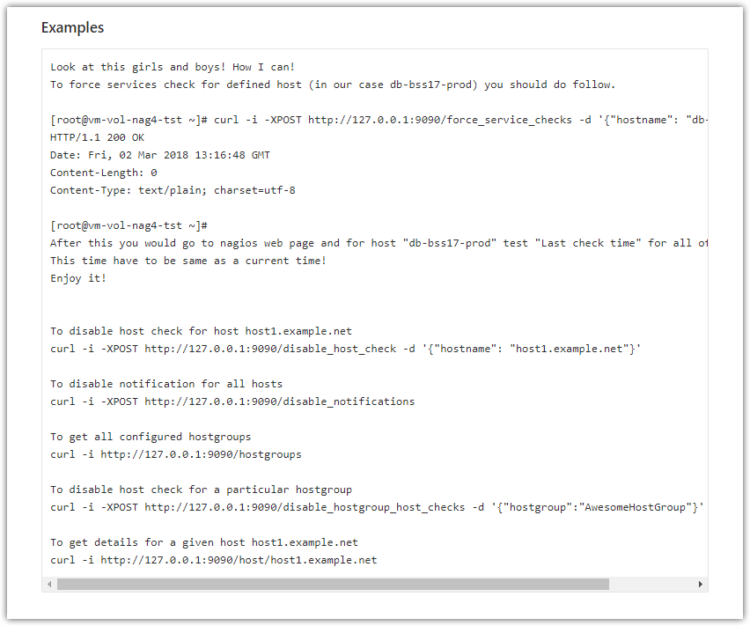
Look at this girls and boys! How I can!
To force services check for defined host (in our case db-bss17-prod) you should do follow.

[root@vm-vol-nag4-tst ~]# curl -i -XPOST http://127.0.0.1:9090/force_service_checks -d '{"hostname": "db-bss17-prod"}'
HTTP/1.1 200 OK
Date: Fri, 02 Mar 2018 13:16:48 GMT
Content-Length: 0
Content-Type: text/plain; charset=utf-8

[root@vm-vol-nag4-tst ~]#
After this you would go to nagios web page and for host "db-bss17-prod" test "Last check time" for all of its services.
This time have to be same as a current time!
Enjoy it!

20161121

Object Inheritance
https://assets.nagios.com/downloads/nagioscore/docs/nagioscore/3/en/objectinheritance.html
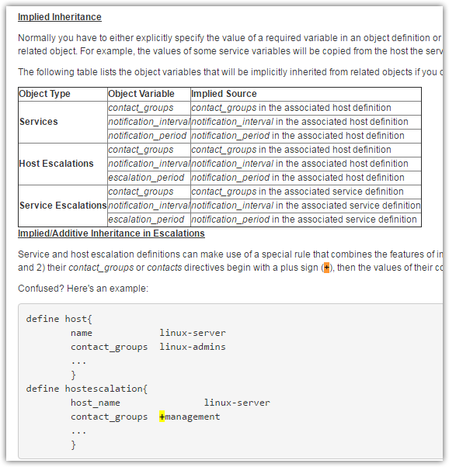

Time-Saving Tricks For Object Definitions
https://assets.nagios.com/downloads/nagioscore/docs/nagioscore/3/en/objecttricks.html
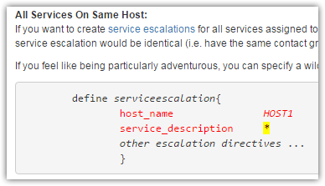

20160920
# Open search in new window.
# It allow use F5 button to refresh page.

http://nag-tst.tcsbank.ru/nagios/cgi-bin/status.cgi?navbarsearch=1&host=*clickhouse*

20160829

Nagios Core Documentation
https://assets.nagios.com/downloads/nagioscore/docs/nagioscore/4/en/toc.html

Understanding Macros and How They Work
https://assets.nagios.com/downloads/nagioscore/docs/nagioscore/4/en/macros.html

Standard Macros in Nagios
https://assets.nagios.com/downloads/nagioscore/docs/nagioscore/4/en/macrolist.html

Nikolaev Roman Dmitrievich
r.nikolaev@tinkoff.ru
Ведущий специалист по мониторингу
Управление поддержки фронт-систем

20160427
Notification Escalations
https://assets.nagios.com/downloads/nagioscore/docs/nagioscore/4/en/escalations.html

Service Escalation Definition
https://assets.nagios.com/downloads/nagioscore/docs/nagioscore/4/en/objectdefinitions.html#serviceescalation

Time-Saving Tricks For Object Definitions
https://assets.nagios.com/downloads/nagioscore/docs/nagioscore/4/en/objecttricks.html

Time Periods
https://assets.nagios.com/downloads/nagioscore/docs/nagioscore/4/en/timeperiods.html

Object Definitions
https://assets.nagios.com/downloads/nagioscore/docs/nagioscore/4/en/objectdefinitions.html#timeperiod

Service Definition
https://assets.nagios.com/downloads/nagioscore/docs/nagioscore/4/en/objectdefinitions.html#service

20160425

#
# Calculation of minutes, when the first notification will send.
# For note: it will send after service become HARD CRITICAL state.
#
# These parameters have its default value.
# max_check_attempts=3
# retry_interval=2
#
[support@centos00 ~]$ max_check_attempts=3 ; retry_interval=2 ; expr $(expr $max_check_attempts - 1) \* $retry_interval
4
[support@centos00 ~]$
#
# If max_check_attempts=1, the notification will send immedietely after service has CRITICAL state.
#
[support@centos00 ~]$ max_check_attempts=1 ; retry_interval=2 ; expr $(expr $max_check_attempts - 1) \* $retry_interval
0
[support@centos00 ~]$

# Calculation of minutes, when the second notification will send.
#
# These parameters have its default value.
# max_check_attempts=3
# retry_interval=2
# check_interval=10
#
[support@centos00 ~]$ notification_interval=9 ; check_interval=10 ; max_check_attempts=3 ; retry_interval=2 ; if [[ $notification_interval -ge $check_interval ]] ; then expr $(expr $(expr $max_check_attempts - 1) \* $retry_interval) + $(expr $(expr $notification_interval / $check_interval) \* $check_interval) ; else expr $(expr $(expr $max_check_attempts - 1) \* $retry_interval) + $(expr $(expr $(expr $notification_interval / $check_interval) + 1) \* $check_interval) ; fi
14
[support@centos00 ~]$
[support@centos00 ~]$ notification_interval=60 ; check_interval=10 ; max_check_attempts=3 ; retry_interval=2 ; if [[ $notification_interval -ge $check_interval ]] ; then expr $(expr $(expr $max_check_attempts - 1) \* $retry_interval) + $(expr $(expr $notification_interval / $check_interval) \* $check_interval) ; else expr $(expr $(expr $max_check_attempts - 1) \* $retry_interval) + $(expr $(expr $(expr $notification_interval / $check_interval) + 1) \* $check_interval) ; fi
64
[support@centos00 ~]$

# Calculation of minutes, when the first escalated notification will send.
#
# These parameters have its default value.
# max_check_attempts=3
# retry_interval=2
# check_interval=10
#
[support@centos00 ~]$ first_notification=4 ; notification_interval=60 ; check_interval=10 ; max_check_attempts=3 ; retry_interval=2 ; if [[ $notification_interval -ge $check_interval ]] ; then expr $(expr $(expr $(expr $max_check_attempts - 1) \* $retry_interval) + $(expr $(expr $notification_interval / $check_interval) \* $check_interval) \* $(expr $first_notification - 1) ) ; else expr $(expr $(expr $(expr $max_check_attempts - 1) \* $retry_interval) + $(expr $(expr $(expr $notification_interval / $check_interval) + 1) \* $check_interval) \* $(expr $first_notification - 1) ) ; fi
184
[support@centos00 ~]$

#
# 20191017
# At this moment there are list of services tuned with escalation.
[root@vm-vol-nag4-tst objects]# grep -irle "serviceescalation" servers/
servers/dc-ds/linux/kvk/ds-kvk-dmz-fe01.cfg
servers/dc-ds/linux/kvk/ds-kvk-prod-be01.cfg
servers/vmware/ds-kvk-dmz-nfe01.cfg
servers/vmware/vm-sitescan01t.cfg
servers/vmware/vm-kvk-dmz-mail01.cfg
servers/vmware/vm-dbamon01.cfg
servers/vmware/m1-kvk-prod-be02.cfg
servers/vmware/sas/vm-saskozin01p.cfg
servers/vmware/vm-sitescan01p.cfg
servers/vmware/vm-bicmsoper01p.cfg
servers/vmware/vm-kvk-prod-stat01.cfg
servers/vmware/m1-kvk-dmz-nfe01.cfg
servers/vmware/vm-kvk-prod-mysql.cfg
servers/vmware/ds-kvk-prod-be02.cfg
servers/vmware/m1-kvk-prod-mc01.cfg
servers/vmware/ds-kvk-prod-mc01.cfg
servers/dc-m1/linux/kvk/m1-kvk-dmz-fe01.cfg
servers/dc-m1/linux/kvk/m1-kvk-prod-be01.cfg
[root@vm-vol-nag4-tst objects]#

#
# 20191017
# SD#3310006
# When, “Current load” become critical the first escalated notification will be send after 19 minutes.
# 4 minutes to test - is it state HARD or no.
# Other escalated notification will be send every hours.
#
define service{
use generic-service-current-load
host_name vm-saskozin01p
service_description Current Load
check_command check_nrpe!check_load
check_interval 5
max_check_attempts 3
retry_interval 2
notification_interval 15
}
define serviceescalation{
host_name vm-saskozin01p
service_description Current Load
first_notification 2
last_notification 0
notification_interval 60
escalation_period 24x7
escalation_options c
}

# It was made for SD#836899
# Если нагрузка на процессор будет выше 90 % в течение 3-х часов, тогда алерт должен сработать.
#
[root@vm-vol-nag4-tst objects]# vim servers/vmware/vm-sitescan01p.cfg
...
define service{
use generic-service
host_name vm-sitescan01p
service_description CPU Load
check_command check_nt!CPULOAD!-l 5,85,90
flap_detection_enabled 0
contacts trash_contact
max_check_attempts 3
retry_interval 2
check_interval 10
notification_interval 60
}
define serviceescalation{
host_name vm-sitescan01p
service_description CPU Load
contacts cards_24x7_email,fraud_acquiring_email,paym_acquiring_email
first_notification 4
last_notification 0
notification_interval 60
escalation_period 24x7
escalation_options c
}
...

# If utilisation of CPU will be grater than 80% longer, than 40 minutes - the alert will be send.
#
# SD#792264
# Create the first notification after 44 minutes later CPU Load changed its state.
# 4 minutes is to test this state is a stable (HARD state in nagios terminology).
define service{
use generic-service
host_name vm-bicmsoper01p
service_description CPU Load
check_command check_nt!CPULOAD!-l 5,79,80
flap_detection_enabled 0
contacts trash_contact
max_check_attempts 3
retry_interval 2
check_interval 10
notification_interval 20
}
define serviceescalation{
host_name vm-bicmsoper01p
service_description CPU Load
contact_groups dwh-admins,windows-admins
first_notification 3
last_notification 0
notification_interval 60
escalation_period 24x7
escalation_options c
}

# One of key point of escalation (and not only escalation) is that notification send only in time when service is checking.
# That’s mean that no reason if “notification_interval” will be not multiplicity of “check_interval”!
# notification_interval = check_interval * n;
# Where n - is integer.

# For example for follow service configuration.
max_check_attempts 3
retry_interval 2
check_interval 10
notification_interval 10

state critical (HARD)
state critical (SOFT) # Even if notification_interval < check_interval
state critical (SOFT) # # Notification will be send only on the closest next check time!
# # # #
############################################################################################> Time line
^ ^ ^ #
The first check # # #
retry_interval=2 # # Here is time to check
The secont check # check_interval=10
retry_interval=2 The third check And time to send notifications, if it exist.
max_check_attempts=3
At this
moment the first
notification will
be send

# Below is an example of created by me configuration, when I was doing SDN#60766 task in new service desk.
#
[root@vm-vol-nag4-tst objects]# cat /usr/local/nagios/etc/objects/servers/vmware/m1-kvk-prod-be02.cfg
define host{
use linux-server
host_name m1-kvk-prod-be02
address 10.218.2.71
hostgroups kvk-servers
}

define service{
use generic-service-ping
host_name m1-kvk-prod-be02
service_description PING
contacts kvk-dev_email,tcb-tech-team_email
contact_groups linux-admins
check_command check_ping!100.0,20%!500.0,60%
max_check_attempts 1
check_interval 5
notification_interval 10
}
define serviceescalation{
host_name m1-kvk-prod-be02
service_description PING
contacts a.a.kalinin_email,a.a.kalinin_sms,Naumen_nag_request_email
contact_groups linux-admins
first_notification 2
last_notification 0
notification_interval 60
escalation_period 24x7
escalation_options c
}

define service{
use generic-service-partition-root
host_name m1-kvk-prod-be02
service_description Partition ROOT
contacts kvk-dev_email,tcb-tech-team_email
check_command check_nrpe!check_root_fs
max_check_attempts 3
retry_interval 2
check_interval 10
notification_interval 10
}
define serviceescalation{
host_name m1-kvk-prod-be02
service_description Partition ROOT
contacts a.a.kalinin_email,a.a.kalinin_sms,Naumen_nag_request_email
contact_groups linux-admins
first_notification 2
last_notification 0
notification_interval 60
escalation_period 24x7
escalation_options c
}

define service{
use generic-service-current-load
host_name m1-kvk-prod-be02
service_description Current Load
contacts kvk-dev_email,tcb-tech-team_email
check_command check_nrpe!check_load
max_check_attempts 3
retry_interval 2
check_interval 10
notification_interval 10
}
define serviceescalation{
host_name m1-kvk-prod-be02
service_description Current Load
contacts a.a.kalinin_email,a.a.kalinin_sms,Naumen_nag_request_email
first_notification 2
last_notification 0
notification_interval 60
escalation_period 24x7
escalation_options c
}
...

20161031
# Below are three lettes, where I explain how notification in nagios and “escalation” working.
#

From: Belogrud Sergey Vladimirovich
Sent: Thursday, October 27, 2016 8:34 PM
To: Kalinin Aleksey Alekseevich
Subject: RE: Уточнение по SDN#60766

Добрый день.

Для сервера ds-kvk-prod-be02 сделаны настройки, аналогичные тем, что уже есть для m1-kvk-prod-be02.
Новые настройки появятся на production nagios завтра после 12:00.

[root@vm-vol-nag4-tst objects]# pynag list service_description contact_groups contacts notification_interval where object_type="service" and host_name="ds-kvk-prod-be02"
service_description contact_groups contacts notification_interval
--------------------------------------------------------------------------------
Check Zombie procs null kvk-dev_email,tcb-tech-team_email 10
Current Load null kvk-dev_email,tcb-tech-team_email 10
Current Memory Load null kvk-dev_email,tcb-tech-team_email 10
PING linux-admins kvk-dev_email,tcb-tech-team_email 10
Partition ROOT null kvk-dev_email,tcb-tech-team_email 10
----------5 objects matches search condition------------------------------------
[root@vm-vol-nag4-tst objects]#
[root@vm-vol-nag4-tst objects]# pynag list service_description contact_groups contacts notification_interval where object_type="serviceescalation" and host_name="ds-kvk-prod-be02"
service_description contact_groups contacts notification_interval
--------------------------------------------------------------------------------
PING linux-admins a.a.kalinin_email,a.a.kalinin_sms,Naumen_nag_request_email 60
Partition ROOT linux-admins a.a.kalinin_email,a.a.kalinin_sms,Naumen_nag_request_email 60
Current Memory Load null a.a.kalinin_email,a.a.kalinin_sms,Naumen_nag_request_email 60
Check Zombie procs null a.a.kalinin_email,a.a.kalinin_sms,Naumen_nag_request_email 60
Current Load null a.a.kalinin_email,a.a.kalinin_sms,Naumen_nag_request_email 60
----------5 objects matches search condition------------------------------------
[root@vm-vol-nag4-tst objects]#

Кстати, просто для справки, эскалацию можно делать и с большим количеством уровней, чем в данном случае два.
Например три – сначала отпраляется первое оповещение, за ним, например спустя 10 минут отправляется на определённые адресаты второе уведомление, допустим на sms-контакты, и, например, спустя 30 минут отправляется третье, которое в числе прочего создаёт заявку в Service Desk.

Сергей Белогруд
Старший системный администратор
Тел.: +7 495 648-10-00, доб. 2173

From: Belogrud Sergey Vladimirovich
Sent: Wednesday, October 26, 2016 7:27 PM
To: Kalinin Aleksey Alekseevich
Subject: RE: Уточнение по SDN#60766

На текущий момент на этапе тестирования для сервера m1-kvk-prod-be02 реализовал следующие настройки уведомлений от проверяемых сервисов.

Первое уведомление о критическом состоянии отправится следующим контактам.
[root@vm-vol-nag4-tst objects]# pynag list service_description contact_groups contacts notification_interval where object_type="service" and host_name="m1-kvk-prod-be02"
service_description contact_groups contacts notification_interval
--------------------------------------------------------------------------------
Check Zombie procs null kvk-dev_email,tcb-tech-team_email 10
Current Load null kvk-dev_email,tcb-tech-team_email 10
Current Memory Load null kvk-dev_email,tcb-tech-team_email 10
PING linux-admins kvk-dev_email,tcb-tech-team_email 10
Partition ROOT null kvk-dev_email,tcb-tech-team_email 10
----------5 objects matches search condition------------------------------------
[root@vm-vol-nag4-tst objects]#
Для сервиса «PING» уведомление отправляется сразу же при обнаружении состояния critical без попыток перепроверить состояние. Это общепринятая настройка уведомлений конкретно по этому сервису. Уведомления отправятся на группу unix-admins и на перечисленные контакты.
Остальные сервисы будут перепроверяться на предмет ложного срабатывания ещё два раза. Это займёт 4 минуты времени.

Второе уведомление о критическом состоянии отправится следующим контактам через 10 минут после отправки первого уведомления.
[root@vm-vol-nag4-tst objects]# pynag list service_description contact_groups contacts notification_interval where object_type="serviceescalation" and host_name="m1-kvk-prod-be02"
service_description contact_groups contacts notification_interval
--------------------------------------------------------------------------------
PING linux-admins a.a.kalinin_email,a.a.kalinin_sms,Naumen_nag_request_email 60
Partition ROOT linux-admins a.a.kalinin_email,a.a.kalinin_sms,Naumen_nag_request_email 60
Current Load null a.a.kalinin_email,a.a.kalinin_sms,Naumen_nag_request_email 60
Check Zombie procs null a.a.kalinin_email,a.a.kalinin_sms,Naumen_nag_request_email 60
Current Memory Load null a.a.kalinin_email,a.a.kalinin_sms,Naumen_nag_request_email 60
----------5 objects matches search condition------------------------------------
[root@vm-vol-nag4-tst objects]#
Для сервисов «PING» и «Partition ROOT» уведомления будут отправлены и на группу unix-admins.

Третье и последующие уведомленя будут отправляться тем же контактам, что и второе уведомление. Уведомления будут отправляться каждые 60 минут.

Вот такая настройка уведомлений взята за исходную.
Новая конфигурация для хоста m1-kvk-prod-be02 применится на production nagios завтра после 12:00. Соответственно, можно будет попробовать её протестировать, при желании.

Сергей Белогруд
Старший системный администратор
Тел.: +7 495 648-10-00, доб. 2173

From: Belogrud Sergey Vladimirovich
Sent: Wednesday, October 26, 2016 5:35 PM
To: Kalinin Aleksey Alekseevich <a.a.kalinin@tinkoff.ru>
Subject: RE: Уточнение по SDN#60766

Хочу уточнить следующий момент.

В любом случае второе уведомление относительно первого придёт через 10 минут.
Но есть нюанс.
Нюанс составляет 4 минуты. Это время в течении которого nagios «точно» определяет, что сервис имеет состояние critical.

Дело в следующем.
В обычной обще-типовой конфигурации nagios отправляет уведомление только после того, как «точно» определит, что сервис перешел в состояние critical. Это сделано для исключения ложного срабатывания.
Для «точного» определения используется способ 3-х попыток проверки состояния сервиса.
1-ая проверка определяет, что сервис изменил своё состояние на critical. Но это может быть сбой в сети или ещё в чём-то.
2-ая попытка проверки происходит через 2 минуты. И состояние сервиса так же должно подтвердиться, что оно всё ещё critical.
3-тья попытка проверки происходит ещё через 2 минуты. И если на этот раз состояние сервиса всё ещё critical, то nagios определяет, что этого достаточно, чтобы «точно» считать, что сервис находится в состоянии critical.

В момент 3-ей проверки отправляется первое уведомление.
То есть формально оно опаздывает (как минимум) на 4 минуты от того момента, когда nagios заметил, что состояние сервиса изменилось на critical.

Эти 4 минуты вносят диссонанс в настройки и их можно или учитывать (но это заметно осложняет понимаемость настроек в nagios и приводит к необоснованному учащению проверок сервисов).
Либо эти 4 минты можно опустить – и считать это временем уточнения состояния сервиса (чем оно и является).

Итого.
1.
Есть вариант получения первого уведомления через 4 минуты после, того, как nagios зметил изменение состояния сервиса, и потом второе уведомление через 10 минут (формально это через 14 минут после обнаружения изменений в состояни сервиса).

2.
Или есть корявый вариант получения первого уведомления через 4 минуты после, того, как nagios зметил изменение состояния сервиса, и потом второе уведомление через 6 минут после первого (зато это формально через 10 минут после обнаружения изменений в состояни сервиса).

Я предлагаю остановиться на 1-м варианте.
По факту текущих настроек Вы и/или Ваши коллеги в подавляющем большинстве получаете уведомление от nagios лишь после 4 минут уточнения состояния сервиса, а не сразу.
Зато с заметно большей гарантией и с минимумом ложных срабатываний по тем или иным причинам.

Сергей Белогруд
Старший системный администратор
Тел.: +7 495 648-10-00, доб. 2173

20160414
#

From: Leonov Aleksey Vladimirovich
Sent: Thursday, April 14, 2016 3:04 PM
To: unix-admins
Subject: намутил кардиограмку для новых нагиосов

Коллеги,

вот тут, авторизация от нагиос:

http://nag-tst/munin/

легкие агент и сервер. база в rrd. архитектура - опросы агентов сервером, раз в 5 минут. может быть полезным при поиске причин каких либо затруднений в ретроспективе.

может кому покажется интересным.

С уважением,

Алексей Леонов
Администратор серверных комплексов

20160119
# Link to new enterprise nagios.

From: Nagios XI [mailto:nagiosxi@tcsbank.ru]
Sent: Tuesday, January 19, 2016 3:44 PM
To: Belogrud Sergey Vladimirovich
Subject: Закрытое beta-тестирование Nagios XI

Вы присоеденены к программе закрытого бэта-тестирования :)

http://vm-nagiosxi01t.tcsbank.ru/

#
# 20200227
# Here is one example how to fix failed nagios check for health status of Dell servers (730 in this case)(R640 - it works too). Rhel 7.x was installed on the server.
#
[root@vm-vol-nag4-tst objects]# /usr/local/nagios/libexec/check_openmanage -H 10.216.42.74 -C tcspub -P 2c -p
ERROR: (SNMP) OpenManage is not installed or is not working correctly
[root@vm-vol-nag4-tst objects]#

#
# I’ve restarted snmp service.
[root@ds-splunk-nidx02 ~]# systemctl restart snmpd
#
# It’s need to wait couple minutes to fix this issue. Periodicaly start checking.
#
# But I tested resutls with follow command. But it’s wrong. I suppose - there is no allowance in ntpd.conf file to get info from localhost.
# Shit is - this command doesn’t work even after nagios started check corrctly.
#
[root@ds-splunk-nidx02 ~]# snmpwalk -v 2c -c tcspub 10.216.42.74 1 | head
Timeout: No Response from 10.216.42.74
[root@ds-splunk-nidx02 ~]#

#
# After that I did follow.
# Was it helped or no - I’m not sure

[root@ds-splunk-nidx02 ~]# systemctl start dataeng
Failed to start dataeng.service: Unit is masked.
[root@ds-splunk-nidx02 ~]# systemctl unmask dataeng
Removed symlink /etc/systemd/system/dataeng.service.
[root@ds-splunk-nidx02 ~]# systemctl start dataeng
[root@ds-splunk-nidx02 ~]# systemctl status dataeng
● dataeng.service - (null)
Loaded: loaded (/etc/rc.d/init.d/dataeng; bad; vendor preset: disabled)
Active: active (exited) since Wed 2020-02-26 18:48:06 MSK; 17s ago
Docs: man:systemd-sysv-generator(8)
Process: 22118 ExecStart=/etc/rc.d/init.d/dataeng start (code=exited, status=0/SUCCESS)

Feb 26 18:48:01 ds-splunk-nidx02.tcsbank.ru systemd[1]: Starting (null)...
Feb 26 18:48:06 ds-splunk-nidx02.tcsbank.ru systemd[1]: Started (null).
[root@ds-splunk-nidx02 ~]#

#
# After that I restarted snmp service too.
[root@ds-splunk-nidx02 ~]# systemctl restart dataeng
[root@ds-splunk-nidx02 ~]# systemctl restart snmpd

#
# And accidentaly I noted - the nagios check started work correctly.
# It was after several minutes of my manipulations.
# One of other thoughts is - it’s require some time to start work correctly health service.
#
[root@vm-vol-nag4-tst objects]# /usr/local/nagios/libexec/check_openmanage -H 10.216.42.74 -C tcspub -P 2c -p
OK - System: 'PowerEdge R730xd', SN: 'CV48RG2', 256 GB ram (16 dimms), 1 logical drives, 24 physical drives|T0_System_Board_Inlet=21C;42;47 T1_System_Board_Exhaust=42C;70;75 T2_CPU1=54C;87;92 T3_CPU2=56C;87;92 W2_System_Board_Pwr_Consumption=350W;0;0 A0_PS1_Current_1=0.8A;0;0 A1_PS2_Current_2=0.6A;0;0 V26_PS1_Voltage_1=230V;0;0 V27_PS2_Voltage_2=226V;0;0 F0_System_Board_Fan1=4320rpm;0;0 F1_System_Board_Fan2=4320rpm;0;0 F2_System_Board_Fan3=4320rpm;0;0 F3_System_Board_Fan4=4200rpm;0;0 F4_System_Board_Fan5=4320rpm;0;0 F5_System_Board_Fan6=4320rpm;0;0
[root@vm-vol-nag4-tst objects]#

# 20180131
# How to create monitoring with nagios for hardware Dell servers with installed rhel 7.x.
[root@ds-mvno-db01-dev ~]# cat /etc/redhat-release
Red Hat Enterprise Linux Server release 7.3 (Maipo)
[root@ds-mvno-db01-dev ~]#
[root@ds-mvno-db01-dev ~]# dmidecode -t system
# dmidecode 3.0
Scanning /dev/mem for entry point.
SMBIOS 2.8 present.

Handle 0x0100, DMI type 1, 27 bytes
System Information
Manufacturer: Dell Inc.
Product Name: PowerEdge R630
Version: Not Specified
Serial Number: 74WXMK2
UUID: 4C4C4544-0034-5710-8058-B7C04F4D4B32
Wake-up Type: Power Switch
SKU Number: SKU=NotProvided;ModelName=PowerEdge R630
Family: Not Specified

Handle 0x0C00, DMI type 12, 5 bytes
System Configuration Options
Option 1: NVRAM_CLR: Clear user settable NVRAM areas and set defaults
Option 2: PWRD_EN: Close to enable password

Handle 0x2000, DMI type 32, 11 bytes
System Boot Information
Status: No errors detected

[root@ds-mvno-db01-dev ~]#

[root@ds-mvno-db01-dev ~]# yum install net-snmp net-snmp-utils
[root@ds-mvno-db01-dev ~]# yum install srvadmin-idracadm7 srvadmin-idracadm dcism

# There is no effect from follow command. Everything were installed by previous two command. That’s good.
[root@ds-mvno-db01-dev ~]# yum install srvadmin-deng-snmp srvadmin-idrac-snmp srvadmin-isvc-snmp
Loaded plugins: product-id, search-disabled-repos, subscription-manager
This system is not registered to Red Hat Subscription Management. You can use subscription-manager to register.
Package srvadmin-deng-snmp-9.1.0-2757.12163.el7.x86_64 already installed and latest version
Package srvadmin-idrac-snmp-9.1.0-2757.12163.el7.x86_64 already installed and latest version
Package srvadmin-isvc-snmp-9.1.0-2757.12163.el7.x86_64 already installed and latest version
Nothing to do
[root@ds-mvno-db01-dev ~]#

[root@ds-mvno-db01-dev ~]# logout
[bsv@ds-mvno-db01-dev ~]$ logout
Connection to ds-mvno-db01-dev closed.
[s.belogrud@TCS4357]#

[s.belogrud@TCS4357]# ssh bsv@ds-mvno-db01-dev
Last login: Tue Jan 30 14:53:35 2018 from 172.16.28.74
[bsv@ds-mvno-db01-dev ~]$ sudo -i
[sudo] password for bsv:
[root@ds-mvno-db01-dev ~]# racadm getniccfg | head

IPv4 settings:
NIC Enabled = 1
IPv4 Enabled = 1
DHCP Enabled = 0
IP Address = 10.219.110.89
Subnet Mask = 255.255.254.0
Gateway = 10.219.111.254

IPv6 settings:
[root@ds-mvno-db01-dev ~]#

[root@ds-mvno-db01-dev ~]# mkdir -p ~/work/20180130-1614
[root@ds-mvno-db01-dev ~]# cp /etc/snmp/snmpd.conf ~/work/20180130-1614/

[root@ds-mvno-db01-dev ~]# cat > /etc/snmp/snmpd.conf
# com2sec notConfigUser default public
group notConfigGroup v1 notConfigUser
group notConfigGroup v2c notConfigUser
rocommunity tcspub nag2.tcsbank.ru
rocommunity tcspub sim.tcsbank.ru
rocommunity tcspub cacti.tcsbank.ru
rocommunity tcspub mon1.tcsbank.ru
rocommunity tcspub mon2.tcsbank.ru
rocommunity tcspub mon3.tcsbank.ru
rocommunity tcspub mon4.tcsbank.ru
rocommunity tcspub mon5.tcsbank.ru
rocommunity tcspub mon6.tcsbank.ru
rocommunity tcspub 172.16.1.115
rocommunity tcspub 172.16.1.117
rocommunity tcspub 10.217.50.167
view all included .1
view systemview included .1.3.6.1.2.1.1
view systemview included .1.3.6.1.2.1.25.1.1
access notConfigGroup "" any noauth exact all none none
syslocation Unknown (edit /etc/snmp/snmpd.conf)
syscontact Root <root@localhost> (configure /etc/snmp/snmp.local.conf)
dontLogTCPWrappersConnects yes
smuxpeer .1.3.6.1.4.1.674.10892.1
com2sec notConfigUser default tcspub
Trapsink 10.216.43.159 tcspub
rocommunity tcspub 10.216.43.159
includeDir /etc/snmp/config.d
[root@ds-mvno-db01-dev ~]#

[root@ds-mvno-db01-dev ~]# systemctl restart snmpd.service
[root@ds-mvno-db01-dev ~]# systemctl status snmpd.service
● snmpd.service - Simple Network Management Protocol (SNMP) Daemon.
Loaded: loaded (/usr/lib/systemd/system/snmpd.service; disabled; vendor preset: disabled)
Active: active (running) since Tue 2018-01-30 16:18:27 MSK; 5s ago
Main PID: 3542 (snmpd)
CGroup: /system.slice/snmpd.service
└─3542 /usr/sbin/snmpd -LS0-6d -f

Jan 30 16:18:27 ds-mvno-db01-dev.tcsbank.ru systemd[1]: Starting Simple Network Management Protocol (SNMP) Daemon....
Jan 30 16:18:27 ds-mvno-db01-dev.tcsbank.ru snmpd[3542]: Duplicate IPv4 address detected, some interfaces may not be visible in IP-MIB
Jan 30 16:18:27 ds-mvno-db01-dev.tcsbank.ru snmpd[3542]: NET-SNMP version 5.7.2
Jan 30 16:18:27 ds-mvno-db01-dev.tcsbank.ru systemd[1]: Started Simple Network Management Protocol (SNMP) Daemon..
[root@ds-mvno-db01-dev ~]# ip -f inet addr | grep inet
inet 127.0.0.1/8 scope host lo
inet 10.250.23.1/24 brd 10.250.23.255 scope global vlan2523
inet 10.250.23.2/24 brd 10.250.23.255 scope global secondary vlan2523
inet 10.217.76.43/24 brd 10.217.76.255 scope global vlan1776
inet 10.217.65.43/24 brd 10.217.65.255 scope global vlan1765
[root@ds-mvno-db01-dev ~]#

[root@ds-zeppelin01p ~]# systemctl enable snmpd.service

[root@ds-mvno-db01-dev ~]# host ds-mvno-db01-dev
ds-mvno-db01-dev.tcsbank.ru has address 10.250.23.1
[root@ds-mvno-db01-dev ~]#

[root@ds-mvno-db01-dev ~]# snmpwalk -v 2c -c tcspub 10.250.23.1 1 | head
SNMPv2-MIB::sysDescr.0 = STRING: Linux ds-mvno-db01-dev.tcsbank.ru 3.10.0-514.el7.x86_64 #1 SMP Wed Oct 19 11:24:13 EDT 2016 x86_64
SNMPv2-MIB::sysObjectID.0 = OID: NET-SNMP-MIB::netSnmpAgentOIDs.10
DISMAN-EVENT-MIB::sysUpTimeInstance = Timeticks: (9728) 0:01:37.28
SNMPv2-MIB::sysContact.0 = STRING: Root <root@localhost> (configure /etc/snmp/snmp.local.conf)
SNMPv2-MIB::sysName.0 = STRING: ds-mvno-db01-dev.tcsbank.ru
SNMPv2-MIB::sysLocation.0 = STRING: Unknown (edit /etc/snmp/snmpd.conf)
SNMPv2-MIB::sysORLastChange.0 = Timeticks: (2) 0:00:00.02
SNMPv2-MIB::sysORID.1 = OID: SNMP-MPD-MIB::snmpMPDCompliance
SNMPv2-MIB::sysORID.2 = OID: SNMP-USER-BASED-SM-MIB::usmMIBCompliance
SNMPv2-MIB::sysORID.3 = OID: SNMP-FRAMEWORK-MIB::snmpFrameworkMIBCompliance
[root@ds-mvno-db01-dev ~]#

[root@ds-mvno-db01-dev ~]# systemctl start dataeng

[root@ds-mvno-db01-dev ~]# /usr/lib64/nagios/plugins/check_openmanage -p
OK - System: 'PowerEdge R630', SN: '74WXMK2', 512 GB ram (16 dimms), 1 logical drives, 4 physical drives|T0_System_Board_Inlet=22C;42;47 T1_System_Board_Exhaust=38C;70;75 T2_CPU1=48C;87;92 T3_CPU2=41C;87;92
W2_System_Board_Pwr_Consumption=154W;896;980 A0_PS1_Current_1=0.4A;0;0 A1_PS2_Current_2=0.4A;0;0 V30_PS1_Voltage_1=232V;0;0 V31_PS2_Voltage_2=226V;0;0 F0_System_Board_Fan1A=4560rpm;0;0 F1_System_Board_Fan2
A=4680rpm;0;0 F2_System_Board_Fan3A=4560rpm;0;0 F3_System_Board_Fan4A=4560rpm;0;0 F4_System_Board_Fan5A=4560rpm;0;0 F5_System_Board_Fan6A=4560rpm;0;0 F6_System_Board_Fan7A=4560rpm;0;0 F7_System_Board_Fan1B=
4200rpm;0;0 F8_System_Board_Fan2B=4200rpm;0;0 F9_System_Board_Fan3B=4200rpm;0;0 F10_System_Board_Fan4B=3960rpm;0;0 F11_System_Board_Fan5B=4080rpm;0;0 F12_System_Board_Fan6B=4200rpm;0;0 F13_System_Board_Fan7
B=4200rpm;0;0
[root@ds-mvno-db01-dev ~]#

# After all, there is no working nagios check for hardware of this server.
# Below I try to find why so.
[root@ds-mvno-db01-dev ~]# netstat -nlptu | grep snmp
tcp 0 0 127.0.0.1:199 0.0.0.0:* LISTEN 3542/snmpd
udp 0 0 0.0.0.0:36646 0.0.0.0:* 3542/snmpd
udp 0 0 0.0.0.0:161 0.0.0.0:* 3542/snmpd
[root@ds-mvno-db01-dev ~]#

[root@ds-mvno-db01-dev ~]# systemctl status firewalld
● firewalld.service - firewalld - dynamic firewall daemon
Loaded: loaded (/usr/lib/systemd/system/firewalld.service; disabled; vendor preset: enabled)
Active: inactive (dead)
Docs: man:firewalld(1)
[root@ds-mvno-db01-dev ~]#

[root@ds-mvno-db01-dev ~]# iptables -n -L -t filter ; iptables -n -L -t nat ; iptables -n -L -t mangle
Chain INPUT (policy ACCEPT)
target prot opt source destination

Chain FORWARD (policy ACCEPT)
target prot opt source destination
...

[root@ds-mvno-db01-dev ~]# ip -f inet addr | grep inet
inet 127.0.0.1/8 scope host lo
inet 10.250.23.1/24 brd 10.250.23.255 scope global vlan2523
inet 10.250.23.2/24 brd 10.250.23.255 scope global secondary vlan2523
inet 10.217.76.43/24 brd 10.217.76.255 scope global vlan1776
inet 10.217.65.43/24 brd 10.217.65.255 scope global vlan1765
[root@ds-mvno-db01-dev ~]#

# There is no access to snmp from nagios.
[root@vm-vol-nag4-tst etc]# snmpwalk -v 2c -c tcspub 10.250.23.1 1 | head
Timeout: No Response from 10.250.23.1
[root@vm-vol-nag4-tst etc]#

# For example if access is working. This is for other server.
[root@vm-vol-nag4-tst etc]# snmpwalk -v 2c -c tcspub ds-pr-onltraces01p 1 | head
SNMPv2-MIB::sysDescr.0 = STRING: Linux ds-pr-onltraces01p.tcsbank.ru 3.10.0-514.el7.x86_64 #1 SMP Tue Nov 22 16:42:41 UTC 2016 x86_64
SNMPv2-MIB::sysObjectID.0 = OID: NET-SNMP-MIB::netSnmpAgentOIDs.10
DISMAN-EVENT-MIB::sysUpTimeInstance = Timeticks: (1157374050) 133 days, 22:55:40.50
SNMPv2-MIB::sysContact.0 = STRING: Root <root@localhost> (configure /etc/snmp/snmp.local.conf)
SNMPv2-MIB::sysName.0 = STRING: ds-pr-onltraces01p.tcsbank.ru
SNMPv2-MIB::sysLocation.0 = STRING: Unknown (edit /etc/snmp/snmpd.conf)
SNMPv2-MIB::sysORLastChange.0 = Timeticks: (11) 0:00:00.11
SNMPv2-MIB::sysORID.1 = OID: SNMP-MPD-MIB::snmpMPDCompliance
SNMPv2-MIB::sysORID.2 = OID: SNMP-USER-BASED-SM-MIB::usmMIBCompliance
SNMPv2-MIB::sysORID.3 = OID: SNMP-FRAMEWORK-MIB::snmpFrameworkMIBCompliance
[root@vm-vol-nag4-tst etc]#

# Same situation if I test with nmap utility.
[root@vm-vol-nag4-tst etc]# nmap -p 161 -sU -P0 10.250.23.1

Starting Nmap 5.51 ( http://nmap.org ) at 2018-01-30 16:48 MSK
Nmap scan report for ds-mvno-db01-dev.tcsbank.ru (10.250.23.1)
Host is up.
PORT STATE SERVICE
161/udp open|filtered snmp

Nmap done: 1 IP address (1 host up) scanned in 2.06 seconds
[root@vm-vol-nag4-tst etc]#

# And for example if access is available for other server.
[root@vm-vol-nag4-tst etc]# nmap -p 161 -sU -P0 ds-pr-onltraces01p

Starting Nmap 5.51 ( http://nmap.org ) at 2018-01-30 16:45 MSK
Nmap scan report for ds-pr-onltraces01p (10.217.9.10)
Host is up (0.037s latency).
rDNS record for 10.217.9.10: ds-pr-onltraces01p.tcsbank.ru
PORT STATE SERVICE
161/udp open snmp

Nmap done: 1 IP address (1 host up) scanned in 0.11 seconds
You have mail in /var/spool/mail/root
[root@vm-vol-nag4-tst etc]#
# At the end, I made Tuffin access request from nagios to this server.
# After my request was successfuly completed, nagios check start working well.
# It was in SD#1017765.

# 20170317
# How to create monitoring with nagios for hardware Dell servers with installed rhel 6.x.
[root@m1-gp-prd-bkp1 ~]# curl repo-linux/tcs-dell-dsu-rhel6.repo.sh | sh
[root@m1-gp-prd-bkp1 ~]# yum install srvadmin-idracadm7 srvadmin-idracadm dcism
[root@m1-gp-prd-bkp1 ~]# yum install srvadmin-deng-snmp srvadmin-idrac-snmp srvadmin-isvc-snmp

[root@m1-gp-prd-bkp1 ~]# logout
Connection to m1-gp-prd-bkp1 closed.
[2017-03-15 18:10.22] ~
[s.belogrud.tcs4500] ➤ ssh root@m1-gp-prd-bkp1
Last login: Wed Mar 15 18:18:30 2017 from tcs4500.tcsbank.ru
[root@m1-gp-prd-bkp1 ~]# racadm getniccfg | head

IPv4 settings:
NIC Enabled = 1
IPv4 Enabled = 1
DHCP Enabled = 0
IP Address = 10.219.9.164
Subnet Mask = 255.255.255.0
Gateway = 10.219.9.254

IPv6 settings:
[root@m1-gp-prd-bkp1 ~]#

[root@m1-gp-prd-bkp1 ~]# cat > /etc/snmp/snmpd.conf
# com2sec notConfigUser default public
group notConfigGroup v1 notConfigUser
group notConfigGroup v2c notConfigUser
rocommunity tcspub nag2.tcsbank.ru
rocommunity tcspub sim.tcsbank.ru
rocommunity tcspub cacti.tcsbank.ru
rocommunity tcspub mon1.tcsbank.ru
rocommunity tcspub mon2.tcsbank.ru
rocommunity tcspub mon3.tcsbank.ru
rocommunity tcspub mon4.tcsbank.ru
rocommunity tcspub mon5.tcsbank.ru
rocommunity tcspub mon6.tcsbank.ru
rocommunity tcspub 172.16.1.115
rocommunity tcspub 172.16.1.117
rocommunity tcspub 10.217.50.167
view all included .1
view systemview included .1.3.6.1.2.1.1
view systemview included .1.3.6.1.2.1.25.1.1
access notConfigGroup "" any noauth exact all none none
syslocation Unknown (edit /etc/snmp/snmpd.conf)
syscontact Root <root@localhost> (configure /etc/snmp/snmp.local.conf)
dontLogTCPWrappersConnects yes
smuxpeer .1.3.6.1.4.1.674.10892.1
com2sec notConfigUser default tcspub
Trapsink 10.216.43.159 tcspub
rocommunity tcspub 10.216.43.159
includeDir /etc/snmp/config.d
[root@m1-gp-prd-bkp1 ~]#

[root@m1-gp-prd-bkp1 ~]# service snmpd restart
Stopping snmpd: [FAILED]
Starting snmpd: [ OK ]
[root@m1-gp-prd-bkp1 ~]# service snmpd status
snmpd (pid 8468) is running...
[root@m1-gp-prd-bkp1 ~]# snmpwalk -v 2c -c tcspub localhost 1 | head
SNMPv2-MIB::sysDescr.0 = STRING: Linux m1-gp-prd-bkp1.tcsbank.ru 2.6.32-431.el6.x86_64 #1 SMP Sun Nov 10 22:19:54 EST 2013 x86_64
SNMPv2-MIB::sysObjectID.0 = OID: NET-SNMP-MIB::netSnmpAgentOIDs.10
DISMAN-EVENT-MIB::sysUpTimeInstance = Timeticks: (4794) 0:00:47.94
SNMPv2-MIB::sysContact.0 = STRING: Root <root@localhost> (configure /etc/snmp/snmp.local.conf)
SNMPv2-MIB::sysName.0 = STRING: m1-gp-prd-bkp1.tcsbank.ru
SNMPv2-MIB::sysLocation.0 = STRING: Unknown (edit /etc/snmp/snmpd.conf)
SNMPv2-MIB::sysORLastChange.0 = Timeticks: (1) 0:00:00.01
SNMPv2-MIB::sysORID.1 = OID: SNMP-MPD-MIB::snmpMPDMIBObjects.3.1.1
SNMPv2-MIB::sysORID.2 = OID: SNMP-USER-BASED-SM-MIB::usmMIBCompliance
SNMPv2-MIB::sysORID.3 = OID: SNMP-FRAMEWORK-MIB::snmpFrameworkMIBCompliance
[root@m1-gp-prd-bkp1 ~]#

[root@m1-gp-prd-bkp1 ~]# ip -f inet addr
1: lo: <LOOPBACK,UP,LOWER_UP> mtu 16436 qdisc noqueue state UNKNOWN
inet 127.0.0.1/8 scope host lo
6: bond0: <BROADCAST,MULTICAST,MASTER,UP,LOWER_UP> mtu 1500 qdisc noqueue state UP
inet 10.216.4.41/24 brd 10.216.4.255 scope global bond0
[root@m1-gp-prd-bkp1 ~]# snmpwalk -v 2c -c tcspub 10.216.4.41 1 | head
SNMPv2-MIB::sysDescr.0 = STRING: Linux m1-gp-prd-bkp1.tcsbank.ru 2.6.32-431.el6.x86_64 #1 SMP Sun Nov 10 22:19:54 EST 2013 x86_64
SNMPv2-MIB::sysObjectID.0 = OID: NET-SNMP-MIB::netSnmpAgentOIDs.10
DISMAN-EVENT-MIB::sysUpTimeInstance = Timeticks: (20890) 0:03:28.90
SNMPv2-MIB::sysContact.0 = STRING: Root <root@localhost> (configure /etc/snmp/snmp.local.conf)
SNMPv2-MIB::sysName.0 = STRING: m1-gp-prd-bkp1.tcsbank.ru
SNMPv2-MIB::sysLocation.0 = STRING: Unknown (edit /etc/snmp/snmpd.conf)
SNMPv2-MIB::sysORLastChange.0 = Timeticks: (1) 0:00:00.01
SNMPv2-MIB::sysORID.1 = OID: SNMP-MPD-MIB::snmpMPDMIBObjects.3.1.1
SNMPv2-MIB::sysORID.2 = OID: SNMP-USER-BASED-SM-MIB::usmMIBCompliance
SNMPv2-MIB::sysORID.3 = OID: SNMP-FRAMEWORK-MIB::snmpFrameworkMIBCompliance
[root@m1-gp-prd-bkp1 ~]#

[root@m1-gp-prd-bkp1 ~]# service dataeng start
Starting Systems Management Data Engine:
Starting dsm_sa_datamgrd: [ OK ]
Starting dsm_sa_eventmgrd: [ OK ]
Starting dsm_sa_snmpd: [ OK ]
[root@m1-gp-prd-bkp1 ~]#

# Sometime server needs to be rebooted to start working check properly.
# It was this this case.
[root@vm-vol-nag4-prod ~]# /usr/lib64/nagios/plugins/check_openmanage -H 10.216.4.41 -C tcspub -P 2c -p
Storage Error! No controllers found|T0_System_Board_Inlet=31C;42;47 T1_System_Board_Exhaust=49C;70;75 T2_CPU1=51C;87;92 T3_CPU2=64C;87;92 W2_System_Board_Pwr_Consumption=280W;0;0 A0_PS1_Current_1=0.6A;0; 0 A1_PS2_Current_2=0.6A;0;0 V27_PS1_Voltage_1=230V;0;0 V28_PS2_Voltage_2=230V;0;0 F0_System_Board_Fan1=6840rpm;0;0 F1_System_Board_Fan2=6720rpm;0;0 F2_System_Board_Fan3=6600rpm;0;0 F3_System_Board_Fan4=6600rpm;0;0 F4_System_Board_Fan5=6720rpm;0;0 F5_System_Board_Fan6=6720rpm;0;0
[root@vm-vol-nag4-prod ~]#

# After reboot, check started work properly.
[root@vm-vol-nag4-prod ~]# /usr/lib64/nagios/plugins/check_openmanage -H 10.216.4.41 -C tcspub -P 2c -p
OK - System: 'PowerEdge R730xd', SN: 'CXD6RG2', 128 GB ram (8 dimms), 2 logical drives, 14 physical drives|T0_System_Board_Inlet=30C;42;47 T1_System_Board_Exhaust=49C;70;75 T2_CPU1=51C;87;92 T3_CPU2=64C; 87;92 W2_System_Board_Pwr_Consumption=280W;0;0 A0_PS1_Current_1=0.6A;0;0 A1_PS2_Current_2=0.6A;0;0 V27_PS1_Voltage_1=230V;0;0 V28_PS2_Voltage_2=230V;0;0 F0_System_Board_Fan1=6600rpm;0;0 F1_System_Board_Fan2=6480rpm;0;0 F2_System_Board_Fan3=6480rpm;0;0 F3_System_Board_Fan4=6360rpm;0;0 F4_System_Board_Fan5=6480rpm;0;0 F5_System_Board_Fan6=6600rpm;0;0
[root@vm-vol-nag4-prod ~]#

# 20170703
# On rhel 6.9.
# I had follow error.
[root@vm-vol-nag4-tst 20170703-1528]# /usr/lib64/nagios/plugins/check_openmanage -H 10.216.4.201 -C tcspub -P 2c -p
Storage Error! No controllers found|T0_System_Board_Inlet=20C;42;47 T1_System_Board_Exhaust=35C;70;75 T2_CPU1=42C;87;92 T3_CPU2=38C;87;92 W2_System_Board_Pwr_Consumption=224W;0;0 A0_PS1_Current_1=0.4A;0;0 A1_PS2_Current_2=0.6A;0;0 V26_PS1_Voltage_1=228V;0;0 V27_PS2_Voltage_2=230V;0;0 F0_System_Board_Fan1=4080rpm;0;0 F1_System_Board_Fan2=4080rpm;0;0 F2_System_Board_Fan3=4080rpm;0;0 F3_System_Board_Fan4=4080rpm;0;0 F4_System_Board_Fan5=4080rpm;0;0 F5_System_Board_Fan6=4080rpm;0;0
[root@vm-vol-nag4-tst 20170703-1528]#

# That error was fixed after I had installed follow package.
[root@m1-2-gp-prd-sdw1 ~]# yum install srvadmin-all
# And restart service dataeng
[root@m1-2-gp-prd-sdw1 ~]# service dataeng restart
# After dataeng service was restarted, test became work properly.
[root@vm-vol-nag4-tst 20170703-1528]# /usr/lib64/nagios/plugins/check_openmanage -H 10.216.4.201 -C tcspub -P 2c -p
OK - System: 'PowerEdge R730xd', SN: 'D8RHXJ2', 320 GB ram (20 dimms), 3 logical drives, 20 physical drives|T0_System_Board_Inlet=20C;42;47 T1_System_Board_Exhaust=36C;70;75 T2_CPU1=42C;87;92 T3_CPU2=38C;87;92 W2_System_Board_Pwr_Consumption=224W;0;0 A0_PS1_Current_1=0.4A;0;0 A1_PS2_Current_2=0.6A;0;0 V26_PS1_Voltage_1=228V;0;0 V27_PS2_Voltage_2=228V;0;0 F0_System_Board_Fan1=4080rpm;0;0 F1_System_Board_Fan2=4080rpm;0;0 F2_System_Board_Fan3=4080rpm;0;0 F3_System_Board_Fan4=3960rpm;0;0 F4_System_Board_Fan5=4080rpm;0;0 F5_System_Board_Fan6=4080rpm;0;0
[root@vm-vol-nag4-tst 20170703-1528]#
# I assumed, that was not installed appropriate plugins of openmanage, that allow it get information about raid controllers and drives.

# In this case section of check in nagios will looks like below:
...
define service{
use hp-health-service
host_name m1-gp-prd-bkp1
service_description Server Health
check_command check_dell
}
...

# 20170530
# I have follow error on server with CentOS 7 installed.
# Reboot was not helped me.
[root@vm-vol-nag4-tst objects]# /usr/lib64/nagios/plugins/check_openmanage -H 10.216.96.61 -C tcspub -P 2c -p
Storage Error! No controllers found|T0_System_Board_Inlet=19C;42;47 T1_System_Board_Exhaust=43C;70;75 T2_CPU1=67C;86;91 T3_CPU2=67C;86;91 W2_System_Board_Pwr_Consumption=210W;0;0 A0_PS1_Current_1=0.6A;0;0 A1_PS2_Current_2=0.4A;0;0 V30_PS1_Voltage_1=228V;0;0 V31_PS2_Voltage_2=230V;0;0 F0_System_Board_Fan1A=4320rpm;0;0 F1_System_Board_Fan2A=4320rpm;0;0 F2_System_Board_Fan3A=4320rpm;0;0 F3_System_Board_Fan4A=4200rpm;0;0 F4_System_Board_Fan5A=4440rpm;0;0 F5_System_Board_Fan6A=4320rpm;0;0 F6_System_Board_Fan7A=4320rpm;0;0 F7_System_Board_Fan1B=4080rpm;0;0 F8_System_Board_Fan2B=4080rpm;0;0 F9_System_Board_Fan3B=4080rpm;0;0 F10_System_Board_Fan4B=3960rpm;0;0 F11_System_Board_Fan5B=4080rpm;0;0 F12_System_Board_Fan6B=4080rpm;0;0 F13_System_Board_Fan7B=4080rpm;0;0
[root@vm-vol-nag4-tst objects]#

# I’ve installed repository for version 7.
[root@m1-asterisk05 ~]# curl repo-linux/tcs-dell-dsu-rhel7.repo.sh | sh
% Total % Received % Xferd Average Speed Time Time Time Current
Dload Upload Total Spent Left Speed
100 342 100 342 0 0 23748 0 --:--:-- --:--:-- --:--:-- 24428
You have new mail in /var/spool/mail/root
[root@m1-asterisk05 ~]#
# Install more than 50 packages with srvadmin-all.
[root@m1-asterisk05 ~]# yum install srvadmin-all
...
Installed:
srvadmin-all.x86_64 0:8.5.0-2372.10488.el7
...
# After that, checks didn’t started.
[root@m1-asterisk05 ~]# /usr/lib64/nagios/plugins/check_openmanage -p
Storage Error! No controllers found
Problem running 'omreport chassis memory': Error: Memory object not found
Problem running 'omreport chassis fans': Error! No fan probes found on this system.
Problem running 'omreport chassis temps': Error! No temperature probes found on this system.
Problem running 'omreport chassis volts': Error! No voltage probes found on this system.
Chassis Service Tag is bogus: 'N/A'
[root@m1-asterisk05 ~]#
# Then I restart dataeng service.
[root@m1-asterisk05 ~]# systemctl stop dataeng
[root@m1-asterisk05 ~]# systemctl start dataeng
You have new mail in /var/spool/mail/root
[root@m1-asterisk05 ~]# systemctl status dataeng
● dataeng.service - LSB: Systems Management Data Engine
Loaded: loaded (/etc/rc.d/init.d/dataeng)
Active: active (running) since Tue 2017-05-30 16:27:08 MSK; 6s ago
Docs: man:systemd-sysv-generator(8)
Process: 26122 ExecStart=/etc/rc.d/init.d/dataeng start (code=exited, status=0/SUCCESS)
CGroup: /system.slice/dataeng.service
├─26203 /opt/dell/srvadmin/sbin/dsm_sa_datamgrd
├─26252 /opt/dell/srvadmin/sbin/dsm_sa_eventmgrd
├─26279 /opt/dell/srvadmin/sbin/dsm_sa_snmpd
└─26356 /opt/dell/srvadmin/sbin/dsm_sa_datamgrd

May 30 16:27:13 m1-asterisk05.tcsbank.ru Server_Administrator[26252]: 26252 2334 - Storage Service Controller event log: Battery temperature is normal: Controller 0 (PERC H730 Mini)
May 30 16:27:13 m1-asterisk05.tcsbank.ru Server_Administrator[26252]: 26252 2334 - Storage Service Controller event log: Current capacity of the battery is above threshold: Controller 0 (PERC H730 Mini)
May 30 16:27:13 m1-asterisk05.tcsbank.ru Server_Administrator[26252]: 26252 2334 - Storage Service Controller event log: Enclosure PD 20(c None/p1) communication restored: Controller 0 (PERC H730 Mini)
May 30 16:27:13 m1-asterisk05.tcsbank.ru Server_Administrator[26252]: 26252 2334 - Storage Service Controller event log: Inserted: Encl PD 20: Controller 0 (PERC H730 Mini)
May 30 16:27:14 m1-asterisk05.tcsbank.ru Server_Administrator[26252]: 26252 2334 - Storage Service Controller event log: Inserted: PD 00(e0x20/s0): Controller 0 (PERC H730 Mini)
May 30 16:27:14 m1-asterisk05.tcsbank.ru Server_Administrator[26252]: 26252 2334 - Storage Service Controller event log: Inserted: PD 01(e0x20/s1): Controller 0 (PERC H730 Mini)
May 30 16:27:14 m1-asterisk05.tcsbank.ru Server_Administrator[26252]: 26252 2334 - Storage Service Controller event log: Inserted: PD 02(e0x20/s2): Controller 0 (PERC H730 Mini)
May 30 16:27:14 m1-asterisk05.tcsbank.ru Server_Administrator[26252]: 26252 2334 - Storage Service Controller event log: Inserted: PD 03(e0x20/s3): Controller 0 (PERC H730 Mini)
May 30 16:27:15 m1-asterisk05.tcsbank.ru Server_Administrator[26252]: 26252 2334 - Storage Service Controller event log: Controller operating temperature within normal range, full operation restored: ...C H730 Mini)
May 30 16:27:15 m1-asterisk05.tcsbank.ru Server_Administrator[26252]: 26252 2334 - Storage Service Controller event log: Time established as 05/07/16 14:24:46; (25 seconds since power on): Controller ...C H730 Mini)
Hint: Some lines were ellipsized, use -l to show in full.

# After that checks started work.
[root@m1-asterisk05 ~]# /usr/lib64/nagios/plugins/check_openmanage -p
OK - System: 'PowerEdge R630', SN: '42MJ8D2', 256 GB ram (16 dimms), 2 logical drives, 4 physical drives|T0_System_Board_Inlet=20C;42;47 T1_System_Board_Exhaust=44C;70;75 T2_CPU1=65C;86;91 T3_CPU2=70C;86;91 W2_System_Board_Pwr_Consumption=224W;896;980 A0_PS1_Current_1=0.6A;0;0 A1_PS2_Current_2=0.4A;0;0 V30_PS1_Voltage_1=228V;0;0 V31_PS2_Voltage_2=230V;0;0 F0_System_Board_Fan1A=4320rpm;0;0 F1_System_Board_Fan2A=4320rpm;0;0 F2_System_Board_Fan3A=4320rpm;0;0 F3_System_Board_Fan4A=4200rpm;0;0 F4_System_Board_Fan5A=4320rpm;0;0 F5_System_Board_Fan6A=4320rpm;0;0 F6_System_Board_Fan7A=4320rpm;0;0 F7_System_Board_Fan1B=4080rpm;0;0 F8_System_Board_Fan2B=4080rpm;0;0 F9_System_Board_Fan3B=4080rpm;0;0 F10_System_Board_Fan4B=3960rpm;0;0 F11_System_Board_Fan5B=4080rpm;0;0 F12_System_Board_Fan6B=4080rpm;0;0 F13_System_Board_Fan7B=4080rpm;0;0
[root@m1-asterisk05 ~]#

#
# Below is a notes how to make monitoring that will work with Dell PowerEdge R930.
# This model of servers have a specific - via snmp check_openmanage software doesn’t work properly.
# This is doesn’t work: /usr/lib64/nagios/plugins/check_openmanage -H x.x.x.x -C tcspub -P 2c -p
#
# To fix that we use nrpe and run this utility locally on server.

# https://exchange.nagios.org/directory/Plugins/Hardware/Server-Hardware/Dell/check_openmanage/details
# ...
# The plugin is designed to be used either locally with NRPE, or remotely via SNMP. In either case, it relies entirely on the Dell OpenManage System Administrator (OMSA) management software and cannot function if OMSA is not installed and running on the monitored system.
#

# Here is how looks error messages.
[root@vm-vol-nag4-tst objects]# /usr/lib64/nagios/plugins/check_openmanage -H 10.216.2.22 -C tcspub -P 2c -p
OK - System: 'PowerEdge R930', SN: '1TXGSG2', 1536 GB ram (48 dimms), 2 logical drives, 19 physical drives
INTERNAL ERROR: Use of uninitialized value $reading in numeric eq (==) at /usr/lib64/nagios/plugins/check_openmanage line 4302.
INTERNAL ERROR: Use of uninitialized value $reading in numeric eq (==) at /usr/lib64/nagios/plugins/check_openmanage line 4302.|T0_System_Board_Inlet=22C;42;47 T1_System_Board_Exhaust=31C;70;75 T2_CPU1=53C;92;97 T3_CPU2=44C;92;97 W3_System_Board_Pwr_Consumption=500W;0;0 A0_PS1_Current_1=1.2A;0;0 A1_PS2_Current_2=0.2A;0;0 A2_PS3_Current_3=1A;0;0 V18_PS1_Voltage_1=228V;0;0 V19_PS2_Voltage_2=228V; 0;0 V20_PS3_Voltage_3=232V;0;0 F0_System_Board_Fan1=3360rpm;0;0 F1_System_Board_Fan2=3360rpm;0;0 F2_System_Board_Fan3=3240rpm;0;0 F3_System_Board_Fan4=3360rpm;0;0 F4_System_Board_Fan5=3120rpm;0;0 F5_System_Board_Fan6=3240rpm;0;0
[root@vm-vol-nag4-tst objects]#

# Here is what I’ve found inside script-file about received error.
[root@vm-vol-nag4-tst objects]# vim /usr/lib64/nagios/plugins/check_openmanage -c ":4302" -c "set nu" -c "view"
...
4296
4297 # Special case: Probe is present but unknown. This happens via
4298 # SNMP on some systems where power monitoring capability is
4299 # disabled due to non-redundant and/or non-instrumented power
4300 # supplies.
4301 # E.g. R410 with newer BMC firmware and 1 power supply
4302 if ($snmp && $status eq 'Unknown' && $reading == 0) {
4303 next AMP;
4304 }
...

# Ok, lets make monitoring for this server with
[root@vm-vol-nag4-tst objects]# scp /usr/lib64/nagios/plugins/check_openmanage bsv@10.216.2.23:/tmp
The authenticity of host '10.216.2.23 (10.216.2.23)' can't be established.
RSA key fingerprint is b6:5f:b3:56:65:5d:86:f4:81:63:d8:60:26:a3:08:0d.
Are you sure you want to continue connecting (yes/no)? yes
Warning: Permanently added '10.216.2.23' (RSA) to the list of known hosts.
bsv@10.216.2.23's password:
check_openmanage 100% 185KB 184.8KB/s 00:00
[root@vm-vol-nag4-tst objects]#

cluster1 [root@n0012 ~]# cp /tmp/check_openmanage /usr/lib64/nagios/plugins/

cluster1 [root@n0011 ~]# /usr/lib64/nagios/plugins/check_openmanage -p
ERROR: Dell OpenManage Server Administrator (OMSA) is not installed
cluster1 [root@n0011 ~]#

# A base package is not fit for us. We need more.
cluster1 [root@n0011 20170202-1522]# yum install srvadmin-base

cluster1 [root@n0011 20170202-1522]# yum install srvadmin-all

cluster1 [root@n0011 20170202-1522]# /usr/lib64/nagios/plugins/check_openmanage -p
OK - System: 'PowerEdge R930', SN: '1TXGSG2', 3072 GB ram (48 dimms), 2 logical drives, 19 physical drives|T0_System_Board_Inlet=23C;42;47 T1_System_Board_Exhaust=32C;70;75 T2_CPU1=54C;92;97 T3_CPU2=44C; 92;97 W3_System_Board_Pwr_Consumption=525W;2500;2750 A0_PS1_Current_1=1.2A;0;0 A1_PS2_Current_2=0.2A;0;0 A2_PS3_Current_3=1.2A;0;0 V18_PS1_Voltage_1=228V;0;0 V19_PS2_Voltage_2=228V;0;0 V20_PS3_Voltage_3=232V;0;0 F0_System_Board_Fan1=3360rpm;0;0 F1_System_Board_Fan2=3360rpm;0;0 F2_System_Board_Fan3=3240rpm;0;0 F3_System_Board_Fan4=3360rpm;0;0 F4_System_Board_Fan5=3120rpm;0;0 F5_System_Board_Fan6=3360rpm;0;0
cluster1 [root@n0011 20170202-1522]#

cluster1 [root@n0011 20170202-1522]# cat > /etc/nrpe.d/check_openmanage.cfg
command[check_openmanage]=/usr/lib64/nagios/plugins/check_openmanage -p
cluster1 [root@n0011 20170202-1522]#

cluster1 [root@n0011 20170202-1522]# service nrpe status
nrpe (pid 80510) is running...
cluster1 [root@n0011 20170202-1522]# service nrpe reload
Reloading nrpe [ OK ]
cluster1 [root@n0011 20170202-1522]#

# In nagios section to check hardware state on the server looks like follow:
...
define service{
use generic-service-server-health
host_name ds-exasol01p
service_description Server Health
check_command check_nrpe!check_openmanage
notification_options w,u,c,r
contacts d.nemchin_sms, d.s.pavlov_sms, d.ovchinnikov_sms, g.bezrukikh_sms,Naumen_nag_request_email
contact_groups linux-admins
}
...

20161128
# For rhel 6.
[root@m1-ignite01t ~]# snmpwalk -v 2c -c tcspub 127.0.0.1 1 | head
Timeout: No Response from 127.0.0.1
[root@m1-ignite01t ~]#

# I was done follow. It was taken from ds-gp-prd-sdw2.
[root@m1-ignite01t ~]# cat > /etc/snmp/snmpd.conf
# com2sec notConfigUser default public
group notConfigGroup v1 notConfigUser
group notConfigGroup v2c notConfigUser
rocommunity tcspub nag2.tcsbank.ru
rocommunity tcspub sim.tcsbank.ru
rocommunity tcspub cacti.tcsbank.ru
rocommunity tcspub mon1.tcsbank.ru
rocommunity tcspub mon2.tcsbank.ru
rocommunity tcspub mon3.tcsbank.ru
rocommunity tcspub mon4.tcsbank.ru
rocommunity tcspub mon5.tcsbank.ru
rocommunity tcspub mon6.tcsbank.ru
rocommunity tcspub 172.16.1.115
rocommunity tcspub 172.16.1.117
rocommunity tcspub 10.217.50.167
view all included .1
view systemview included .1.3.6.1.2.1.1
view systemview included .1.3.6.1.2.1.25.1.1
access notConfigGroup "" any noauth exact all none none
syslocation Unknown (edit /etc/snmp/snmpd.conf)
syscontact Root <root@localhost> (configure /etc/snmp/snmp.local.conf)
dontLogTCPWrappersConnects yes
smuxpeer .1.3.6.1.4.1.674.10892.1
com2sec notConfigUser default tcspub
Trapsink 10.216.43.159 tcspub
rocommunity tcspub 10.216.43.159
includeDir /etc/snmp/config.d
[root@m1-ignite01t ~]#

[root@m1-ignite01t ~]# service snmpd restart
Stopping snmpd: [ OK ]
Starting snmpd: [ OK ]
[root@m1-ignite01t ~]#

[root@m1-ignite01t ~]# snmpwalk -v 2c -c tcspub 127.0.0.1 1 | head
SNMPv2-MIB::sysDescr.0 = STRING: Linux m1-ignite01t.tcsbank.ru 2.6.32-504.el6.x86_64 #1 SMP Tue Sep 16 01:56:35 EDT 2014 x86_64
SNMPv2-MIB::sysObjectID.0 = OID: NET-SNMP-MIB::netSnmpAgentOIDs.10
DISMAN-EVENT-MIB::sysUpTimeInstance = Timeticks: (916) 0:00:09.16
SNMPv2-MIB::sysContact.0 = STRING: Root <root@localhost> (configure /etc/snmp/snmp.local.conf)
SNMPv2-MIB::sysName.0 = STRING: m1-ignite01t.tcsbank.ru
SNMPv2-MIB::sysLocation.0 = STRING: Unknown (edit /etc/snmp/snmpd.conf)
SNMPv2-MIB::sysORLastChange.0 = Timeticks: (6) 0:00:00.06
SNMPv2-MIB::sysORID.1 = OID: SNMP-MPD-MIB::snmpMPDMIBObjects.3.1.1
SNMPv2-MIB::sysORID.2 = OID: SNMP-USER-BASED-SM-MIB::usmMIBCompliance
SNMPv2-MIB::sysORID.3 = OID: SNMP-FRAMEWORK-MIB::snmpFrameworkMIBCompliance
[root@m1-ignite01t ~]#

20161006
# Example of using mib definition.
[root@vm-vol-nag4-prod ~]# snmpwalk -v 2c -c tcspub_123 172.20.16.213 IF-MIB::ifOperStatus | head
IF-MIB::ifOperStatus.1 = INTEGER: down(2)
IF-MIB::ifOperStatus.2 = INTEGER: down(2)
IF-MIB::ifOperStatus.3 = INTEGER: down(2)
IF-MIB::ifOperStatus.4 = INTEGER: down(2)
IF-MIB::ifOperStatus.5 = INTEGER: down(2)
IF-MIB::ifOperStatus.6 = INTEGER: up(1)
IF-MIB::ifOperStatus.7 = INTEGER: up(1)
IF-MIB::ifOperStatus.8 = INTEGER: up(1)
IF-MIB::ifOperStatus.9 = INTEGER: up(1)
IF-MIB::ifOperStatus.10 = INTEGER: up(1)
[root@vm-vol-nag4-prod ~]#
[root@vm-vol-nag4-prod ~]# snmpwalk -v 2c -c tcspub_123 172.20.16.213 IF-MIB::ifOperStatus.14
IF-MIB::ifOperStatus.14 = INTEGER: up(1)
[root@vm-vol-nag4-prod ~]#

20160922
# Without “dot”!!! This command works right!
[root@ds-gp-prd-sdw1 ~]# snmpwalk -v 2c -c tcspub 127.0.0.1 1 | head
SNMPv2-MIB::sysDescr.0 = STRING: Linux ds-gp-prd-sdw1 2.6.32-504.el6.x86_64 #1 SMP Tue Sep 16 01:56:35 EDT 2014 x86_64
SNMPv2-MIB::sysObjectID.0 = OID: NET-SNMP-MIB::netSnmpAgentOIDs.10
DISMAN-EVENT-MIB::sysUpTimeInstance = Timeticks: (318474495) 36 days, 20:39:04.95
SNMPv2-MIB::sysContact.0 = STRING: Root <root@localhost> (configure /etc/snmp/snmp.local.conf)
SNMPv2-MIB::sysName.0 = STRING: ds-gp-prd-sdw1
SNMPv2-MIB::sysLocation.0 = STRING: Unknown (edit /etc/snmp/snmpd.conf)
SNMPv2-MIB::sysORLastChange.0 = Timeticks: (13) 0:00:00.13
SNMPv2-MIB::sysORID.1 = OID: SNMP-MPD-MIB::snmpMPDMIBObjects.3.1.1
SNMPv2-MIB::sysORID.2 = OID: SNMP-USER-BASED-SM-MIB::usmMIBCompliance
SNMPv2-MIB::sysORID.3 = OID: SNMP-FRAMEWORK-MIB::snmpFrameworkMIBCompliance
[root@ds-gp-prd-sdw1 ~]#

20151002
# Testing snmp availability for a hardware Dell host with MS Windows installed.
[bsv@vm-vol-nag01t vm-vol-nag01t]$ /usr/lib64/nagios/plugins/check_openmanage -H 10.216.90.55 -C tcspub -P 2c -p
SNMP CRITICAL: No response from remote host "10.216.90.55"
[bsv@vm-vol-nag01t vm-vol-nag01t]$

[bsv@vm-vol-nag01t vm-vol-nag01t]$ snmpwalk -v 2c -c tcspub 10.216.90.55 1. | head
Timeout: No Response from 10.216.90.55
[bsv@vm-vol-nag01t vm-vol-nag01t]$

# How it looks after snmp access was granted.
[bsv@vm-vol-nag01t vm-vol-nag01t]$ snmpwalk -v 2c -c tcspub 10.216.90.55 1. | head
SNMPv2-TM::rfc1157Proxy = No more variables left in this MIB View (It is past the end of the MIB tree)
[bsv@vm-vol-nag01t vm-vol-nag01t]$
# But special software produced by Dell (OpenManage) was not installed.
[bsv@vm-vol-nag01t vm-vol-nag01t]$ /usr/lib64/nagios/plugins/check_openmanage -H 10.216.90.55 -C tcspub -P 2c -p
ERROR: (SNMP) OpenManage is not installed or is not working correctly
[bsv@vm-vol-nag01t vm-vol-nag01t]$

20161128
# For rhel 6 solution is follow.
[root@m1-ignite01t ~]# service dataeng start
Starting Systems Management Device Drivers:
Starting dell_rbu: [ OK ]
Starting ipmi driver:
[ OK ]
Starting Systems Management Data Engine:
Starting dsm_sa_datamgrd: [ OK ]
Starting dsm_sa_eventmgrd: [ OK ]
Starting dsm_sa_snmpd: [ OK ]
[root@m1-ignite01t ~]#
[root@m1-ignite01t ~]# chkconfig --list dataeng
dataeng 0:off 1:off 2:off 3:on 4:off 5:on 6:off
[root@m1-ignite01t ~]# chkconfig dataeng on

# In assume, how it looks after OpenManage was installed.
[bsv@vm-vol-nag01t vm-vol-nag01t]$ /usr/lib64/nagios/plugins/check_openmanage -H 10.216.90.54 -C tcspub -P 2c -p
Battery probe 0 [System Board CMOS Battery] is Unknown reading
Controller 0 [PERC H730 Mini]: Driver '6.600.21.08' is out of date|T0_System_Board_Inlet=27C;42;47 T1_CPU1=73C;95;100 T2_CPU2=74C;95;100 W2_System_Board_Pwr_Consumption=140W;658;728 A0_PS1_Current_1=0.6A;0;0 A1_PS2_Current_2=0A;0;0 V27_PS1_Voltage_1=230V;0;0 V28_PS2_Voltage_2=230V;0;0 F0_System_Board_Fan1A=3000rpm;0;0 F1_System_Board_Fan1B=2880rpm;0;0 F2_System_Board_Fan2A=2880rpm;0;0 F3_System_Board_Fan2B=2760rpm;0;0 F4_System_Board_Fan3A=3360rpm;0;0 F5_System_Board_Fan3B=3240rpm;0;0 F6_System_Board_Fan4A=3480rpm;0;0 F7_System_Board_Fan4B=3240rpm;0;0 F8_System_Board_Fan5A=3360rpm;0;0 F9_System_Board_Fan5B=3240rpm;0;0 F10_System_Board_Fan6A=3360rpm;0;0 F11_System_Board_Fan6B=3360rpm;0;0
[bsv@vm-vol-nag01t vm-vol-nag01t]$

# 20200805
# Some advises to fix problem with not working server health monitoring on Dell servers.
# It was placed on wiki in Open Stack space (it is not accessable for me).
# Aleksandrov Aleksey printed it in Slack.
Александров Алексей 11:35 AM
# systemctl restart snmpd
# /opt/dell/srvadmin/sbin/srvadmin-services.sh restart

#
# 20181026
# Sometimes it help for Hewlett Packard.
[root@ds-spl-indexer ~]# cat /etc/redhat-release
Red Hat Enterprise Linux Server release 7.5 (Maipo)
[root@ds-spl-indexer ~]#
[root@ds-spl-indexer ~]# dmidecode -t system | egrep -ie "Product Name"
Product Name: ProLiant DL380 G7
[root@ds-spl-indexer ~]#

[root@ds-spl-indexer ~]# systemctl restart snmpd

[root@ds-spl-indexer ~]# snmpwalk -v 2c -c tcspub localhost 1 | head
SNMPv2-MIB::sysDescr.0 = STRING: Linux ds-spl-indexer 3.10.0-862.el7.x86_64 #1 SMP Wed Mar 21 18:14:51 EDT 2018 x86_64
SNMPv2-MIB::sysObjectID.0 = OID: NET-SNMP-MIB::netSnmpAgentOIDs.10
DISMAN-EVENT-MIB::sysUpTimeInstance = Timeticks: (5756) 0:00:57.56
SNMPv2-MIB::sysContact.0 = STRING: Root <root@localhost> (configure /etc/snmp/snmp.local.conf)
SNMPv2-MIB::sysName.0 = STRING: ds-spl-indexer
SNMPv2-MIB::sysLocation.0 = STRING: Unknown (edit /etc/snmp/snmpd.conf)
SNMPv2-MIB::sysORLastChange.0 = Timeticks: (3) 0:00:00.03
SNMPv2-MIB::sysORID.1 = OID: SNMP-MPD-MIB::snmpMPDCompliance
SNMPv2-MIB::sysORID.2 = OID: SNMP-USER-BASED-SM-MIB::usmMIBCompliance
SNMPv2-MIB::sysORID.3 = OID: SNMP-FRAMEWORK-MIB::snmpFrameworkMIBCompliance
[root@ds-spl-indexer ~]#

[root@vm-vol-nag4-tst etc]# /usr/local/nagios/libexec/check_hpasm --hostname 10.216.42.25 --community tcspub --perfdata=short -t 120
OK - System: 'proliant dl380 g7', S/N: 'GB803550KE', ROM: 'P67 08/16/2015', hardware working fine, da: 1 logical drives, 8 physical drives | pc_1=75;460;460 pc_2=90;460;460 fan_1=50% fan_2=50% fan_3=50% fan_4=50% fan_5=50% fan_6=50% temp_1=18;41;41 temp_2=40;82;82 temp_3=40;82;82 temp_4=30;87;87 temp_5=30;87;87 temp_6=38;87;87 temp_7=37;87;87 temp_8=40;90;90 temp_9=35;65;65 temp_10=43;90;90 temp_11=30;70;70 temp_12=39;90;90 temp_13=31;70;70 temp_14=34;70;70 temp_15=33;70;70 temp_19=22;70;70 temp_20=30;70;70 temp_21=30;80;80 temp_22=31;80;80 temp_23=36;77;77 temp_24=31;70;70 temp_25=33;70;70 temp_26=34;70;70 temp_29=35;60;60 temp_30=59;110;110
[root@vm-vol-nag4-tst etc]#

20150930
# Statments for nagios, that relates to notification.

# contact_groups empty-group
# contacts a.leonov_email
# check_period 8x5
# notification_period 8x5

windows-admins
./objects/groups/contact-group/windows-admins-critical.cfg
./objects/groups/contact-group/windows-admins.cfg

20150930
# This is test availability from nagios for fresh-created server.

[root@vm-vol-nag01t ~]# check_nrpe3 -H vm-biweb01d -p 5666
NRPE v2.15
[root@vm-vol-nag01t ~]# check_nrpe3 -H vm-biweb01d -c check_root_fs
DISK OK - free space: / 36733 MB (96% inode=98%);| /=1164MB;31946;35939;0;39933
[root@vm-vol-nag01t ~]#

20150914
Leonov said.
http://nag2/nagvis/
guest
guest

20150908
Nagios BPI

[bsv@vm-vol-nag01t vm-vol-nag01t]$ vim +view /usr/share/nagios/html/nagiosbpi/bpi.conf

20150826
Leonov’s recomendation how to test changed contacts for appropriate host.

We should go to nagios pre-production server http://vm-vol-nag4/nagios/
and do follow check:

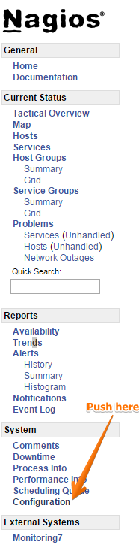

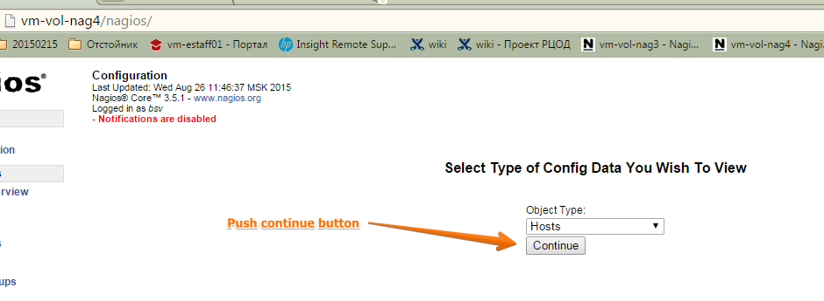

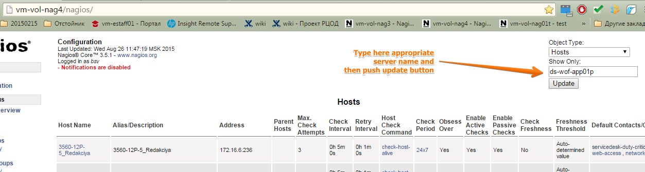

or

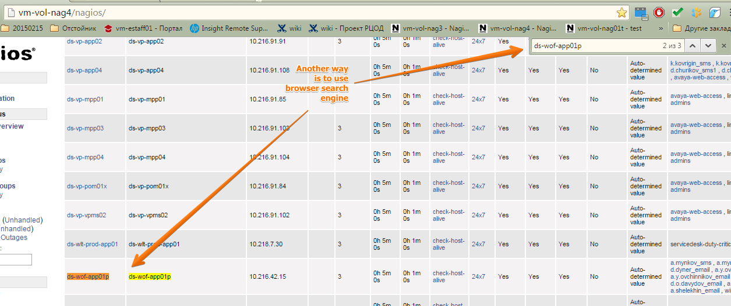

Then push on link of server name and see what notification their services are use.

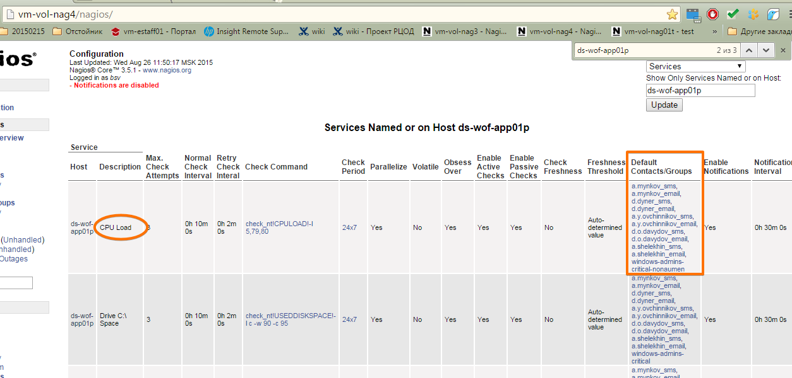

20150825
To see brief info about group of hosts and their services.

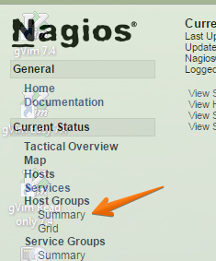

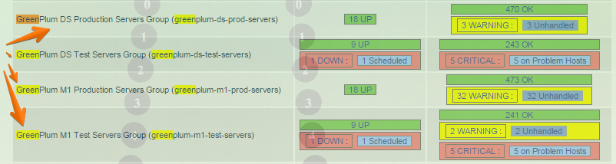

Below are brief links to greenplum and hadoop servers groups.

http://nag2/nagios/cgi-bin//status.cgi?hostgroup=greenplum-m1-test-servers&style=overview
http://nag2/nagios/cgi-bin//status.cgi?hostgroup=greenplum-m1-prod-servers&style=overview
http://nag2/nagios/cgi-bin//status.cgi?hostgroup=greenplum-ds-prod-servers&style=overview
http://nag2/nagios/cgi-bin//status.cgi?hostgroup=greenplum-ds-test-servers&style=overview
http://nag2/nagios/cgi-bin//status.cgi?hostgroup=ds-hadoop-prod&style=overview
http://nag2/nagios/cgi-bin//status.cgi?hostgroup=m1-hadoop-tst&style=overview

20150127
Here is the latest recomendation by Leonov Alexey to configure default monitoring for fresh created server under vmware.

[root@vm-vol-nag3 20150127-1622]# cat /etc/nagios/objects/servers/vmware/sas/vm-sastm01p.cfg
define host{
use linux-server
host_name vm-sastm01p
alias SAS monitoring server
hostgroups linux-servers
address 10.216.24.18
display_name vm-sastm01p
icon_image redhat.png
contacts d.s.pavlov_email, d.s.pavlov_sms
contact_groups dwh-dq-system-admins,linux-admins
}

define service{
use generic-service
host_name vm-sastm01p
service_description PING
contacts d.s.pavlov_email, d.s.pavlov_sms
contact_groups dwh-dq-system-admins
check_command check_ping!100.0,20%!500.0,60%
flap_detection_enabled 0
}

define service{
use generic-service
host_name vm-sastm01p
service_description /Root Partition
contacts d.s.pavlov_email, d.s.pavlov_sms
contact_groups dwh-dq-system-admins,linux-admins
check_command check_nrpe!check_root_fs
}

define service{
use generic-service
host_name vm-sastm01p
service_description /Var Partition
contacts d.s.pavlov_email, d.s.pavlov_sms
contact_groups dwh-dq-system-admins,linux-admins
check_command check_nrpe!check_var_fs
}

define service{
use generic-service
host_name vm-sastm01p
service_description /Opt Partition
contacts d.s.pavlov_email, d.s.pavlov_sms
contact_groups dwh-dq-system-admins
check_command check_nrpe!check_opt_fs
}

define service{
use generic-service
host_name vm-sastm01p
service_description Current Memory Load
contacts d.s.pavlov_email, d.s.pavlov_sms
contact_groups dwh-dq-system-admins
check_command check_nrpe!check_memory_load_linux
}

define service{
use generic-service
host_name vm-sastm01p
service_description Current Load
contacts d.s.pavlov_email, d.s.pavlov_sms
contact_groups dwh-dq-system-admins
check_command check_nrpe!check_load
}

define service{
use generic-service
host_name vm-sastm01p
service_description Zombie procs
contacts d.s.pavlov_email, d.s.pavlov_sms
contact_groups dwh-dq-system-admins
check_command check_nrpe!check_zombie_procs
}

define service{
use generic-service
host_name vm-sastm01p
service_description NTP Time
contacts d.s.pavlov_email, d.s.pavlov_sms
contact_groups dwh-dq-system-admins
check_command check_nrpe!check_ntp_time
}
[root@vm-vol-nag3 20150127-1622]#

[root@vm-sasmon01p ~]# vim /etc/nagios/nrpe.cfg
...
command[check_users]=/usr/lib64/nagios/plugins/check_users -w 5 -c 10
command[check_load]=/usr/lib64/nagios/plugins/check_load -w 15,10,5 -c 30,25,20
command[check_hda1]=/usr/lib64/nagios/plugins/check_disk -w 20% -c 10% -p /dev/hda1
command[check_zombie_procs]=/usr/lib64/nagios/plugins/check_procs -w 5 -c 10 -s Z
command[check_total_procs]=/usr/lib64/nagios/plugins/check_procs -w 150 -c 200

[root@vm-sasmon01p ~]# ls -Alh /etc/nrpe.d/
total 24K
-rw-r--r-- 1 root root 198 Jun 20 2014 access.cfg
-rwxr-xr-x. 1 root root 597 Nov 21 2013 check_disks.cfg
-rwxr-xr-x. 1 root root 104 Nov 21 2013 check_load.cfg
-rwxr-xr-x. 1 root root 126 Nov 21 2013 check_memory.cfg
-rwxr-xr-x 1 root root 469 Feb 19 2014 check_ntp.cfg
-rwxr-xr-x. 1 root root 161 Nov 21 2013 check_procs.cfg
[root@vm-sasmon01p ~]#

[root@vm-sasmon01p ~]# cat /etc/nrpe.d/check_disks.cfg
command[check_boot_fs]=/usr/lib64/nagios/plugins/check_disk -W 20% -K 10% -w 20% -c 10% -p /boot
command[check_root_fs]=/usr/lib64/nagios/plugins/check_disk -W 20% -K 10% -u MB -w 100 -c 50 -p /
command[check_home_fs]=/usr/lib64/nagios/plugins/check_disk -W 20% -K 10% -u MB -w 100 -c 50 -p /home
command[check_var_fs]=/usr/lib64/nagios/plugins/check_disk -W 20% -K 10% -u MB -w 100 -c 50 -p /var
command[check_tmp_fs]=/usr/lib64/nagios/plugins/check_disk -W 20% -K 10% -u MB -w 100 -c 50 -p /tmp
command[check_opt_fs]=/usr/lib64/nagios/plugins/check_disk -W 20% -K 10% -u MB -w 100 -c 50 -p /opt
[root@vm-sasmon01p ~]#

As Aleksey said, this check might to be removed from nagios check at all. Because it’s absolutely not informative for everyone and only produce questions and night calls.
But directly for this case of SAS server, this checks may be stay. It has not bad parameters as 63 and 64 it is well enough for SAS’s high load servers.
[root@vm-sasmon01p ~]# cat /etc/nrpe.d/check_load.cfg
#It needs calibration.
command[check_load]=/usr/lib64/nagios/plugins/check_load -w 63,63,63 -c 64,64,64
[root@vm-sasmon01p ~]#

Aleksey have recommended, in addition, to use option “-C” for this check. It send notification about free amount of memory.
[root@vm-sasmon01p ~]# cat /etc/nrpe.d/check_memory.cfg
#200M - 0.03
#100M - 0.01

command[check_memory_load_linux]=/usr/lib64/nagios/plugins/check_mem_linux.pl -f -w 0.03 -c 0.01 -C
[root@vm-sasmon01p ~]#

It looks like this one.
[root@vm-sastm01p ~]# /usr/lib64/nagios/plugins/check_mem_linux.pl -f -w 0.03 -c 0.01 -C
OK - 98.8% (32493792 kB) free.|TOTAL=32880560KB;;;; USED=386768KB;;;; FREE=32493792KB;;;; CACHES=670960KB;;;;
[root@vm-sastm01p ~]#

[root@vm-sasmon01p ~]# cat /etc/nrpe.d/check_ntp.cfg
command[check_ntp_time]=NTP_SERVER=$(/usr/sbin/ntpq -pn | grep ^'*' | cut -d" " -f1 | cut -d'*' -f2) && /usr/lib64/nagios/plugins/check_ntp_time -H $NTP_SERVER -w 0.7 -c 1
command[check_ntp01_time]=/usr/lib64/nagios/plugins/check_ntp_time -H ntp01.tcsbank.ru -w 0.7 -c 1
command[check_ntp02_time]=/usr/lib64/nagios/plugins/check_ntp_time -H ntp02.tcsbank.ru -w 0.7 -c 1
command[check_ntp03_time]=/usr/lib64/nagios/plugins/check_ntp_time -H ntp03.tcsbank.ru -w 0.7 -c 1
[root@vm-sasmon01p ~]#

[root@vm-sasmon01p ~]# cat /etc/nrpe.d/check_procs.cfg
command[check_total_procs]=/usr/lib64/nagios/plugins/check_procs -w 150 -c 200
command[check_zombie_procs]=/usr/lib64/nagios/plugins/check_procs -w 5 -c 10 -s Z
[root@vm-sasmon01p ~]#

[root@ds-sasetl01x ~]# yum install nagios-plugins nagios-plugins-disk nagios-plugins-load nagios-plugins-nrpe nagios-plugins-procs nagios-plugins-users nagios-plugins-load nagios-plugins-swap nrpe

Добавить возможность подключения с nag2.
[root@m1-asterisk01 ~]# vim /etc/nagios/nrpe.cfg
allowed_hosts=127.0.0.1,nag2.tcsbank.ru,monitoring1.tcsbank.ru,monitoring2.tcsbank.ru,monitoring3.tcsbank.ru,monitoring4.tcsbank.ru,monitoring5.tcsbank.ru,monitoring6.tcsbank.ru,vm-vol-nag3.tcsbank.ru

[root@ds-sasetl01x ~]# service nrpe restart
Shutting down nrpe: [ OK ]
Starting nrpe: [ OK ]
[root@ds-sasetl01x ~]#

[support@centos00 nagios]$ tar cv ./check* | ssh -t bsv@ds-sasetl01x "( tar xvf - -C /tmp/ )"
Pseudo-terminal will not be allocated because stdin is not a terminal.
./check_disks.cfg
./check_load.cfg
./check_mem_linux.pl
./check_memory.cfg
./check_procs.cfg
bsv@ds-sasetl01x's password:
./check_disks.cfg
./check_load.cfg
./check_mem_linux.pl
./check_memory.cfg
./check_procs.cfg
[support@centos00 nagios]$

[s.belogrud.tcs4500] ➤ scp /drives/d/share/nagios/nrpe.d/check* bsv@vm-ilog-app01:/tmp/
check_disks.cfg 100% 597 0.6KB/s 00:00
check_load.cfg 100% 104 0.1KB/s 00:00
check_memory.cfg 100% 126 0.1KB/s 00:00
check_nofile.cfg 100% 86 0.1KB/s 00:00
check_ntp.cfg 100% 469 0.5KB/s 00:00
check_procs.cfg

[root@vm-ilog-app01 ~]# cp /tmp/check_* /etc/nrpe.d/
[root@vm-ilog-app01 ~]# ls -Alh /etc/nrpe.d/
total 24K
----------. 1 root root 597 May 6 12:41 check_disks.cfg
----------. 1 root root 104 May 6 12:41 check_load.cfg
----------. 1 root root 126 May 6 12:41 check_memory.cfg
----------. 1 root root 86 May 6 12:41 check_nofile.cfg
----------. 1 root root 469 May 6 12:41 check_ntp.cfg
----------. 1 root root 161 May 6 12:41 check_procs.cfg
[root@vm-ilog-app01 ~]# chmod 644 /etc/nrpe.d/check_*
[root@vm-ilog-app01 ~]# ls -Alh /etc/nrpe.d/
total 24K
-rw-r--r--. 1 root root 597 May 6 12:41 check_disks.cfg
-rw-r--r--. 1 root root 104 May 6 12:41 check_load.cfg
-rw-r--r--. 1 root root 126 May 6 12:41 check_memory.cfg
-rw-r--r--. 1 root root 86 May 6 12:41 check_nofile.cfg
-rw-r--r--. 1 root root 469 May 6 12:41 check_ntp.cfg
-rw-r--r--. 1 root root 161 May 6 12:41 check_procs.cfg
[root@vm-ilog-app01 ~]# rm /tmp/check_*

[s.belogrud.tcs4500] ➤ scp /drives/d/share/nagios/plugins/check_* bsv@vm-ilog-app01:/tmp/

[root@vm-ilog-app01 ~]# chmod 755 /tmp/check_*
[root@vm-ilog-app01 ~]# cp /tmp/check_* /usr/lib64/nagios/plugins/
[root@vm-ilog-app01 ~]# chown root:root /usr/lib64/nagios/plugins/check*
[root@vm-ilog-app01 ~]# rm /tmp/check_*

[root@vm-ilog-app01 ~]# service nrpe reload

[root@ds-sasetl01x nrpe.d]# for FILE in * ; do echo $FILE ; cat $FILE ; done
check_disks.cfg
command[check_boot_fs]=/usr/lib64/nagios/plugins/check_disk -W 20% -K 10% -w 20% -c 10% -p /boot
command[check_root_fs]=/usr/lib64/nagios/plugins/check_disk -W 20% -K 10% -w 20% -c 10% -p /
command[check_home_fs]=/usr/lib64/nagios/plugins/check_disk -W 20% -K 10% -w 20% -c 10% -p /home
command[check_var_fs]=/usr/lib64/nagios/plugins/check_disk -W 20% -K 10% -w 20% -c 10% -p /var
command[check_tmp_fs]=/usr/lib64/nagios/plugins/check_disk -W 20% -K 10% -w 20% -c 10% -p /tmp
command[check_opt_fs]=/usr/lib64/nagios/plugins/check_disk -W 20% -K 10% -u MB -w 100 -c 50 -p /opt
command[check_u0_fs]=/usr/lib64/nagios/plugins/check_disk -W 20% -K 10% -w 20% -c 10% -p /u0
command[check_ramdisk_fs]=/usr/lib64/nagios/plugins/check_disk -W 20% -K 10% -w 10% -c 5% -p /mnt/ramdisk
command[check_ramdisk_fs]=/usr/lib64/nagios/plugins/check_disk -W 20% -K 10% -w 20% -c 10% -p /mnt/sas_data1_ds-sasetl01x

check_load.cfg
#Neet to be colibrated
command[check_load]=/usr/lib64/nagios/plugins/check_load -w 63,63,63 -c 64,64,64

check_memory.cfg
#200M - 0.03
#100M - 0.01
command[check_memory_load_linux]=/usr/lib64/nagios/plugins/check_mem_linux.pl -f -w 0.03 -c 0.01

check_ntp.cfg
command[check_ntp01_time]=/usr/lib64/nagios/plugins/check_ntp_time -H ntp01.tcsbank.ru -w 0.7 -c 1
command[check_ntp02_time]=/usr/lib64/nagios/plugins/check_ntp_time -H ntp02.tcsbank.ru -w 0.7 -c 1
command[check_ntp03_time]=/usr/lib64/nagios/plugins/check_ntp_time -H ntp03.tcsbank.ru -w 0.7 -c 1
command[check_ntp_time]=NTP_SERVER=$(/usr/sbin/ntpq -pn | grep ^'*' | cut -d" " -f1 | cut -d'*' -f2) && /usr/lib64/nagios/plugins/check_ntp_time -H $NTP_SERVER -w 0.7 -c 1

check_procs.cfg
command[check_total_procs]=/usr/lib64/nagios/plugins/check_procs -w 150 -c 200
command[check_zombie_procs]=/usr/lib64/nagios/plugins/check_procs -w 5 -c 10 -s Z

[root@nag2 ~/work/20140619-1135]# cat vm-sasmon01p.cfg
define host{
use linux-server
host_name vm-sasmon01p
alias SAS monitoring server
hostgroups linux-servers
address 10.216.24.13
display_name vm-sasmon01p
icon_image redhat.png
contacts d.s.pavlov_email, d.s.pavlov_sms
contact_groups linux-admins
}

define service{
use generic-service
host_name vm-sasmon01p
service_description PING
contacts Naumen_nag_request_email, d.s.pavlov_email, d.s.pavlov_sms
contact_groups linux-admins
check_interval 5
max_check_attempts 1
check_command check_ping!100.0,20%!500.0,60%
}

define service{
use generic-service
host_name vm-sasmon01p
service_description /Root Partition
contacts Naumen_nag_request_email, d.s.pavlov_email, d.s.pavlov_sms
contact_groups linux-admins
check_command check_nrpe!check_root_fs
}

define service{
use generic-service
host_name vm-sasmon01p
service_description /Var Partition
contacts Naumen_nag_request_email, d.s.pavlov_email, d.s.pavlov_sms
contact_groups linux-admins
check_command check_nrpe!check_var_fs
}

define service{
use generic-service
host_name vm-sasmon01p
service_description /Opt Partition
contacts Naumen_nag_request_email, d.s.pavlov_email, d.s.pavlov_sms
contact_groups linux-admins
check_command check_nrpe!check_opt_fs
}

define service{
use generic-service
host_name vm-sasmon01p
service_description Current Memory Load
contacts d.s.pavlov_email, d.s.pavlov_sms
contact_groups linux-admins
check_command check_nrpe!check_memory_load_linux
}

define service{
use generic-service
host_name vm-sasmon01p
service_description Current Load
contacts d.s.pavlov_email, d.s.pavlov_sms
contact_groups linux-admins
check_command check_nrpe!check_load
}

define service{
use generic-service
host_name vm-sasmon01p
service_description Zombie procs
contacts d.s.pavlov_email, d.s.pavlov_sms
contact_groups linux-admins
check_command check_nrpe!check_zombie_procs
}

define service{
use generic-service
host_name vm-sasmon01p
service_description NTP Time
contacts d.s.pavlov_email, d.s.pavlov_sms
contact_groups linux-admins
check_command check_nrpe!check_ntp_time
}

or like this:

[root@nag2 /usr/local/etc/nagios/objects/servers/vmware]# cat ~/work/20140124-1304/vm-bigdata-bild01.cfg
define host{
use linux-server
host_name vm-bigdata-bild01
alias Jenkins Server for DMP project
hostgroups linux-servers
address 10.216.22.23
display_name vm-bigdata-bild01
icon_image redhat.png
contact_groups linux-admins, sas-admins
}

define service{
use generic-service
host_name vm-bigdata-bild01
service_description PING
contacts Naumen_nag_request_email
contact_groups linux-admins, esb-admins
check_interval 5
max_check_attempts 1
check_command check_ping!100.0,20%!500.0,60%
}

define service{
use generic-service
host_name vm-bigdata-bild01
service_description /Root Partition
contacts Naumen_nag_request_email
contact_groups linux-admins
check_command check_nrpe!check_root_fs
}

define service{
use generic-service
host_name vm-bigdata-bild01
service_description /Var Partition
contacts Naumen_nag_request_email
contact_groups linux-admins
check_command check_nrpe!check_var_fs
}

define service{
use generic-service
host_name vm-bigdata-bild01
service_description /Opt Partition
contacts Naumen_nag_request_email
contact_groups linux-admins
check_command check_nrpe!check_opt_fs
}

define service{
use generic-service
host_name vm-bigdata-bild01
service_description Current Memory Load
contacts
contact_groups linux-admins
check_command check_nrpe!check_memory_load_linux
}

define service{
use generic-service
host_name vm-bigdata-bild01
service_description Current Load
contacts
contact_groups linux-admins
check_command check_nrpe!check_load
}

define service{
use generic-service
host_name vm-bigdata-bild01
service_description Zombie procs
contacts
contact_groups linux-admins
check_command check_nrpe!check_zombie_procs
}

define service{
use generic-service
host_name vm-bigdata-bild01
service_description NTP Time
contacts
contact_groups linux-admins
check_command check_nrpe!check_ntp_time
}

[root@nag2 /usr/local/etc/nagios/objects/servers/vmware]#

[root@nag2 /usr/local/etc/nagios/objects/servers/vmware]# cat /usr/local/etc/nagios/objects/servers/dc-ds/linux/ds-sasetl01x.cfg
define host{
use linux-server
host_name ds-sasetl01x
alias SAS Test ETL Server
hostgroups linux-servers, sas-servers
address 10.216.29.14
display_name ds-sasetl01x
icon_image redhat.png
contact_groups linux-admins, sas-admins
}

define service{
use generic-service
host_name ds-sasetl01x
service_description PING
contacts Naumen_nag_request_email
contact_groups linux-admins, sas-admins
check_interval 5
max_check_attempts 1
check_command check_ping!100.0,20%!500.0,60%
}

define service{
use generic-service
host_name ds-sasetl01x
service_description /Boot Partition
contacts Naumen_nag_request_email
contact_groups linux-admins, sas-admins
check_command check_nrpe!check_boot_fs
}

define service{
use generic-service
host_name ds-sasetl01x
service_description /Root Partition
contacts Naumen_nag_request_email
contact_groups linux-admins, sas-admins
check_command check_nrpe!check_root_fs
}

define service{
use generic-service
host_name ds-sasetl01x
service_description /Home Partition
contacts Naumen_nag_request_email
contact_groups linux-admins, sas-admins
check_command check_nrpe!check_home_fs
}

define service{
use generic-service
host_name ds-sasetl01x
service_description /Tmp Partition
contacts Naumen_nag_request_email
contact_groups linux-admins, sas-admins
check_command check_nrpe!check_tmp_fs
}

define service{
use generic-service
host_name ds-sasetl01x
service_description /Var Partition
contacts
contact_groups linux-admins, sas-admins
check_command check_nrpe!check_var_fs
}

define service{
use generic-service
host_name ds-sasetl01x
service_description /U0 Partition
contacts Naumen_nag_request_email
contact_groups linux-admins, sas-admins
check_command check_nrpe!check_u0_fs
}

define service{
use generic-service
host_name ds-sasetl01x
service_description /mnt/ramdisk Mount point
contacts Naumen_nag_request_email
contact_groups linux-admins, sas-admins
check_command check_nrpe!check_ramdisk_fs
}

define service{
use generic-service
host_name ds-sasetl01x
service_description /mnt/sas_data1_ds-sasetl01x Mount point
contacts Naumen_nag_request_email
contact_groups linux-admins, sas-admins
check_command check_nrpe!check_sas_data1_ds-sasetl01x_fs
}

define service{
use generic-service
host_name ds-sasetl01x
service_description Current Memory Load
contacts
contact_groups linux-admins, sas-admins
check_command check_nrpe!check_memory_load_linux
}

define service{
use generic-service
host_name ds-sasetl01x
service_description Current Load
contacts
contact_groups linux-admins, sas-admins
check_command check_nrpe!check_load
}

#define service{
# use generic-service
# host_name ds-sasetl01x
# service_description Total Procs
# contacts
# contact_groups linux-admins, sas-admins
# check_command check_nrpe!check_total_procs
#}

define service{
use generic-service
host_name ds-sasetl01x
service_description Zombie procs
contacts
contact_groups linux-admins, sas-admins
check_command check_nrpe!check_zombie_procs
}

define service{
use generic-service
host_name ds-sasetl01x
service_description NTP01 Time
contacts
contact_groups linux-admins, sas-admins
check_command check_nrpe!check_ntp01_time
}

define service{
use generic-service
host_name ds-sasetl01x
service_description NTP02 Time
contacts
contact_groups linux-admins, sas-admins
check_command check_nrpe!check_ntp02_time
}

define service{
use generic-service
host_name ds-sasetl01x
service_description NTP03 Time
contacts
contact_groups linux-admins, sas-admins
check_command check_nrpe!check_ntp03_time
}

[root@nag2 /usr/local/etc/nagios/objects/servers/vmware]#

[root@nag2 /usr/local/etc/nagios/objects/servers/vmware]# /usr/local/bin/nagios -v /usr/local/etc/nagios/nagios.cfg && /usr/local/etc/rc.d/nagios reload

Examples of configuration with using minimal timeouts.
/usr/local/etc/nagios/objects/servers/vmware/vm-dbamon01.cfg
...
define service{
use generic-service
host_name vm-dbamon01
service_description SMOG bad statuses E
check_command check_nrpe!check_tcs_monitor_mfm_bad_statuses_E
normal_check_interval 1
first_notification_delay 0
contact_groups processing-admins
notification_options w,u,c,r
flap_detection_enabled 0
max_check_attempts 1
}

define service{
use generic-service
host_name vm-dbamon01
service_description OPS_AUTH_ELEKSNET
check_command check_nrpe!check_tcs_monitor_ops_auth_eleksnet
normal_check_interval 1
first_notification_delay 0
contact_groups processing-admins
notification_options w,u,c,r
flap_detection_enabled 0
max_check_attempts 1
}

20131115
Directory that contains backuped hosts that was removed from nagios monitoring.

/usr/local/etc/nagios/temp/

20131127
How to check access to nrpe on server. And additionally we had seen version of package.

[root@nag2 ~/work/20131127]# check_nrpe2 -H ds-sasetl01p -p 5666
NRPE v2.14
[root@nag2 ~/work/20131127]#

Настройка для selinux решающая трудности работы скриптов nagios.
http://edvoncken.net/2012/01/workaround-for-nagios-check_disk-failure-in-rhel-centos-6-2/

Workaround for Nagios check_disk failure in RHEL / CentOS 6.2
After updating from EL 6.1 to 6.2, the Nagios “check_disk” plugin suddenly stopped working with “Permission denied” errors. This problem is related to the SElinux policy (you *are* running with SElinux enabled, aren’t you?).

By default, these AVC denials are not logged in /var/log/audit/audit.log which makes this problem harder to spot (if you want, you can enable all audit-messages by running semodule -DB).

There are at least two relevant entries in Bugzilla:

Bug 771245 – nagios-plugins-disk fails when checking /boot on RHEL6.2 boxes
Bug 768055 – SELinux silent denials of Nagios NRPE check of /boot
Fortunately, there is a simple workaround while we wait for an updated selinux-policy package. As root, do the following:

chcon -t nagios_unconfined_plugin_exec_t /usr/lib64/nagios/plugins/check_disk
Or, for 32-bit systems:

chcon -t nagios_unconfined_plugin_exec_t /usr/lib/nagios/plugins/check_disk
No need to restart anything; just wait until Nagios re-checks the service and the problem should be gone. Enjoy!

With enabled Enforcing we get troubles.

[root@vm-mq-tst02 nrpe.d]# getenforce
Enforcing
[root@vm-mq-tst02 nrpe.d]#

[root@vm-mq-tst02 nrpe.d]# service nrpe restart ; tail /var/log/messages
...
Dec 3 12:24:11 vm-mq-tst02 nrpe[19528]: Caught SIGTERM - shutting down...
Dec 3 12:24:11 vm-mq-tst02 nrpe[19528]: Daemon shutdown
Dec 3 12:24:11 vm-mq-tst02 nrpe[19558]: Unable to open config file '/etc/nrpe.d/check_memory.cfg' for reading
Dec 3 12:24:11 vm-mq-tst02 nrpe[19558]: Continuing with errors...
Dec 3 12:24:11 vm-mq-tst02 nrpe[19559]: Starting up daemon
Dec 3 12:24:11 vm-mq-tst02 nrpe[19559]: Cannot write to pidfile '/var/run/nrpe/nrpe.pid' - check your privileges.
Dec 3 12:24:11 vm-mq-tst02 nrpe[19559]: Listening for connections on port 5666
Dec 3 12:24:11 vm-mq-tst02 nrpe[19559]: Allowing connections from: 127.0.0.1,nag2,monitoring1,monitoring2,monitoring3,monitoring4,monitoring5,monitoring6
[root@vm-mq-tst02 nrpe.d]#

After disabling selinux - we have all fine!

[root@vm-mq-tst02 nrpe.d]# setenforce Permissive
[root@vm-mq-tst02 nrpe.d]#

[root@vm-mq-tst02 nrpe.d]# service nrpe restart ; tail /var/log/messages
...
Dec 3 12:25:05 vm-mq-tst02 nrpe[19559]: Caught SIGTERM - shutting down...
Dec 3 12:25:05 vm-mq-tst02 nrpe[19559]: Daemon shutdown
Dec 3 12:25:06 vm-mq-tst02 nrpe[19588]: Starting up daemon
Dec 3 12:25:06 vm-mq-tst02 nrpe[19588]: Listening for connections on port 5666
Dec 3 12:25:06 vm-mq-tst02 nrpe[19588]: Allowing connections from: 127.0.0.1,nag2,monitoring1,monitoring2,monitoring3,monitoring4,monitoring5,monitoring6
[root@vm-mq-tst02 nrpe.d]#

[root@vm-mq-tst02 nrpe.d]# ls /usr/lib64/nagios/plugins/
check_dbtest.sh check_disk check_hpsa check_load check_mem_linux.pl check_nrpe check_ntp_time check_procs check_swap check_users negate urlize utils.sh
[root@vm-mq-tst02 nrpe.d]# chcon -t nagios_unconfined_plugin_exec_t /usr/lib64/nagios/plugins/check_dbtest.sh
[root@vm-mq-tst02 nrpe.d]# chcon -t nagios_unconfined_plugin_exec_t /usr/lib64/nagios/plugins/check_disk
[root@vm-mq-tst02 nrpe.d]# chcon -t nagios_unconfined_plugin_exec_t /usr/lib64/nagios/plugins/check_hpsa
[root@vm-mq-tst02 nrpe.d]# chcon -t nagios_unconfined_plugin_exec_t /usr/lib64/nagios/plugins/check_load
[root@vm-mq-tst02 nrpe.d]# chcon -t nagios_unconfined_plugin_exec_t /usr/lib64/nagios/plugins/check_mem_linux.pl
[root@vm-mq-tst02 nrpe.d]# chcon -t nagios_unconfined_plugin_exec_t /usr/lib64/nagios/plugins/check_nrpe
[root@vm-mq-tst02 nrpe.d]# chcon -t nagios_unconfined_plugin_exec_t /usr/lib64/nagios/plugins/check_ntp_time
[root@vm-mq-tst02 nrpe.d]# chcon -t nagios_unconfined_plugin_exec_t /usr/lib64/nagios/plugins/check_procs
[root@vm-mq-tst02 nrpe.d]# chcon -t nagios_unconfined_plugin_exec_t /usr/lib64/nagios/plugins/check_swap
[root@vm-mq-tst02 nrpe.d]# chcon -t nagios_unconfined_plugin_exec_t /usr/lib64/nagios/plugins/check_users
[root@vm-mq-tst02 nrpe.d]# chcon -t nagios_unconfined_plugin_exec_t /usr/lib64/nagios/plugins/negate
[root@vm-mq-tst02 nrpe.d]# chcon -t nagios_unconfined_plugin_exec_t /usr/lib64/nagios/plugins/urlize
[root@vm-mq-tst02 nrpe.d]# chcon -t nagios_unconfined_plugin_exec_t /usr/lib64/nagios/plugins/utils.sh
[root@vm-mq-tst02 nrpe.d]#

[root@vm-mq-tst02 nrpe.d]# setenforce Enforcing
[root@vm-mq-tst02 nrpe.d]#

http://www.krenger.ch/blog/nagios-escape-dollar-character/

Nagios: Escape dollar character
27. FEBRUARY 2012, BY SIMON KRENGER
Some services (such as MSSQL instances) include a dollar character ($) in their name. A few weeks ago, I had to add a service called “$02_JBoss Server” to our internal Nagios configuration. After searching through theNagios documentation and FAQs, this is what I found:
For Nagios 3, add two backslashes and a second dollar (\$) symbol, like this: check_command check_command check_nt!SERVICESTATE!-d SHOWALL -l MSSQL\$$INSTANCE
Source
The above example actually has a small error in it, because there is no second backslash (even though it says so in the description)!
The correct way to check a service named “$02_JBoss Server” is to use a definition like this:
check_command check_nrpe_args!CheckServiceState!ShowAll "\\$$02_JBoss Server"
TAGS: ESCAPE, LINUX, NAGIOS, OPEN SYSTEMS, TROUBLESHOOTING
NATIG (MARCH 16, 2012):
I moved from Nagios to Icinga one year ago and there haven’t been any problems since today. The guys are making a great job. How big is your monitoring environment?
JEREMY (JULY 19, 2013):
You’re a genius. Thanks for sharing this.
In my case wanted to check a service called MSSQL$SQLPROD and it worked great with
“MSSQL\\$$SQLPROD”
Jeremy

20140312
Basic configuration of windows servers monitoring in nagios.

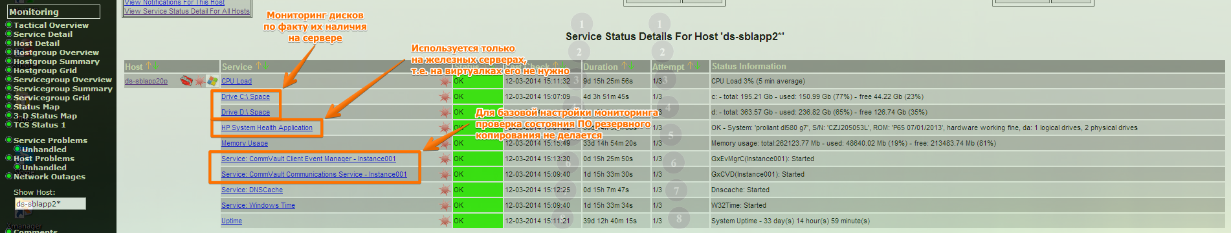

[root@nag2 ~/work/20140221-1734]# cat /usr/local/etc/nagios/objects/servers/dc-ds/windows/sbl/ds-sblapp20p.cfg

define host{
use windows-server
host_name ds-sblapp20p
alias ds-sblapp20p
hostgroups siebel-servers
address 10.216.20.20
contact_groups sibel-admins, windows-admins-critical
}
define service{
use generic-service
host_name ds-sblapp20p
service_description Uptime
check_command check_nt!UPTIME
contact_groups sibel-admins, windows-admins-critical-nonaumen
notifications_enabled 1
}
define service{
use generic-service
host_name ds-sblapp20p
service_description CPU Load
check_command check_nt!CPULOAD!-l 5,79,80
contact_groups sibel-admins, windows-admins-critical-nonaumen
notifications_enabled 1
}
define service{
use generic-service
host_name ds-sblapp20p
service_description Memory Usage
check_command check_nt!MEMUSE!-w 94 -c 95
contact_groups sibel-admins, windows-admins-critical-nonaumen
notifications_enabled 1
}
define service{
use generic-service
host_name ds-sblapp20p
service_description Drive C:\ Space
check_command check_nt!USEDDISKSPACE!-l c -w 90 -c 95
contact_groups sibel-admins, windows-admins-critical
notifications_enabled 1
}
define service{
use generic-service
host_name ds-sblapp20p
service_description Drive D:\ Space
check_command check_nt!USEDDISKSPACE!-l d -w 75 -c 88
contact_groups sibel-admins, windows-admins-critical
notifications_enabled 1
}
define service{
use generic-service
host_name ds-sblapp20p
service_description Service: DNSCache
check_command check_nt!SERVICESTATE!-d SHOWALL -l Dnscache
check_interval 5
retry_interval 5
contact_groups sibel-admins, windows-admins-critical
notifications_enabled 1
}
define service{
use generic-service
host_name ds-sblapp20p
service_description Service: Windows Time
check_command check_nt!SERVICESTATE!-d SHOWALL -l W32Time
contact_groups sibel-admins, windows-admins-critical
notifications_enabled 1
}
#define service{
# use generic-service
# host_name ds-sblapp20p
#service_description Smart Array
#check_command check_nrpe!check_smartarray!
#contact_groups sibel-admins, windows-admins-critical
#notifications_enabled 0
#}

define service{
use generic-service
host_name ds-sblapp20p
service_description HP System Health Application
check_command check_hpasm
contact_groups sibel-admins, windows-admins-critical
service_groups HP System Health - Service Group
}
define service{
use generic-service
host_name ds-sblapp20p
service_description Service: CommVault Communications Service - Instance001
check_command check_nt!SERVICESTATE!-d SHOWALL -l "GxCVD(Instance001)"
contact_groups sibel-admins, windows-admins-critical
notifications_enabled 1
}
define service{
use generic-service
host_name ds-sblapp20p
service_description Service: CommVault Client Event Manager - Instance001
check_command check_nt!SERVICESTATE!-d SHOWALL -l "GxEvMgrC(Instance001)"
contact_groups sibel-admins, windows-admins-critical
notifications_enabled 1
}
[root@nag2 ~/work/20140221-1734]#

20140312
Basic configuration for vmware windows server.

[root@nag2 ~/work/20140312-1524]# cat vm-hrcrm-app01.cfg
define host{
use windows-server
host_name vm-hrcrm-app01
alias vm-hrcrm-app01, HR CRM
hostgroups windows-servers
address 10.216.40.16
contacts d.petrovskiy_email, d.petrovskiy_sms
contact_groups windows-admins-critical
}
define service{
use generic-service
host_name vm-hrcrm-app01
service_description Uptime
check_command check_nt!UPTIME
contacts d.petrovskiy_email, d.petrovskiy_sms
contact_groups windows-admins-critical-nonaumen
notifications_enabled 1
}
define service{
use generic-service
host_name vm-hrcrm-app01
service_description CPU Load
check_command check_nt!CPULOAD!-l 5,79,80
contacts d.petrovskiy_email, d.petrovskiy_sms
contact_groups windows-admins-critical-nonaumen
notifications_enabled 1
}
define service{
use generic-service
host_name vm-hrcrm-app01
service_description Memory Usage
check_command check_nt!MEMUSE!-w 94 -c 95
contacts d.petrovskiy_email, d.petrovskiy_sms
contact_groups windows-admins-critical-nonaumen
notifications_enabled 1
}
define service{
use generic-service
host_name vm-hrcrm-app01
service_description Drive C:\ Space
check_command check_nt!USEDDISKSPACE!-l c -w 90 -c 95
contacts d.petrovskiy_email, d.petrovskiy_sms
contact_groups windows-admins-critical
notifications_enabled 1
}
define service{
use generic-service
host_name vm-hrcrm-app01
service_description Service: DNSCache
check_command check_nt!SERVICESTATE!-d SHOWALL -l Dnscache
check_interval 5
retry_interval 5
contacts d.petrovskiy_email, d.petrovskiy_sms
contact_groups windows-admins-critical
notifications_enabled 1
}
define service{
use generic-service
host_name vm-hrcrm-app01
service_description Service: Windows Time
check_command check_nt!SERVICESTATE!-d SHOWALL -l W32Time
contacts d.petrovskiy_email, d.petrovskiy_sms
contact_groups windows-admins-critical
notifications_enabled 1
}
[root@nag2 ~/work/20140312-1524]#

20140711

On several servers were configured monitoring temperature of Network adapters via iLO!
I used this server (ds-mon11t 10.216.43.43)

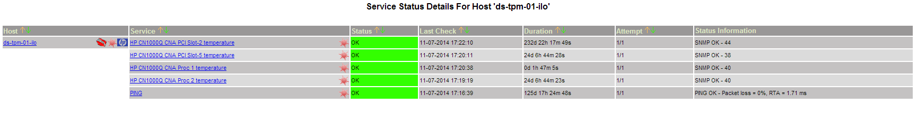

Here is how it was been done!

[root@nag2 /usr/local/etc/nagios/objects/servers/dc-ds/linux/greenplum/production]# cat /usr/local/etc/nagios/objects/servers/dc-ds/ilo/ds-tpm-01-ilo.cfg
define host{
use ilo
host_name ds-tpm-01-ilo
alias ds-tpm-01 Integrated Lights-Out
display_name ds-tpm-01 Integrated Lights-Out
address 10.219.10.117
}

define service{
use generic-service
host_name ds-tpm-01-ilo
service_description PING
check_interval 5
max_check_attempts 1
check_command check_ping!100.0,20%!500.0,60%
}

define service{
use generic-service
host_name ds-tpm-01-ilo
service_description HP CN1000Q CNA Proc 1 temperature
check_interval 5
max_check_attempts 1
check_command check_snmp!-o .1.3.6.1.4.1.232.6.2.6.8.1.4.0.2 -C Fgtkmcby11 -P 2c
}

define service{
use generic-service
host_name ds-tpm-01-ilo
service_description HP CN1000Q CNA Proc 2 temperature
check_interval 5
max_check_attempts 1
check_command check_snmp!-o .1.3.6.1.4.1.232.6.2.6.8.1.4.0.3 -C Fgtkmcby11 -P 2c
}

define service{
use generic-service
host_name ds-tpm-01-ilo
service_description HP CN1000Q CNA PCI Slot-2 temperature
check_interval 5
max_check_attempts 1
check_command check_snmp!-o .1.3.6.1.4.1.232.6.2.6.8.1.4.0.35 -C Fgtkmcby11 -P 2c
}

define service{
use generic-service
host_name ds-tpm-01-ilo
service_description HP CN1000Q CNA PCI Slot-5 temperature
check_interval 5
max_check_attempts 1
check_command check_snmp!-o .1.3.6.1.4.1.232.6.2.6.8.1.4.0.38 -C Fgtkmcby11 -P 2c
}
[root@nag2 /usr/local/etc/nagios/objects/servers/dc-ds/linux/greenplum/production]#

[root@nag2 /usr/local/etc/nagios/objects/servers/dc-ds/linux/greenplum/production]# ls -Alh /usr/local/etc/nagios/objects/servers/dc-ds/ilo/
total 4
-rw-rw-r-- 1 root wheel 1.8K May 27 2013 ds-tpm-01-ilo.cfg
[root@nag2 /usr/local/etc/nagios/objects/servers/dc-ds/linux/greenplum/production]#

20150306
How to manually check nagios statment from test-nagios server nag3 (vm-vol-nag4).

ds-gp-tst-sm

[root@vm-vol-nag4 testing]# su -m nagios -c "/usr/lib64/nagios/plugins/check_by_ssh3 -H 10.216.29.19 -C '/opt/TCS/scripts/nagios/plugins/check_hpsa -v' -i /export/home/nagios/.ssh/id_rsa -l nagios_check -p 22"
RAID OK: Smart Array P410i in Slot 0 (Embedded) array A logicaldrive 1 (1.6 TB, RAID 5, OK) [Controller Status: OK Cache Status: OK Battery/Capacitor Status: OK]
[root@vm-vol-nag4 testing]#

Follow are old style. When it was used old nag2 server based on FreeBSD.

For hq-msk-gp-tst1.
[root@nag2 ~]# su -m nagios -c "/usr/local/libexec/nagios/check_by_ssh3 -H 10.216.27.31 -C \"ssh 192.168.253.1 '/opt/TCS/scripts/nagios/plugins/check_hpsa -v -e 1'\" -i /export/home/nagios/.ssh/id_rsa -l nagios_check -p 22"
RAID OK: Smart Array P410i in Slot 0 (Embedded) array A logicaldrive 1 (3.8 TB, RAID 5, OK) [Controller Status: OK Cache Status: OK Battery/Capacitor Status: OK Controller Status: OK Cache Status: OK Battery/Capacitor Status: OK]
[root@nag2 ~]#

For hq-msk-gp-sm.
[root@nag2 ~]# su -m nagios -c "/usr/local/libexec/nagios/check_by_ssh3 -H 10.216.27.31 -C '/opt/TCS/scripts/nagios/plugins/check_hpsa -v' -i /export/home/nagios/.ssh/id_rsa -l nagios_check -p 22"
RAID OK: Smart Array P410i in Slot 0 (Embedded) array A logicaldrive 1 (1.6 TB, RAID 5, OK) [Controller Status: OK Cache Status: OK Battery/Capacitor Status: OK]
[root@nag2 ~]#

check_nrpe2 -H m1-asterisk01 -c check_root_fs

20150401
Checking before create nagios config file for this host monitoring.

[root@vm-vol-nag01t ~]# check_nrpe -H 10.216.29.29 -c check_root_fs
CHECK_NRPE: Error - Could not complete SSL handshake.
[root@vm-vol-nag01t ~]#

[root@vm-vol-nag01t ~]# check_nrpe -H 10.216.29.29 -p 5666
CHECK_NRPE: Error - Could not complete SSL handshake.
[root@vm-vol-nag01t ~]#

[root@vm-vol-nag01t ~]# check_ping -H 10.216.29.29 -w 100.0,20% -c 500.0,60%
PING OK - Packet loss = 0%, RTA = 1.65 ms|rta=1.650000ms;100.000000;500.000000;0.000000 pl=0%;20;60;0
[root@vm-vol-nag01t ~]#

[root@vm-vol-nag01t ~]# check_hpasm --hostname ds-sas-ods01t --community tcspub -v --perfdata=short
CRITICAL - could not contact snmp agent, wrong device

[root@vm-vol-nag01t ~]#

[root@vm-vol-nag3 ~]# check_hpasm --hostname ds-sas-ods01t --community tcspub -v --perfdata=short
CRITICAL - snmpwalk returns no product name (cpqsinfo-mib), wrong device

[root@vm-vol-nag3 ~]#

[root@ds-sas-ods01t conf]# vim /etc/snmp/snmpd.conf
...
# Access Control
###############################################################################
rocommunity tcspub 127.0.0.1
rocommunity tcspub nag2.tcsbank.ru
rocommunity tcspub vm-vol-nag3.tcsbank.ru
rocommunity tcspub vm-vol-nag4.tcsbank.ru
rocommunity tcspub vm-vol-nag01t.tcsbank.ru
rocommunity tcspub sim.tcsbank.ru
rocommunity tcspub cacti.tcsbank.ru
rocommunity tcspub netdot0.tcsbank.ru
rocommunity tcspub mon1.tcsbank.ru
rocommunity tcspub mon2.tcsbank.ru
rocommunity tcspub mon3.tcsbank.ru
rocommunity tcspub mon4.tcsbank.ru
rocommunity tcspub mon5.tcsbank.ru
rocommunity tcspub mon6.tcsbank.ru
rocommunity tcspub m1-irs.tcsbank.ru
trapcommunity tcspub
trapsink 172.16.1.11 tcspub
trapsink m1-irs.tcsbank.ru
...

[root@ds-sas-ods01t conf]# service snmpd restart
Stopping snmpd: [ OK ]
Starting snmpd: [ OK ]
[root@ds-sas-ods01t conf]#

From: Belogrud Sergey Vladimirovich
Sent: Wednesday, April 01, 2015 4:28 PM
To: helpdesk_in
Cc: net-admins
Subject: Подключение к nagios мониторингу

Администраторам ЛВС

Прошу проверить и в случае отсутствия предоставить доступ с серверов мониторинга
vm-vol-nag3 (172.16.1.11),
vm-vol-nag4 (172.16.1.115),
vm-vol-nag01t (172.16.1.117),
monitoring2 (192.168.1.111),
monitoring3(10.216.40.111),
monitoring4 (10.216.41.111),
monitoring5(10.216.42.111)
до следующих серверов по следующим портам
ds-sas-ods01t (10.216.29.29);
ds-sas-ods01p (10.216.28.28);
порт: 5666;
протокол: tcp.
Назначение: Связь с сервером мониторинга по протоколу nrpe.

[root@vm-vol-nag3 ~]# check_nrpe -H 10.216.29.29 -p 5666
CHECK_NRPE: Error - Could not complete SSL handshake.
[root@vm-vol-nag3 ~]#

[root@vm-vol-nag01t ~]# check_nrpe -H 10.216.29.29 -p 5666
CHECK_NRPE: Error - Could not complete SSL handshake.
[root@vm-vol-nag01t ~]#

С уважением,

Сергей Белогруд
Старший системный администратор

[root@vm-vol-nag01t ~]# check_hpasm --hostname ds-sas-ods01t --community tcspub -v --perfdata=short
CRITICAL - snmpwalk returns no product name (cpqsinfo-mib), wrong device

[root@vm-vol-nag01t ~]#

# At this moment starts magic of configuration and tuning check_hpasm via snmp!

[root@vm-vol-nag01t ~]# check_hpasm --hostname ds-sas-ods01t --community tcspub -v --perfdata=short
CRITICAL - could not contact snmp agent, wrong device

[root@vm-vol-nag01t ~]#

[root@vm-vol-nag3 ~]# check_hpasm --hostname ds-sas-ods01t --community tcspub -v --perfdata=short
CRITICAL - snmpwalk returns no product name (cpqsinfo-mib), wrong device

[root@vm-vol-nag3 ~]#

[root@ds-sas-ods01t conf]# vim /etc/snmp/snmpd.conf
...
# Access Control
###############################################################################
rocommunity tcspub 127.0.0.1
rocommunity tcspub nag2.tcsbank.ru
rocommunity tcspub vm-vol-nag3.tcsbank.ru
rocommunity tcspub vm-vol-nag4.tcsbank.ru
rocommunity tcspub vm-vol-nag01t.tcsbank.ru
rocommunity tcspub sim.tcsbank.ru
rocommunity tcspub cacti.tcsbank.ru
rocommunity tcspub netdot0.tcsbank.ru
rocommunity tcspub mon1.tcsbank.ru
rocommunity tcspub mon2.tcsbank.ru
rocommunity tcspub mon3.tcsbank.ru
rocommunity tcspub mon4.tcsbank.ru
rocommunity tcspub mon5.tcsbank.ru
rocommunity tcspub mon6.tcsbank.ru
rocommunity tcspub m1-irs.tcsbank.ru
trapcommunity tcspub
trapsink 172.16.1.11 tcspub
trapsink m1-irs.tcsbank.ru
...

[root@ds-sas-ods01t conf]# service snmpd restart
Stopping snmpd: [ OK ]
Starting snmpd: [ OK ]
[root@ds-sas-ods01t conf]#

[root@vm-vol-nag01t ~]# check_hpasm --hostname ds-sas-ods01t --community tcspub -v --perfdata=short
CRITICAL - snmpwalk returns no product name (cpqsinfo-mib), wrong device

[root@vm-vol-nag01t ~]#

[root@ds-sas-ods01t conf]# snmpwalk -v 2c -c tcspub localhost 1.3.6.1.4.1.232 | head
SNMPv2-SMI::enterprises.232 = No Such Object available on this agent at this OID
[root@ds-sas-ods01t conf]#

I have added two lines!
[root@ds-sas-ods01t 20150401-1446]# vim /etc/snmp/snmpd.conf
...
dlmod cmaX /usr/lib64/libcmaX64.so
rwcommunity tcspub 127.0.0.1
...

[support@centos00 20150323-1807.kickstart.ds-sas-ods01t]$ sshpass -e scp /media/sf_share/hp/CPQSINFO-MIB.mib bsv@ds-sas-ods01t:/tmp/
[support@centos00 20150323-1807.kickstart.ds-sas-ods01t]$

[root@ds-sas-ods01t 20150401-1446]# cp /tmp/CPQSINFO-MIB.mib /usr/share/snmp/mibs/
[root@ds-sas-ods01t 20150401-1446]#

[root@ds-sas-ods01t 20150401-1446]# service hp-snmp-agents stop

Shutting down NIC Agent Daemon (cmanicd): [FAILED]
Already stopped Storage Event Logger (cmaeventd): [ OK ]
Already stopped FCA agent (cmafcad): [ OK ]
Already stopped SAS agent (cmasasd): [ OK ]
Already stopped IDA agent (cmaidad): [ OK ]
Already stopped IDE agent (cmaided): [ OK ]
Already stopped SCSI agent (cmascsid): [ OK ]
Already stopped Health agent (cmahealthd): [ OK ]
Already stopped Standard Equipment agent (cmastdeqd): [ OK ]
Already stopped Host agent (cmahostd): [ OK ]
Already stopped Threshold agent (cmathreshd): [ OK ]
Already stopped RIB agent (cmasm2d): [ OK ]
Already stopped Performance agent (cmaperfd): [ OK ]
Already stopped SNMP Peer (cmapeerd): [ OK ]
[root@ds-sas-ods01t 20150401-1446]# service hp-snmp-agents start
Starting Health agent (cmahealthd): [ OK ]
Starting Standard Equipment agent (cmastdeqd): [ OK ]
Starting Host agent (cmahostd): [ OK ]
Starting Threshold agent (cmathreshd): [ OK ]
Starting RIB agent (cmasm2d): [ OK ]
Starting Performance agent (cmaperfd): [ OK ]
Starting SNMP Peer (cmapeerd): [ OK ]
Starting Storage Event Logger (cmaeventd): [ OK ]
Starting FCA agent (cmafcad): [ OK ]
Starting SAS agent (cmasasd): [ OK ]
Starting IDA agent (cmaidad): [ OK ]
Starting IDE agent (cmaided): [ OK ]
Starting SCSI agent (cmascsid): [ OK ]
Starting NIC Agent Daemon (cmanicd): [ OK ]

[root@ds-sas-ods01t 20150401-1446]#

[root@ds-sas-ods01t 20150401-1446]# snmpwalk -v 2c -c tcspub localhost 1.3.6.1.4.1.232 | head
SNMPv2-SMI::enterprises.232.1.1.1.0 = INTEGER: 1
SNMPv2-SMI::enterprises.232.1.1.2.0 = INTEGER: 32
SNMPv2-SMI::enterprises.232.1.1.3.0 = INTEGER: 2
SNMPv2-SMI::enterprises.232.1.2.1.4.1.0 = INTEGER: 30
SNMPv2-SMI::enterprises.232.1.2.1.4.2.1.1.1 = INTEGER: 1
SNMPv2-SMI::enterprises.232.1.2.1.4.2.1.2.1 = STRING: "HP Standard Equipment Agent for Linux"
SNMPv2-SMI::enterprises.232.1.2.1.4.2.1.3.1 = ""
SNMPv2-SMI::enterprises.232.1.2.1.4.2.1.4.1 = Hex-STRING: 00 00 00 00 00 00 00
SNMPv2-SMI::enterprises.232.1.2.1.4.2.1.5.1 = STRING: "To gather Standard Equipment data for Linux."
SNMPv2-SMI::enterprises.232.1.2.2.1.1.1.0 = INTEGER: 0
[root@ds-sas-ods01t 20150401-1446]#

[root@vm-vol-nag01t ~]# check_hpasm --hostname ds-sas-ods01t --community tcspub -v --perfdata=short
OK - System: 'proliant dl580 g7', S/N: 'CZ3237VVXN', ROM: 'P65 10/01/2013', hardware working fine, da: 1 logical drives, 2 physical drives
checking cpus
cpu 0 is ok
cpu 1 is ok
cpu 2 is ok
cpu 3 is ok
checking power supplies
powersupply 1 is ok
powersupply 2 is ok
powersupply 3 is ok
powersupply 4 is ok
checking fans
overall fan status: system=ok, cpu=ok
fan 1 is present, speed is normal, pctmax is 50%, location is system, redundance is redundant, partner is 2
fan 2 is present, speed is normal, pctmax is 50%, location is system, redundance is redundant, partner is 3
fan 3 is present, speed is normal, pctmax is 50%, location is system, redundance is redundant, partner is 4
fan 4 is present, speed is normal, pctmax is 50%, location is system, redundance is redundant, partner is 1
checking temperatures
1 ambient temperature is 22C (42 max)
2 cpu temperature is 40C (126 max)
3 cpu temperature is 40C (126 max)
4 cpu temperature is 40C (126 max)
5 cpu temperature is 40C (126 max)
6 memory temperature is 33C (87 max)
7 memory temperature is 32C (87 max)
8 memory temperature is 32C (87 max)
9 memory temperature is 33C (87 max)
10 memory temperature is 33C (87 max)
11 memory temperature is 32C (87 max)
12 memory temperature is 33C (87 max)
13 memory temperature is 34C (87 max)
14 system temperature is 40C (68 max)
15 system temperature is 33C (62 max)
16 system temperature is 39C (60 max)
17 system temperature is 38C (60 max)
18 system temperature is 37C (60 max)
19 system temperature is 63C (110 max)
20 system temperature is 35C (60 max)
checking memory
dimm module 1:1 (module 1 @ cartridge 1) is ok
dimm module 1:2 (module 2 @ cartridge 1) is ok
dimm module 1:3 (module 3 @ cartridge 1) is ok
dimm module 1:4 (module 4 @ cartridge 1) is ok
dimm module 1:5 (module 5 @ cartridge 1) is ok
dimm module 1:6 (module 6 @ cartridge 1) is ok
dimm module 1:7 (module 7 @ cartridge 1) is ok
dimm module 1:8 (module 8 @ cartridge 1) is ok
dimm module 2:1 (module 1 @ cartridge 2) is ok
dimm module 2:2 (module 2 @ cartridge 2) is ok
dimm module 2:3 (module 3 @ cartridge 2) is ok
dimm module 2:4 (module 4 @ cartridge 2) is ok
dimm module 2:5 (module 5 @ cartridge 2) is ok
dimm module 2:6 (module 6 @ cartridge 2) is ok
dimm module 2:7 (module 7 @ cartridge 2) is ok
dimm module 2:8 (module 8 @ cartridge 2) is ok
dimm module 3:1 (module 1 @ cartridge 3) is ok
dimm module 3:2 (module 2 @ cartridge 3) is ok
dimm module 3:3 (module 3 @ cartridge 3) is ok
dimm module 3:4 (module 4 @ cartridge 3) is ok
dimm module 3:5 (module 5 @ cartridge 3) is ok
dimm module 3:6 (module 6 @ cartridge 3) is ok
dimm module 3:7 (module 7 @ cartridge 3) is ok
dimm module 3:8 (module 8 @ cartridge 3) is ok
dimm module 4:1 (module 1 @ cartridge 4) is ok
dimm module 4:2 (module 2 @ cartridge 4) is ok
dimm module 4:3 (module 3 @ cartridge 4) is ok
dimm module 4:4 (module 4 @ cartridge 4) is ok
dimm module 4:5 (module 5 @ cartridge 4) is ok
dimm module 4:6 (module 6 @ cartridge 4) is ok
dimm module 4:7 (module 7 @ cartridge 4) is ok
dimm module 4:8 (module 8 @ cartridge 4) is ok
dimm module 5:1 (module 1 @ cartridge 5) is ok
dimm module 5:2 (module 2 @ cartridge 5) is ok
dimm module 5:3 (module 3 @ cartridge 5) is ok
dimm module 5:4 (module 4 @ cartridge 5) is ok
dimm module 5:5 (module 5 @ cartridge 5) is ok
dimm module 5:6 (module 6 @ cartridge 5) is ok
dimm module 5:7 (module 7 @ cartridge 5) is ok
dimm module 5:8 (module 8 @ cartridge 5) is ok
dimm module 6:1 (module 1 @ cartridge 6) is ok
dimm module 6:2 (module 2 @ cartridge 6) is ok
dimm module 6:3 (module 3 @ cartridge 6) is ok
dimm module 6:4 (module 4 @ cartridge 6) is ok
dimm module 6:5 (module 5 @ cartridge 6) is ok
dimm module 6:6 (module 6 @ cartridge 6) is ok
dimm module 6:7 (module 7 @ cartridge 6) is ok
dimm module 6:8 (module 8 @ cartridge 6) is ok
dimm module 7:1 (module 1 @ cartridge 7) is ok
dimm module 7:2 (module 2 @ cartridge 7) is ok
dimm module 7:3 (module 3 @ cartridge 7) is ok
dimm module 7:4 (module 4 @ cartridge 7) is ok
dimm module 7:5 (module 5 @ cartridge 7) is ok
dimm module 7:6 (module 6 @ cartridge 7) is ok
dimm module 7:7 (module 7 @ cartridge 7) is ok
dimm module 7:8 (module 8 @ cartridge 7) is ok
dimm module 8:1 (module 1 @ cartridge 8) is ok
dimm module 8:2 (module 2 @ cartridge 8) is ok
dimm module 8:3 (module 3 @ cartridge 8) is ok
dimm module 8:4 (module 4 @ cartridge 8) is ok
dimm module 8:5 (module 5 @ cartridge 8) is ok
dimm module 8:6 (module 6 @ cartridge 8) is ok
dimm module 8:7 (module 7 @ cartridge 8) is ok
dimm module 8:8 (module 8 @ cartridge 8) is ok
checking disk subsystem
controller accelerator is ok
controller accelerator battery is ok
logical drive 0:1 is ok (mirroring)
physical drive 0:0 is ok
physical drive 0:1 is ok
da controller 0 in slot 0 is ok
ide controller 1 in slot 0 is ok
fcal host controller 128 in slot 7 is ok
fcal host controller 128 overall condition is ok
fcal host controller 129 in slot 7 is ok
fcal host controller 129 overall condition is ok
checking ASR
ASR overall condition is ok
checking events
Event: 27 Added: 1388404500 Class: (Maintenance Note) informational IML Cleared (iLO 3 user:Administrator)
Event: 28 Added: 1395917700 Class: (System Revision) informational ROM flashed (New version: 10/01/2013)
Event: 29 Added: 1402148400 Class: (Power Subsystem) repaired System Power Supply: General Failure (Power Supply 1)
Event: 30 Added: 1402148400 Class: (Power Subsystem) repaired System Power Supply: General Failure (Power Supply 3)
Event: 31 Added: 1402148400 Class: (Power Subsystem) repaired System Power Supplies Not Redundant
Event: 32 Added: 1412430180 Class: (Power Subsystem) repaired System Power Supply: General Failure (Power Supply 2)
Event: 33 Added: 1412430180 Class: (Power Subsystem) repaired System Power Supply: General Failure (Power Supply 4)
Event: 34 Added: 1412430180 Class: (Power Subsystem) repaired System Power Supplies Not Redundant
Event: 35 Added: 1417269060 Class: (Power Subsystem) repaired System Power Supply: General Failure (Power Supply 1)
Event: 36 Added: 1417269060 Class: (Power Subsystem) repaired System Power Supply: General Failure (Power Supply 3)
Event: 37 Added: 1417269060 Class: (Power Subsystem) repaired System Power Supplies Not Redundant
Event: 38 Added: 1380571560 Class: (POST Messages) caution POST Error: 1785-Drive Array not Configured | pc_1=110;1200;1200 pc_2=130;1200;1200 pc_3=115;1200;1200 pc_4=135;1200;1200 fan_1=50% fan_2=50% fan_3=50% fan_4=50% temp_1=22;42;42 temp_2=40;126;126 temp_3=40;126;126 temp_4=40;126;126 temp_5=40;126;126 temp_6=33;87;87 temp_7=32;87;87 temp_8=32;87;87 temp_9=33;87;87 temp_10=33;87;87 temp_11=32;87;87 temp_12=33;87;87 temp_13=34;87;87 temp_14=40;68;68 temp_15=33;62;62 temp_16=39;60;60 temp_17=38;60;60 temp_18=37;60;60 temp_19=63;110;110 temp_20=35;60;60
[root@vm-vol-nag01t ~]#

Here is final config.
[root@ds-sas-ods01t 20150401-1446]# vim /etc/snmp/snmpd.conf
...
###############################################################################
# Access Control
###############################################################################
dlmod cmaX /usr/lib64/libcmaX64.so
rwcommunity tcspub 127.0.0.1
rocommunity tcspub 127.0.0.1
rocommunity tcspub nag2.tcsbank.ru
rocommunity tcspub vm-vol-nag3.tcsbank.ru
rocommunity tcspub vm-vol-nag4.tcsbank.ru
rocommunity tcspub vm-vol-nag01t.tcsbank.ru
rocommunity tcspub sim.tcsbank.ru
rocommunity tcspub cacti.tcsbank.ru
rocommunity tcspub netdot0.tcsbank.ru
rocommunity tcspub mon1.tcsbank.ru
rocommunity tcspub mon2.tcsbank.ru
rocommunity tcspub mon3.tcsbank.ru
rocommunity tcspub mon4.tcsbank.ru
rocommunity tcspub mon5.tcsbank.ru
rocommunity tcspub mon6.tcsbank.ru
rocommunity tcspub m1-irs.tcsbank.ru
trapcommunity tcspub
trapsink 172.16.1.11 tcspub
trapsink m1-irs.tcsbank.ru
syscontact admins@tcsbank.ru
syslocation DS
...

From: Belogrud Sergey Vladimirovich
Sent: Friday, April 03, 2015 7:06 PM
To: Leonov Aleksey Vladimirovich
Subject: RE: Диск в GP DS Prod

А вот, кстати, спустя некоторое время, после изменения имени проверки (с «HDD State Slot 1» на «HDD State Slot 2» - см. предыдущее письмо), графики-то появились.
Значит простое удаление фалов базы rrd вылечило бы проблему и закрыло вопрос…
Чего было мозги сношать…?

http://vm-vol-nag01t/pnp4nagios/graph?host=ds-gp-prod7&srv=HDD%20State%20Slot%202%20Drive%200

From: Belogrud Sergey Vladimirovich
Sent: Friday, April 03, 2015 6:21 PM
To: Leonov Aleksey Vladimirovich
Subject: RE: Диск в GP DS Prod

Проверяю.

Один и тот же хотс ds-gp-prd-sdw7.

Пока ничего не обнаружил.
Есть предположение, что база rrdtool для диска с не рисующимися графиками была создана не корректно в период, когда скрипт отлаживался и когда серийный номер диска передавался в rrd для посторения графика. Поскольку такая схема работы вывода скрипта проработала некоторое время, возможно эти настройки успели распространиться на все nagios серверы и, как следствие, на всех nagios-серверах посоздавались кривые базы rrdtool для этого диска.
Лечение – очистка базы на тестовом nagios-сервере и проверка результата. Если выличилось, то очистка этой же базы для этого же диска на всех nagios-серверах.

Хотя, вот, я сменил имя проверок с «HDD State Slot 1» на «HDD State Slot 2». Файлы rrd по не работающей проверке создались новые, как я понимаю. Однако графиков, так и не появилось…

[root@vm-vol-nag01t ds-gp-prod7]# ls -Alh HDD_State_Slot_{1,2}_Drive_0.{rrd,xml}
-rw-r--r-- 1 nagios nagios 1.1M Mar 16 18:46 HDD_State_Slot_1_Drive_0.rrd
-rw-r--r-- 1 nagios nagios 3.1K Apr 3 18:02 HDD_State_Slot_1_Drive_0.xml
-rw-rw-r-- 1 nagios nagios 751K Apr 3 18:07 HDD_State_Slot_2_Drive_0.rrd
-rw-rw-r-- 1 nagios nagios 3.1K Apr 3 18:13 HDD_State_Slot_2_Drive_0.xml
[root@vm-vol-nag01t ds-gp-prod7]#

Ну и здесь тоже вроде бы ничего.
[root@vm-vol-nag01t ds-gp-prod7]# sdiff /tmp/ds-gp-prod7.HDD_State_Slot_2_Drive_0.nonworked_graph /tmp/ds-gp-prod7.HDD_State_Slot_0_Drive_3.worked_graph
filename = "/var/lib/pnp4nagios/ds-gp-prod7/HDD_State_Slot_2_ | filename = "/var/lib/pnp4nagios/ds-gp-prod7/HDD_State_Slot_0_
rrd_version = "0003" rrd_version = "0003"
step = 60 step = 60
last_update = 1428073639 | last_update = 1428065760
header_size = 4064 header_size = 4064
ds[1].index = 0 ds[1].index = 0
ds[1].type = "GAUGE" ds[1].type = "GAUGE"
ds[1].minimal_heartbeat = 8460 ds[1].minimal_heartbeat = 8460
ds[1].min = NaN ds[1].min = NaN
ds[1].max = NaN ds[1].max = NaN
ds[1].last_ds = "U" | ds[1].last_ds = "1"
ds[1].value = 0.0000000000e+00 ds[1].value = 0.0000000000e+00
ds[1].unknown_sec = 19 | ds[1].unknown_sec = 0
ds[2].index = 1 ds[2].index = 1
ds[2].type = "GAUGE" ds[2].type = "GAUGE"
ds[2].minimal_heartbeat = 8460 ds[2].minimal_heartbeat = 8460
ds[2].min = NaN ds[2].min = NaN
ds[2].max = NaN ds[2].max = NaN
…

Ну и это старая проверка до смены имени проверки в конфигурационном файле nagios.

Вывод проверок похоже одинаков.
Эта проверка диска с рисующимися графиками HDD State Slot 0 Drive 3.
[root@vm-vol-nag01t ~]# su -m nagios -c "/usr/lib64/nagios/plugins/check_by_ssh3 -H 10.216.28.18 -C \"ssh 10.216.2.7 '/opt/TCS/scripts/nagios/plugins/check_defects_on_hdd.nagios.pluging.sh -s 0 -p 3'\" -i /export/home/nagios/.ssh/id_rsa -l nagios_check -p 22"
OK - Read Errors Hard (Since Reset): 1, Read Errors Hard (Since Factory): 21, Serial number: KNH9V6BF|read_errors_hard_since_reset=1errors;90;100;0; read_errors_hard_since_factory=21errors;;;0;
[root@vm-vol-nag01t ~]#

Эта с не рисующимися HDD State Slot 1 Drive 0.
[root@vm-vol-nag01t ~]# su -m nagios -c "/usr/lib64/nagios/plugins/check_by_ssh3 -H 10.216.28.18 -C \"ssh 10.216.2.7 '/opt/TCS/scripts/nagios/plugins/check_defects_on_hdd.nagios.pluging.sh -s 2 -p 0'\" -i /export/home/nagios/.ssh/id_rsa -l nagios_check -p 22"
OK - Read Errors Hard (Since Reset): 5, Read Errors Hard (Since Factory): 8, Serial number: 6XR1V0R40000B227A4TA|read_errors_hard_since_reset=5errors;90;100;0; read_errors_hard_since_factory=8errors;;;0;
[root@vm-vol-nag01t ~]#

[root@vm-vol-nag01t production]# rrdtool info /var/lib/pnp4nagios/ds-gp-prod7/HDD_State_Slot_1_Drive_0.rrd > /tmp/ds-gp-prod7.HDD_State_Slot_1_Drive_0.nonworked_graph
[root@vm-vol-nag01t production]# rrdtool info /var/lib/pnp4nagios/ds-gp-prod7/HDD_State_Slot_0_Drive_3.rrd > /tmp/ds-gp-prod7.HDD_State_Slot_0_Drive_3.worked_graph
[root@vm-vol-nag01t production]#

[root@vm-vol-nag01t production]# sdiff /tmp/ds-gp-prod7.HDD_State_Slot_1_Drive_0.nonworked_graph /tmp/ds-gp-prod7.HDD_State_Slot_0_Drive_3.worked_graph
filename = "/var/lib/pnp4nagios/ds-gp-prod7/HDD_State_Slot_1_ | filename = "/var/lib/pnp4nagios/ds-gp-prod7/HDD_State_Slot_0_
rrd_version = "0003" rrd_version = "0003"
step = 60 step = 60
last_update = 1426518118 | last_update = 1428065760
header_size = 5256 | header_size = 4064
ds[1].index = 0 ds[1].index = 0
ds[1].type = "GAUGE" ds[1].type = "GAUGE"
ds[1].minimal_heartbeat = 8460 ds[1].minimal_heartbeat = 8460
ds[1].min = NaN ds[1].min = NaN
ds[1].max = NaN ds[1].max = NaN
ds[1].last_ds = "1" ds[1].last_ds = "1"
ds[1].value = NaN | ds[1].value = 0.0000000000e+00
ds[1].unknown_sec = 58 | ds[1].unknown_sec = 0
ds[2].index = 1 ds[2].index = 1
ds[2].type = "GAUGE" ds[2].type = "GAUGE"
ds[2].minimal_heartbeat = 8460 ds[2].minimal_heartbeat = 8460
ds[2].min = NaN ds[2].min = NaN
ds[2].max = NaN ds[2].max = NaN
ds[2].last_ds = "1" | ds[2].last_ds = "21"
ds[2].value = NaN | ds[2].value = 0.0000000000e+00
ds[2].unknown_sec = 58 | ds[2].unknown_sec = 0
ds[3].index = 2 <
ds[3].type = "GAUGE" <
ds[3].minimal_heartbeat = 8460 <
ds[3].min = NaN <
ds[3].max = NaN <
ds[3].last_ds = "6" <
ds[3].value = NaN <
ds[3].unknown_sec = 58 <
rra[0].cf = "AVERAGE" rra[0].cf = "AVERAGE"
rra[0].rows = 2880 rra[0].rows = 2880
rra[0].cur_row = 2374 | rra[0].cur_row = 1177
rra[0].pdp_per_row = 1 rra[0].pdp_per_row = 1
rra[0].xff = 5.0000000000e-01 rra[0].xff = 5.0000000000e-01
rra[0].cdp_prep[0].value = NaN rra[0].cdp_prep[0].value = NaN
rra[0].cdp_prep[0].unknown_datapoints = 0 rra[0].cdp_prep[0].unknown_datapoints = 0
rra[0].cdp_prep[1].value = NaN rra[0].cdp_prep[1].value = NaN
rra[0].cdp_prep[1].unknown_datapoints = 0 rra[0].cdp_prep[1].unknown_datapoints = 0
rra[0].cdp_prep[2].value = NaN <
rra[0].cdp_prep[2].unknown_datapoints = 0 <
rra[1].cf = "AVERAGE" rra[1].cf = "AVERAGE"
rra[1].rows = 2880 rra[1].rows = 2880
rra[1].cur_row = 1547 | rra[1].cur_row = 1386
rra[1].pdp_per_row = 5 rra[1].pdp_per_row = 5
rra[1].xff = 5.0000000000e-01 rra[1].xff = 5.0000000000e-01
rra[1].cdp_prep[0].value = 0.0000000000e+00 | rra[1].cdp_prep[0].value = 1.0000000000e+00
rra[1].cdp_prep[0].unknown_datapoints = 1 | rra[1].cdp_prep[0].unknown_datapoints = 0
rra[1].cdp_prep[1].value = 0.0000000000e+00 | rra[1].cdp_prep[1].value = 2.1000000000e+01
rra[1].cdp_prep[1].unknown_datapoints = 1 | rra[1].cdp_prep[1].unknown_datapoints = 0
rra[1].cdp_prep[2].value = 0.0000000000e+00 <
rra[1].cdp_prep[2].unknown_datapoints = 1 <
rra[2].cf = "AVERAGE" rra[2].cf = "AVERAGE"
rra[2].rows = 4320 rra[2].rows = 4320
rra[2].cur_row = 1057 | rra[2].cur_row = 2172
rra[2].pdp_per_row = 30 rra[2].pdp_per_row = 30
rra[2].xff = 5.0000000000e-01 rra[2].xff = 5.0000000000e-01
rra[2].cdp_prep[0].value = 0.0000000000e+00 | rra[2].cdp_prep[0].value = 2.6000000000e+01
rra[2].cdp_prep[0].unknown_datapoints = 1 | rra[2].cdp_prep[0].unknown_datapoints = 0
rra[2].cdp_prep[1].value = 0.0000000000e+00 | rra[2].cdp_prep[1].value = 5.4600000000e+02
rra[2].cdp_prep[1].unknown_datapoints = 1 | rra[2].cdp_prep[1].unknown_datapoints = 0
rra[2].cdp_prep[2].value = 0.0000000000e+00 <
rra[2].cdp_prep[2].unknown_datapoints = 1 <
rra[3].cf = "AVERAGE" rra[3].cf = "AVERAGE"
rra[3].rows = 5840 rra[3].rows = 5840
rra[3].cur_row = 5591 | rra[3].cur_row = 906
rra[3].pdp_per_row = 360 rra[3].pdp_per_row = 360
rra[3].xff = 5.0000000000e-01 rra[3].xff = 5.0000000000e-01
rra[3].cdp_prep[0].value = 2.0000000000e+01 | rra[3].cdp_prep[0].value = 5.6000000000e+01
rra[3].cdp_prep[0].unknown_datapoints = 161 | rra[3].cdp_prep[0].unknown_datapoints = 0
rra[3].cdp_prep[1].value = 2.0000000000e+01 | rra[3].cdp_prep[1].value = 1.1760000000e+03
rra[3].cdp_prep[1].unknown_datapoints = 161 | rra[3].cdp_prep[1].unknown_datapoints = 0
rra[3].cdp_prep[2].value = 1.2000000000e+02 <
rra[3].cdp_prep[2].unknown_datapoints = 161 <
rra[4].cf = "MAX" rra[4].cf = "MAX"
rra[4].rows = 2880 rra[4].rows = 2880
rra[4].cur_row = 1850 | rra[4].cur_row = 370
rra[4].pdp_per_row = 1 rra[4].pdp_per_row = 1
rra[4].xff = 5.0000000000e-01 rra[4].xff = 5.0000000000e-01
rra[4].cdp_prep[0].value = NaN rra[4].cdp_prep[0].value = NaN
rra[4].cdp_prep[0].unknown_datapoints = 0 rra[4].cdp_prep[0].unknown_datapoints = 0
rra[4].cdp_prep[1].value = NaN rra[4].cdp_prep[1].value = NaN
rra[4].cdp_prep[1].unknown_datapoints = 0 rra[4].cdp_prep[1].unknown_datapoints = 0
rra[4].cdp_prep[2].value = NaN <
rra[4].cdp_prep[2].unknown_datapoints = 0 <
rra[5].cf = "MAX" rra[5].cf = "MAX"
rra[5].rows = 2880 rra[5].rows = 2880
rra[5].cur_row = 1715 | rra[5].cur_row = 2843
rra[5].pdp_per_row = 5 rra[5].pdp_per_row = 5
rra[5].xff = 5.0000000000e-01 rra[5].xff = 5.0000000000e-01
rra[5].cdp_prep[0].value = -inf | rra[5].cdp_prep[0].value = 1.0000000000e+00
rra[5].cdp_prep[0].unknown_datapoints = 1 | rra[5].cdp_prep[0].unknown_datapoints = 0
rra[5].cdp_prep[1].value = -inf | rra[5].cdp_prep[1].value = 2.1000000000e+01
rra[5].cdp_prep[1].unknown_datapoints = 1 | rra[5].cdp_prep[1].unknown_datapoints = 0
rra[5].cdp_prep[2].value = -inf <
rra[5].cdp_prep[2].unknown_datapoints = 1 <
rra[6].cf = "MAX" rra[6].cf = "MAX"
rra[6].rows = 4320 rra[6].rows = 4320
rra[6].cur_row = 3673 | rra[6].cur_row = 791
rra[6].pdp_per_row = 30 rra[6].pdp_per_row = 30
rra[6].xff = 5.0000000000e-01 rra[6].xff = 5.0000000000e-01
rra[6].cdp_prep[0].value = -inf | rra[6].cdp_prep[0].value = 1.0000000000e+00
rra[6].cdp_prep[0].unknown_datapoints = 1 | rra[6].cdp_prep[0].unknown_datapoints = 0
rra[6].cdp_prep[1].value = -inf | rra[6].cdp_prep[1].value = 2.1000000000e+01
rra[6].cdp_prep[1].unknown_datapoints = 1 | rra[6].cdp_prep[1].unknown_datapoints = 0
rra[6].cdp_prep[2].value = -inf <
rra[6].cdp_prep[2].unknown_datapoints = 1 <
rra[7].cf = "MAX" rra[7].cf = "MAX"
rra[7].rows = 5840 rra[7].rows = 5840
rra[7].cur_row = 304 | rra[7].cur_row = 588
rra[7].pdp_per_row = 360 rra[7].pdp_per_row = 360
rra[7].xff = 5.0000000000e-01 rra[7].xff = 5.0000000000e-01
rra[7].cdp_prep[0].value = 1.0000000000e+00 rra[7].cdp_prep[0].value = 1.0000000000e+00
rra[7].cdp_prep[0].unknown_datapoints = 161 | rra[7].cdp_prep[0].unknown_datapoints = 0
rra[7].cdp_prep[1].value = 1.0000000000e+00 | rra[7].cdp_prep[1].value = 2.1000000000e+01
rra[7].cdp_prep[1].unknown_datapoints = 161 | rra[7].cdp_prep[1].unknown_datapoints = 0
rra[7].cdp_prep[2].value = 6.0000000000e+00 <
rra[7].cdp_prep[2].unknown_datapoints = 161 <
rra[8].cf = "MIN" rra[8].cf = "MIN"
rra[8].rows = 2880 rra[8].rows = 2880
rra[8].cur_row = 100 | rra[8].cur_row = 1156
rra[8].pdp_per_row = 1 rra[8].pdp_per_row = 1
rra[8].xff = 5.0000000000e-01 rra[8].xff = 5.0000000000e-01
rra[8].cdp_prep[0].value = NaN rra[8].cdp_prep[0].value = NaN
rra[8].cdp_prep[0].unknown_datapoints = 0 rra[8].cdp_prep[0].unknown_datapoints = 0
rra[8].cdp_prep[1].value = NaN rra[8].cdp_prep[1].value = NaN
rra[8].cdp_prep[1].unknown_datapoints = 0 rra[8].cdp_prep[1].unknown_datapoints = 0
rra[8].cdp_prep[2].value = NaN <
rra[8].cdp_prep[2].unknown_datapoints = 0 <
rra[9].cf = "MIN" rra[9].cf = "MIN"
rra[9].rows = 2880 rra[9].rows = 2880
rra[9].cur_row = 1371 | rra[9].cur_row = 239
rra[9].pdp_per_row = 5 rra[9].pdp_per_row = 5
rra[9].xff = 5.0000000000e-01 rra[9].xff = 5.0000000000e-01
rra[9].cdp_prep[0].value = inf | rra[9].cdp_prep[0].value = 1.0000000000e+00
rra[9].cdp_prep[0].unknown_datapoints = 1 | rra[9].cdp_prep[0].unknown_datapoints = 0
rra[9].cdp_prep[1].value = inf | rra[9].cdp_prep[1].value = 2.1000000000e+01
rra[9].cdp_prep[1].unknown_datapoints = 1 | rra[9].cdp_prep[1].unknown_datapoints = 0
rra[9].cdp_prep[2].value = inf <
rra[9].cdp_prep[2].unknown_datapoints = 1 <
rra[10].cf = "MIN" rra[10].cf = "MIN"
rra[10].rows = 4320 rra[10].rows = 4320
rra[10].cur_row = 3847 | rra[10].cur_row = 1299
rra[10].pdp_per_row = 30 rra[10].pdp_per_row = 30
rra[10].xff = 5.0000000000e-01 rra[10].xff = 5.0000000000e-01
rra[10].cdp_prep[0].value = inf | rra[10].cdp_prep[0].value = 1.0000000000e+00
rra[10].cdp_prep[0].unknown_datapoints = 1 | rra[10].cdp_prep[0].unknown_datapoints = 0
rra[10].cdp_prep[1].value = inf | rra[10].cdp_prep[1].value = 2.1000000000e+01
rra[10].cdp_prep[1].unknown_datapoints = 1 | rra[10].cdp_prep[1].unknown_datapoints = 0
rra[10].cdp_prep[2].value = inf <
rra[10].cdp_prep[2].unknown_datapoints = 1 <
rra[11].cf = "MIN" rra[11].cf = "MIN"
rra[11].rows = 5840 rra[11].rows = 5840
rra[11].cur_row = 887 | rra[11].cur_row = 1650
rra[11].pdp_per_row = 360 rra[11].pdp_per_row = 360
rra[11].xff = 5.0000000000e-01 rra[11].xff = 5.0000000000e-01
rra[11].cdp_prep[0].value = 1.0000000000e+00 rra[11].cdp_prep[0].value = 1.0000000000e+00
rra[11].cdp_prep[0].unknown_datapoints = 161 | rra[11].cdp_prep[0].unknown_datapoints = 0
rra[11].cdp_prep[1].value = 1.0000000000e+00 | rra[11].cdp_prep[1].value = 2.1000000000e+01
rra[11].cdp_prep[1].unknown_datapoints = 161 | rra[11].cdp_prep[1].unknown_datapoints = 0
rra[11].cdp_prep[2].value = 6.0000000000e+00 <
rra[11].cdp_prep[2].unknown_datapoints = 161 <
[root@vm-vol-nag01t production]#

From: Leonov Aleksey Vladimirovich
Sent: Friday, April 03, 2015 5:38 PM
To: Belogrud Sergey Vladimirovich
Subject: RE: Диск в GP DS Prod

я бы посмотрел на выхлоп команд, если их пускать с нагиос (/usr/lib64/Nagios/plugins/check_nrpe….)

т.к. на все трех нагиосах не отображаются одни и те же графики.

также, интересна разница в структурах баз для, казалось бы, одинаковых проверок:

[root@vm-vol-nag01t nagios]# rrdtool info /var/lib/pnp4nagios/ds-gp-prod7/HDD_State_Slot_1_Drive_0.rrd > /tmp/worked_graph
[root@vm-vol-nag01t nagios]# rrdtool info /var/lib/pnp4nagios/ds-gp-prod7/HDD_State_Slot_1_Drive_1.rrd > /tmp/unworked_graph
[root@vm-vol-nag01t nagios]# vimdiff /tmp/unworked_graph /tmp/worked_graph

погляди

From: Belogrud Sergey Vladimirovich
Sent: Friday, April 03, 2015 4:44 PM
To: Leonov Aleksey Vladimirovich
Subject: RE: Диск в GP DS Prod

define service{
use generic-service
host_name ds-gp-prod15
service_description HDD State Slot 0 Drive 4
check_command check_by_ssh3!"ssh 10.216.2.19 '/opt/TCS/scripts/nagios/plugins/check_defects_on_hdd.nagios.pluging.sh -s 0 -p 4'"!/export/home/nagios/.ssh/id_rsa!nagios_check!22 -t 60
check_interval 120
notifications_enabled 1
contact_groups empty-group
}

[root@sdw15 ~]# /opt/TCS/scripts/nagios/plugins/check_defects_on_hdd.nagios.pluging.sh -s 0 -p 4
OK - Read Errors Hard (Since Reset): 2, Read Errors Hard (Since Factory): 7, Serial number: KNH9VKUF|read_errors_hard_since_reset=2errors;90;100;0; read_errors_hard_since_factory=7errors;;;0;
[root@sdw15 ~]#

From: Belogrud Sergey Vladimirovich
Sent: Friday, April 03, 2015 4:42 PM
To: Leonov Aleksey Vladimirovich
Subject: RE: Диск в GP DS Prod

Вот тут с графиками порядок, как будто.

http://vm-vol-nag01t/pnp4nagios/graph?host=ds-gp-prod15&srv=HDD%20State%20Slot%200%20Drive%204

From: Belogrud Sergey Vladimirovich
Sent: Friday, April 03, 2015 4:40 PM
To: Leonov Aleksey Vladimirovich
Subject: RE: Диск в GP DS Prod

Это я использовал следующий формат предоставления данных для rrd.

# Here is a quick reference how to undestand parameters that send to RRDTOOL
#
# rta=2.687ms;3000.000;5000.000;0;
# | | | | | | |
# |----|--|----|---------|-----|-|----- * label
# |--|----|---------|-----|-|----- * current value
# |----|---------|-----|-|----- unit ( UOM = UNIT of Measurement )
# |---------|-----|-|----- warning threshold
# |-----|-|----- critical threshold
# |-|----- minimum value
# |----- maximum value
#

Вот в таком виде скрипт выполняется nagios’ом на сервере.

[root@sdw7 ~]# /opt/TCS/scripts/nagios/plugins/check_defects_on_hdd.nagios.pluging.sh -s 2 -p 0
OK - Read Errors Hard (Since Reset): 5, Read Errors Hard (Since Factory): 8, Serial number: 6XR1V0R40000B227A4TA|read_errors_hard_since_reset=5errors;90;100;0; read_errors_hard_since_factory=8errors;;;0;
[root@sdw7 ~]#

From: Leonov Aleksey Vladimirovich
Sent: Friday, April 03, 2015 3:51 PM
To: Belogrud Sergey Vladimirovich
Subject: RE: Диск в GP DS Prod

мне кажется подозрительным отсутствие пробела:

2015-04-03 15:49:10 [26559] [1] Found Performance Data for ds-gp-prod7 / HDD_State_Slot_1_Drive_1 (read_errors_hard_since_reset=0errors;90;100;0; read_errors_hard_since_factory=0errors;;;0;)
2015-04-03 15:49:10 [26559] [1] Found Performance Data for ds-gp-prod7 / HDD_State_Slot_0_Drive_0 (read_errors_hard_since_reset=0errors;90;100;0; read_errors_hard_since_factory=0errors;;;0;)

From: Belogrud Sergey Vladimirovich
Sent: Friday, April 03, 2015 3:23 PM
To: Leonov Aleksey Vladimirovich
Subject: RE: Диск в GP DS Prod

Тому, кто будет это делать, так думал.

Если бы это делал я – ,то я бы не усложнял.
Но посколько не я назначен админом nagios, то, - как удобно, тому, кто будет делать.

From: Leonov Aleksey Vladimirovich
Sent: Friday, April 03, 2015 3:04 PM
To: Belogrud Sergey Vladimirovich
Subject: RE: Диск в GP DS Prod

пардон, удобно кому?

From: Belogrud Sergey Vladimirovich
Sent: Friday, April 03, 2015 2:59 PM
To: Leonov Aleksey Vladimirovich
Subject: RE: Диск в GP DS Prod

Как будет удобно.
Я лишь озвучил эффект.

From: Leonov Aleksey Vladimirovich
Sent: Friday, April 03, 2015 2:53 PM
To: Belogrud Sergey Vladimirovich
Subject: RE: Диск в GP DS Prod

если графики не рисуются на _всех_ то выбрать по имени файла базы данных, и удалить рекурсивно. но, только после проверки корректности работы скрипта, и верности предоставляемых перфдата.

From: Belogrud Sergey Vladimirovich
Sent: Friday, April 03, 2015 2:50 PM
To: Leonov Aleksey Vladimirovich
Subject: RE: Диск в GP DS Prod

Дисков более 700 шт.

From: Leonov Aleksey Vladimirovich
Sent: Friday, April 03, 2015 2:49 PM
To: Belogrud Sergey Vladimirovich
Subject: RE: Диск в GP DS Prod

только точечно чистить конкретные базы, и следить за тем, что они завелись корректно.

From: Belogrud Sergey Vladimirovich
Sent: Friday, April 03, 2015 2:42 PM
To: Leonov Aleksey Vladimirovich
Subject: RE: Диск в GP DS Prod

Лёха, может-ли уполномоченное по nagios лицо провентилировать тему отсутствия графиков?
Графики – это пожалуй единственное полезное, что есть в мониторинге, который мне пришлось сделать по ошибкам на дисках.
И этих графиков нет…
Ну ты понимаешь…

Я не знаю, там, может, тотально прочистить все файлы rrdtools по этим проверкам на всех nagios серверах, или как?

http://nag2/pnp4nagios/graph?host=ds-gp-prod7&srv=HDD%20State%20Slot%201%20Drive%200

http://vm-vol-nag01t/pnp4nagios/graph?host=ds-gp-prod7&srv=HDD%20State%20Slot%201%20Drive%200

http://vm-vol-nag4/pnp4nagios/graph?host=ds-gp-prod7&srv=HDD%20State%20Slot%201%20Drive%200

20160728
# Here is how to connect dell server with rhel 7, centos 7 to nagios.
#

Можно испробовать проверить/проделать следущее.

yum install net-snmp net-snmp-utils
systemctl start snmpd.service
systemctl enable snmpd.service

# cat > /etc/yum.repos.d/tcs-dell-dsu.repo
[tcs-dell-dsu]
name=DSU
baseurl=http://repo-linux.tcsbank.ru/dell/dsu
enabled=1
gpgcheck=0
proxy=_none_

# cat > /etc/yum.repos.d/tcs-dell.repo
[tcs-dell]
name=DLR
baseurl=http://repo-linux.tcsbank.ru/dell/rhel/6/$basearch
enabled=1
gpgcheck=0
proxy=_none_

yum install srvadmin-idracadm7
yum install srvadmin-idracadm
yum install dcism

yum install --disablerepo tcs-dell-dsu srvadmin-deng-snmp srvadmin-idrac-snmp srvadmin-isvc-snmp srvadmin-server-snmp srvadmin-storage-snmp srvadmin-storageservices-snmp

From: Leonov Aleksey Vladimirovich
Sent: Friday, January 13, 2017 11:06 AM
To: Belogrud Sergey Vladimirovich
Subject: RE: dell srvadmin sudden segfault

на m1-arc-manager01

в нагиос выглядело как отвал Server Health по snmp.

Алексей Леонов
Администратор серверных комплексов
Тел.: +7 495 648-10-00, доб. 2536

From: Belogrud Sergey Vladimirovich
Sent: Friday, January 13, 2017 10:55 AM
To: Leonov Aleksey Vladimirovich
Subject: RE: dell srvadmin sudden segfault

Добрый день.

А это на где так стало?
И как оно себя предъявляло в виде ошибок? От nagios что-то сыпалось?

Сергей Белогруд
Старший системный администратор
Тел.: +7 495 648-10-00, доб. 2173

From: Leonov Aleksey Vladimirovich
Sent: Friday, January 13, 2017 9:27 AM
To: unix-admins
Subject: dell srvadmin sudden segfault

Доброго времени суток, Коллеги.

как говорится, я просто оставлю это здесь:

симптом:
OMSA, всех мастей, внезапно начинает сегфолтится.

вся проблема в семафорах. их кончилось. надо увеличить:

sysctl -w kernel.sem="250 32000 100 1184"

и в /etc/sysctl.conf
kernel.sem=250 32000 100 1184

ну и рестарт служб.

все сразу начнет работать

С уважением,

Алексей Леонов
Администратор серверных комплексов

From: Aleksandrov Aleksey Valerievich
Sent: Wednesday, February 01, 2017 2:13 PM
To: unix-admins
Subject: Nagios и Telegram

Коллеги,

Если просят добавить оповещения из Nagios в Telegram, то для этого нужно

1. Инициатору добавить и запустить бота @TinkoffNagios_bot
2. Мы смотрим со стороны Nagios кто подписался на бота и находим его ID

[root@vm-vol-nag4-tst etc]# http POST https://api.telegram.org/bot302130573:AAESqNCjkkSGqvmVVDnG26AT6Yg8pmUbdz8\/getUpdates | jq --compact-output '.result[].message.chat'
{"type":"private","username":"aleksey_a","last_name":"A","first_name":"Aleksey","id":136920772}
{"type":"private","username":"Palavasik","last_name":"Baranov","first_name":"Ivan","id":257118001}
{"type":"private","username":"payti_moyton","last_name":"Tarbeev","first_name":"Sergey","id":42268335}
{"type":"private","username":"payti_moyton","last_name":"Tarbeev","first_name":"Sergey","id":42268335}
{"type":"private","username":"payti_moyton","last_name":"Tarbeev","first_name":"Sergey","id":42268335}

3. На основе полученного ID создаем контакт и добавляем его на необходимые проверки

Как формировать контакт можно посмотреть в моей конфигурации a.aleksandrov.cfg

Алексей Александров
Старший администратор
[root@vm-vol-nag4-tst objects]# cat contacts/a.aleksandrov.cfg
define contact{
contact_name a.aleksandrov_email
use generic-contact
alias Aleksey Aleksandrov
email a.v.aleksandrov@tcsbank.ru
}

define contact{
contact_name a.aleksandrov_sms
use generic-contact-critical
alias Aleksey Aleksandrov
email a.v.aleksandrov@tcsbank.ru
address1 79653006334
pager 79653006334
}

define contact {
contact_name a.aleksandrov_telegram
alias Aleksey Aleksandrov
service_notification_options u,c,r
service_notification_period 24x7
service_notification_commands notify-service-by-tg
host_notification_period 24x7
host_notification_commands notify-host-by-tg
host_notification_options d,r
_TELEGRAM_ID 136920772
}
[root@vm-vol-nag4-tst objects]#

20170213
# To fix errors during nagios “Health check” on Dell servers, sometime helps follow method.
# It was taken from here: “gp/20170210 SD#208923 Hard drive is in Predictive failure state“.
#
# Nagios not changed status of health for this server.
# I've restart follow service to fix it.
#

[root@ds-gp-dev-sdw8 ~]# service dataeng restart
Stopping Systems Management Data Engine:
Stopping dsm_sa_snmpd: [ OK ]
Stopping dsm_sa_eventmgrd: [ OK ]
Stopping dsm_sa_datamgrd: [ OK ]
Starting Systems Management Data Engine:
Starting dsm_sa_datamgrd: [ OK ]
Starting dsm_sa_eventmgrd: [ OK ]
Starting dsm_sa_snmpd: [ OK ]
[root@ds-gp-dev-sdw8 ~]#

# Same shit, but for HP servers and “HP System Health Application” service check.
# SD#222003.
[root@ds-hadoop-wk05p ~]# service hp-snmp-agents restart

Shutting down NIC Agent Daemon (cmanicd): [FAILED]
Already stopped Storage Event Logger (cmaeventd): [ OK ]
Already stopped FCA agent (cmafcad): [ OK ]
Already stopped SAS agent (cmasasd): [ OK ]
Already stopped IDA agent (cmaidad): [ OK ]
Already stopped IDE agent (cmaided): [ OK ]
Already stopped SCSI agent (cmascsid): [ OK ]
Already stopped Health agent (cmahealthd): [ OK ]
Already stopped Standard Equipment agent (cmastdeqd): [ OK ]
Already stopped Host agent (cmahostd): [ OK ]
Already stopped Threshold agent (cmathreshd): [ OK ]
Already stopped RIB agent (cmasm2d): [ OK ]
Already stopped Performance agent (cmaperfd): [ OK ]
Already stopped SNMP Peer (cmapeerd): [ OK ]
Starting Health agent (cmahealthd): [ OK ]
Starting Standard Equipment agent (cmastdeqd): [ OK ]
Starting Host agent (cmahostd): [ OK ]
Starting Threshold agent (cmathreshd): [ OK ]
Starting RIB agent (cmasm2d): [ OK ]
Starting Performance agent (cmaperfd): [ OK ]
Starting SNMP Peer (cmapeerd): [ OK ]
Starting Storage Event Logger (cmaeventd): [ OK ]
Starting FCA agent (cmafcad): [ OK ]
Starting SAS agent (cmasasd): [ OK ]
Starting IDA agent (cmaidad): [ OK ]
Starting IDE agent (cmaided): [ OK ]
Starting SCSI agent (cmascsid): [ OK ]
Starting NIC Agent Daemon (cmanicd): [ OK ]

[root@ds-hadoop-wk05p ~]#

#
# 20180326
#

#
# Difficulty is below. My command doesn’t execute on remote server correctly.
# There is follow error message: “CHECK_NRPE: Received 0 bytes from daemon. Check the remote server logs for error messages.”.
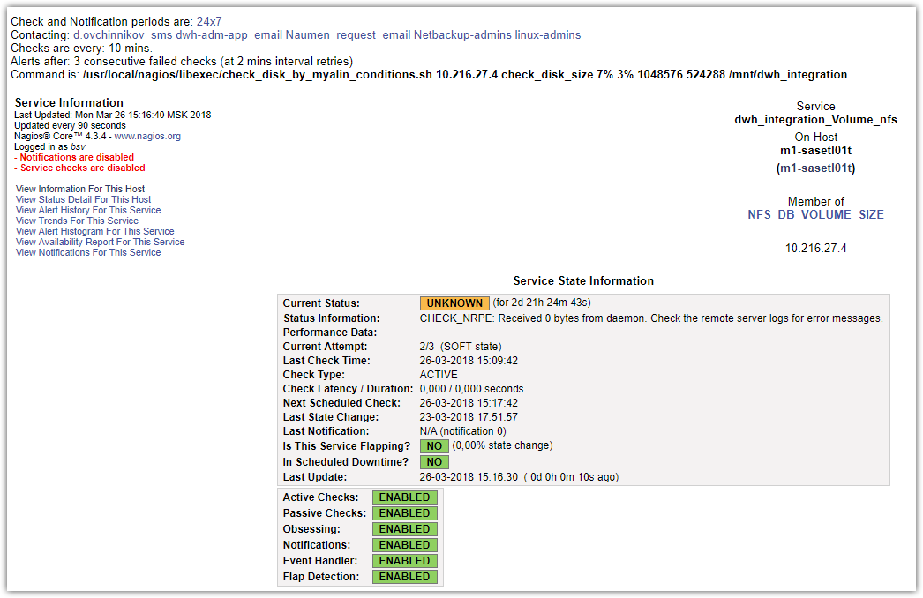

#
# After forced check in nagios, I’ve found follow lines in log file.
#
[root@m1-sasetl01t ~]# less /var/log/messages
...
Mar 26 15:09:42 m1-sasetl01t nrpe[47585]: Error: Request contained command arguments, but argument option is not enabled!
Mar 26 15:09:42 m1-sasetl01t nrpe[47585]: Client request from 172.16.1.117 was invalid, bailing out...
Mar 26 15:09:42 m1-sasetl01t nrpe[47587]: Error: Request contained command arguments, but argument option is not enabled!
Mar 26 15:09:42 m1-sasetl01t nrpe[47587]: Client request from 172.16.1.117 was invalid, bailing out...
...

[root@m1-sasetl01t ~]# sed -e 's/^dont_blame_nrpe=0/dont_blame_nrpe=1/' /etc/nagios/nrpe.cfg | grep -e "dont_blame_nrpe"
dont_blame_nrpe=1
# command arguments *AND* the dont_blame_nrpe directive in this
[root@m1-sasetl01t ~]#

[root@m1-sasetl01t ~]# sed -i -e 's/^dont_blame_nrpe=0/dont_blame_nrpe=1/' /etc/nagios/nrpe.cfg && service nrpe restart

#
# Related link.
#
https://www.thegeekstuff.com/2010/12/enable-nrpe-command-arguments/

Nagios: How to Enable check_nrpe Command Line Arguments
by RAMESH NATARAJAN on DECEMBER 21, 2010
Question: When I execute check_nrpe command with some arguments, I get the message “CHECK_NRPE: Received 0 bytes from daemon. Check the remote server logs for error messages.”. How do I fix this issue?
Answer: The issue is very straight forward. check_nrpe doesn’t take any arguments by default. You should enable the command line arguments for check_nrpe as shown below.

Verify the check_nrpe error message
Just for testing purpose, let us assume that you are execuing the following check_nrpe command that displays the “CHECK_NRPE: Received 0 bytes from daemon.” error message.
$ /usr/local/nagios/libexec/check_nrpe -H 192.168.1.20 -c check_disk -a 60 80 /dev/sdb1
CHECK_NRPE: Received 0 bytes from daemon. Check the remote server logs for error messages.
If you view the /var/log/messages on the remote host, (in the above example, that is 192.168.1.20), you’ll see the nrpe error “Error: Request contained command arguments!” as shown below, indicating that check_nrpe is not enabled to take the command arguments.
$ tail -f /var/log/messages
Dec 5 11:11:52 dev-db xinetd[2536]: START: nrpe pid=24187 from=192.168.101.108
Dec 5 11:11:52 dev-db nrpe[24187]: Error: Request contained command arguments!
Dec 5 11:11:52 dev-db nrpe[24187]: Client request was invalid, bailing out...
Dec 5 11:11:52 dev-db xinetd[2536]: EXIT: nrpe status=0 pid=24187 duration=0(sec)

Enable check_nrpe command arguments
To enable command arguments in NRPE, you should do the following two things.

1. Configure NRPE with –enable-command-args
Typically when you install NRPE on the remote host, you’ll do ./configure without any arguments. To enable support for command arguments in the NRPE daemon, you should install it with –enable-command-args as shown below.
[remotehost]# tar xvfz nrpe-2.12.tar.gz
[remotehost]# cd nrpe-2.12
[remotehost]# ./configure --enable-command-args
[remotehost]# make all
[remotehost]# make install-plugin
[remotehost]# make install-daemon
[remotehost]# make install-daemon-config
[remotehost]# make install-xinetd

2. Modify nrpe.cfg and set dont_blame_nrpe
Modify the /usr/local/nagios/etc/nrpe.cfg on the remote server and set the dont_blame_nrpe directive to 1 as shown below.
$ /usr/local/nagios/etc/nrpe.cfg
dont_blame_nrpe=1

Execute check_nrpe with command arguments
After the above two changes, if you execute the check_nrpe for this particular remote host, you’ll not see the error message anymore as shown below.
$ /usr/local/nagios/libexec/check_nrpe -H 192.168.1.20 -c check_disk -a 60 80 /dev/sdb1
DISK OK - free space: / 111199 MB (92% inode=99%);| /=9319MB;101662;114370;0;127078

Security Warning
Enabling NRPE command line arguments is a security risk. If you don’t know what you are doing, don’t enable this.
Probably by now you’ve already figured out that you can’t blame NRPE if something goes wrong. After all you did set dont_blame_nrpe to 1.

#
# 20191213
#
# In this task need to make https check. If returned “200 OK” - test is OK.
#
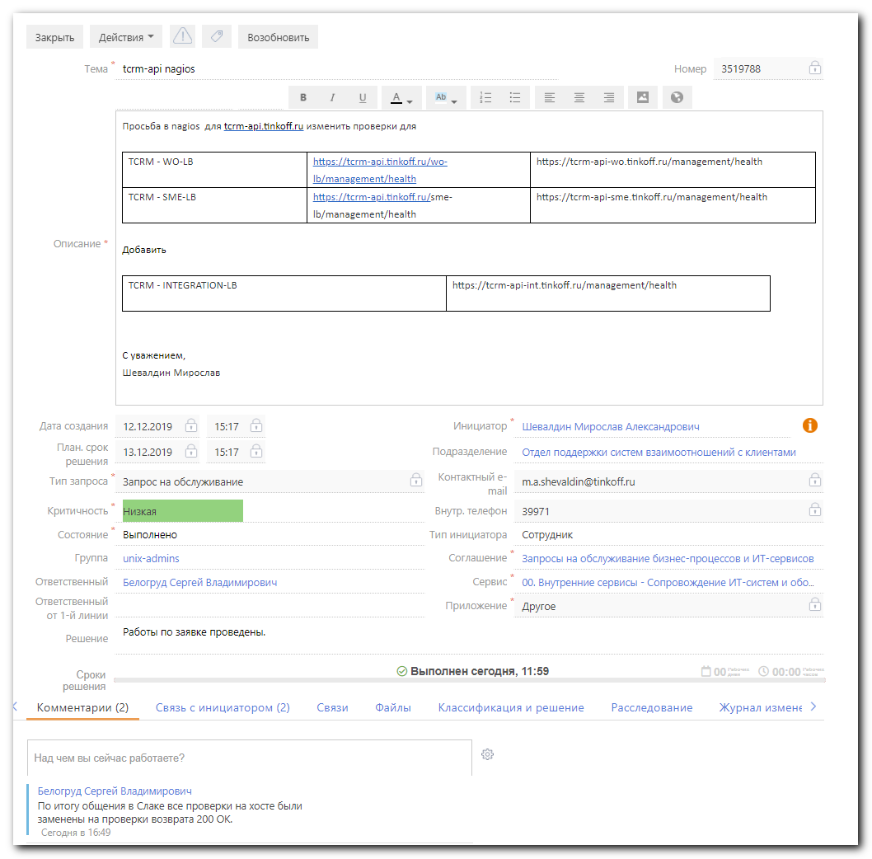

[root@vm-vol-nag4-tst objects]# /usr/local/nagios/libexec/check_tcrm_api.sh https://tcrm-api-int.tinkoff.ru/management/health
CRITICAL Response: |res=0
[root@vm-vol-nag4-tst objects]#
​
[root@vm-vol-nag4-tst objects]# cat /usr/local/nagios/libexec/check_tcrm_api.sh
#!/bin/bash
​
# Path to jq utility
JQ='/usr/bin/jq'
CURL='/usr/bin/curl'
URL="$1"
​
# Nagios exit codes
OK=0
CRITICAL=2
UNKNOWN=3
​
OK_STRING="UP"
​
if [ ! -f "$JQ" ]; then
echo "jq tool is not installed. Install it first!"
exit 1
fi
​
res=$(curl -s $URL | $JQ -r '.status')
​
if [ "$res" == "$OK_STRING" ]; then
echo "OK Response: $res|res=1"
exit $OK
else
echo "CRITICAL Response: $res|res=0"
exit $CRITICAL
fi
[root@vm-vol-nag4-tst objects]#
​
[root@vm-vol-nag4-tst objects]# /usr/bin/curl -s https://tcrm-api-int.tinkoff.ru/management/health
[root@vm-vol-nag4-tst objects]#

[root@vm-vol-nag4-tst objects]# /usr/bin/curl -s https://tcrm-api.tinkoff.ru/sme-customer/management/health
{"description":"Composite Discovery Client","status":"UP"}
[root@vm-vol-nag4-tst objects]#

[root@vm-vol-nag4-tst objects]# /usr/local/nagios/libexec/check_http -I 10.218.84.22 -H tcrm-api.tinkoff.ru --ssl -e "200 OK" -u "/sme-customer/management/health"
HTTP OK: Status line output matched "200 OK" - 547 bytes in 0.019 second response time |time=0.018508s;;;0.000000 size=547B;;;0

[root@vm-vol-nag4-tst objects]# /usr/local/nagios/libexec/check_http -I 10.218.84.22 -H tcrm-api-int.tinkoff.ru --ssl -e "200 OK" -u "/management/health"
HTTP OK: Status line output matched "200 OK" - 165 bytes in 0.012 second response time |time=0.011989s;;;0.000000 size=165B;;;0
[root@vm-vol-nag4-tst objects]#

[root@vm-vol-nag4-tst objects]# cat servers/tcrm-api.tinkoff.ru.cfg
define host{
use linux-server
host_name tcrm-api.tinkoff.ru
address 10.218.84.22
notes_url https://wiki.tcsbank.ru/display/sd/$HOSTNAME$
contacts m.kovalev_sms,crm_support_email,r.nosov_sms,k.kashin_sms
}
define service{
use generic-service-ping
host_name tcrm-api.tinkoff.ru
service_description PING
check_command check_ping!100.0,20%!500.0,60%
check_interval 1
}
...
define service{
use generic-service
host_name tcrm-api.tinkoff.ru
service_description TCRM - UAA
# check_command check_tcrm_api!https://tcrm-api.tinkoff.ru/uaa/management/health
check_command check_http! -H tcrm-api.tinkoff.ru --ssl -e "200 OK" -u "/uaa/management/health"
check_interval 1
max_check_attempts 2
}
define service{
use generic-service
host_name tcrm-api.tinkoff.ru
service_description TCRM - INTEGRATION-LB
# check_command check_tcrm_api!https://tcrm-api-int.tinkoff.ru/management/health
check_command check_http! -H tcrm-api-int.tinkoff.ru --ssl -e "200 OK" -u "/management/health"
check_interval 1
max_check_attempts 2
}
[root@vm-vol-nag4-tst objects]#

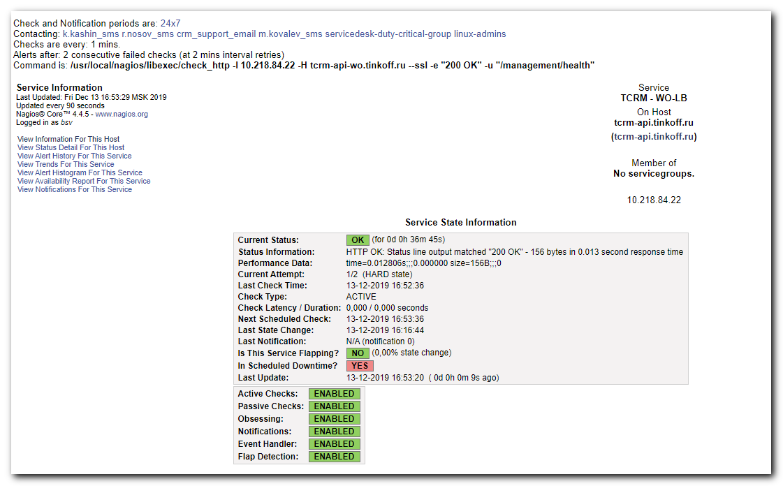

#
# 20191219
# In this task need same - http check and return code 200 - means - Ok.
# But here I’ve used custom check.
# Differ is in this test absent auto created “-I ip_address”. Address is the same as what server cfg file this check belong.
#

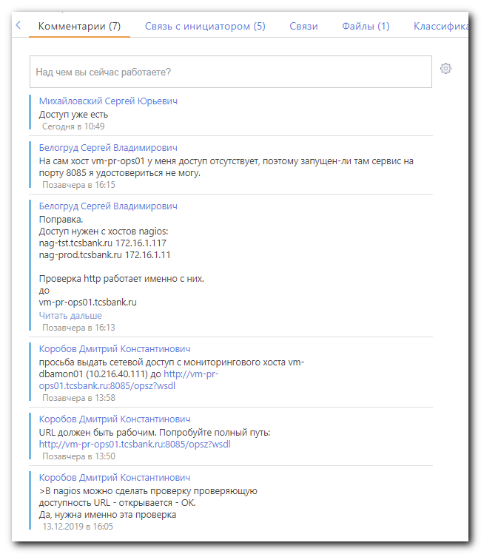

#
# The check run from current nagios server (test, or prod). And I’ve asked permissions from nagios servers.
#

[root@vm-vol-nag4-tst objects]# tail -n 15 servers/vmware/vm-dbamon01.cfg
# SD#3505400
define service{
use generic-service
host_name vm-dbamon01
service_description OPS - Z-service
check_interval 10
first_notification_delay 0
contacts paym_ops_email
contact_groups empty-group
notification_options w,u,c,r
flap_detection_enabled 0
max_check_attempts 1
check_command check_http_custom! -H vm-pr-ops01.tcsbank.ru -p 8085 -e "200 OK" -u "/opsz?wsdl"
notification_interval 10
}
[root@vm-vol-nag4-tst objects]#

[root@vm-vol-nag4-tst objects]# /usr/local/nagios/libexec/check_http -H vm-pr-ops01 -p 8085 -e "200 OK" -u "/opsz?wsdl"
HTTP OK: Status line output matched "200 OK" - 3224 bytes in 0.024 second response time |time=0.024256s;;;0.000000 size=3224B;;;0
[root@vm-vol-nag4-tst objects]#

[root@vm-vol-nag4-tst objects]# vim -R commands.cfg
...
# 'check_http_custom' command definition
define command{
command_name check_http_custom
command_line $USER1$/check_http $ARG1$
}
...
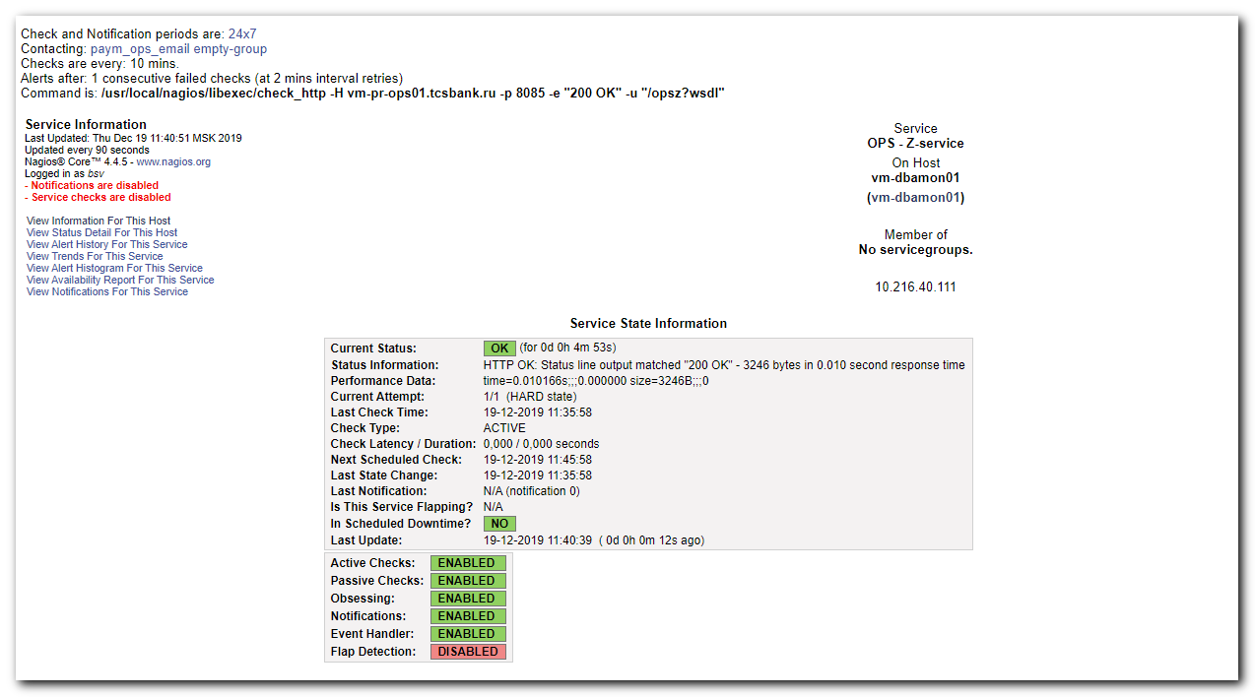

#
# But if used this check. Into final test inserts “-I ip_addr” option. And the ip_addr will be the ip address server vm-dbamon01.
#
[root@vm-vol-nag4-tst objects]# vim -R commands.cfg
...
# 'check_http' command definition
define command{
command_name check_http
command_line $USER1$/check_http -I $HOSTADDRESS$ $ARG1$
}
...

[root@vm-vol-nag4-tst objects]# /usr/local/nagios/libexec/check_http -I 10.216.40.111 -H vm-pr-ops01.tcsbank.ru -p 8085 -e "200 OK" -u "/opsz?wsdl"
No route to host
HTTP CRITICAL - Unable to open TCP socket
[root@vm-vol-nag4-tst objects]#

[root@vm-vol-nag4-tst objects]# host 10.216.40.111
111.40.216.10.in-addr.arpa domain name pointer vm-dbamon01.tcsbank.ru.
[root@vm-vol-nag4-tst objects]#

#
# 20200120
#
# In nagios if timeperiod made wrong. In one definition time pass though midnight.
# I suppose in this situation we have stuck “Last Check Time:”
#
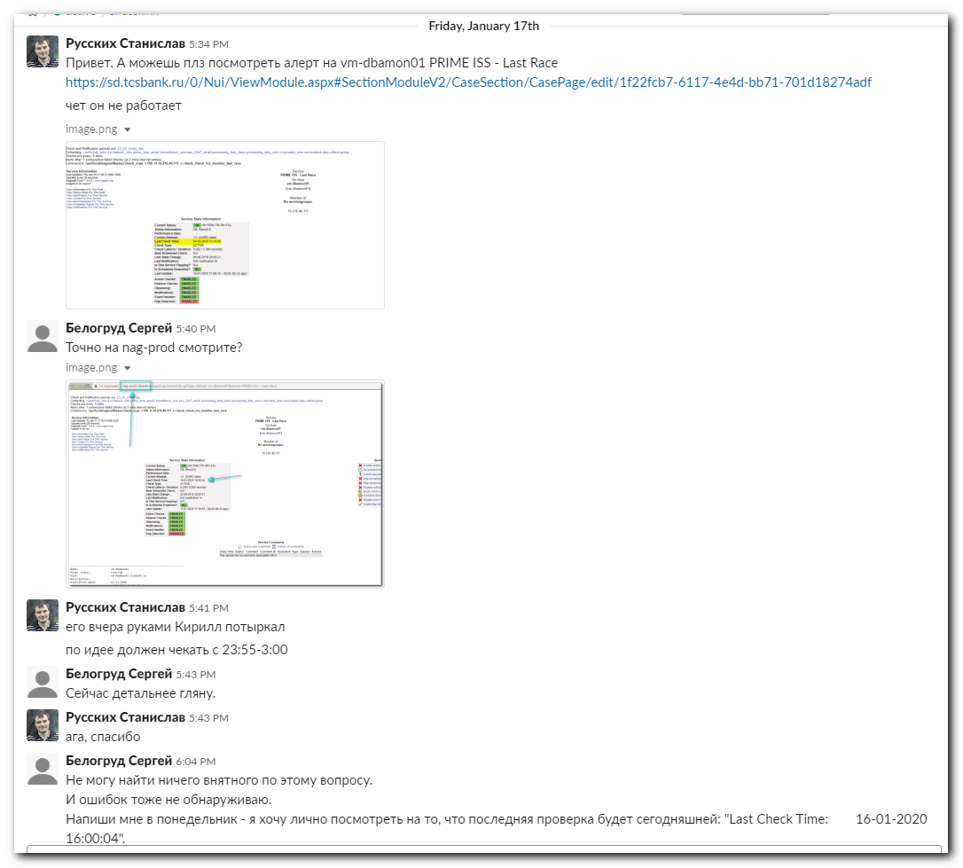
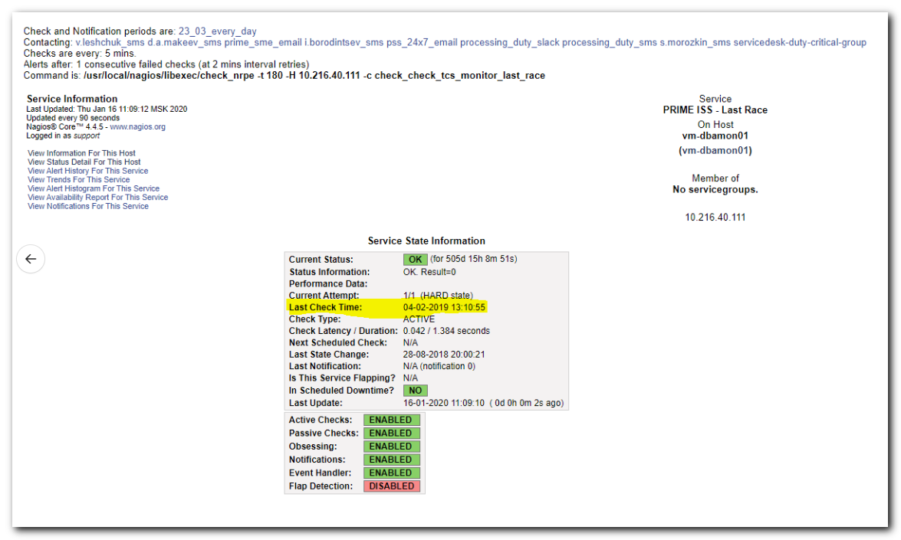

#
# Previous variant of time period looked like follow.
# And I suppose it’s wrong. Because in one interval time pass throug midnight (previous day and day after).
#
[root@vm-vol-nag4-tst objects]# vim -R ./timeperiods.cfg
...
#SD2239814
define timeperiod{
timeperiod_name 23_03_every_day
alias 23_03_every_day
sunday 23:55-03:00
monday 23:55-03:00
tuesday 23:55-03:00
wednesday 23:55-03:00
thursday 23:55-03:00
friday 23:55-03:00
saturday 23:55-03:00
}
...

#
# I’ve modified it to follow.
#
[root@vm-vol-nag4-tst objects]# vim -O -c ":/PRIME ISS - Last Race" servers/vmware/vm-dbamon01.cfg
...
#sd 1371424
define timeperiod{
timeperiod_name last_race_period
alias last_race_period
monday 00:00-03:00,23:55-24:00
tuesday 00:00-03:00,23:55-24:00
wednesday 00:00-03:00,23:55-24:00
thursday 00:00-03:00,23:55-24:00
friday 00:00-03:00,23:55-24:00
saturday 00:00-03:00,23:55-24:00
sunday 00:00-03:00,23:55-24:00
}
define service{
use generic-service
host_name vm-dbamon01
service_description PRIME ISS - Last Race
check_command check_nrpe!check_check_tcs_monitor_last_race
check_interval 5
max_check_attempts 1
notification_interval 180
contacts s.morozkin_sms, processing_duty_sms,processing_duty_slack, pss_24x7_email, i.borodintsev_sms, prime_sme_email,d.a.makeev_sms,v.leshchuk_sms
contact_groups servicedesk-duty-critical-group
flap_detection_enabled 0
check_period last_race_period
notification_period last_race_period
}
...

[root@vm-vol-nag4-tst objects]# git --no-pager log -n 1 -p servers/vmware/vm-dbamon01.cfg
commit 2eef1bb7b855e372f7d2ee054ae81eaab5d6ab59
Author: Belogrud <s.belogrud@tinkoff.ru>
Date: Mon Jan 20 12:21:55 2020 +0300

Russkikh Stanislav asked in Slack. Service has unusual behavior - Last check date was too late.

diff --git a/objects/servers/vmware/vm-dbamon01.cfg b/objects/servers/vmware/vm-dbamon01.cfg
index e3684d1..c090310 100644
--- a/objects/servers/vmware/vm-dbamon01.cfg
+++ b/objects/servers/vmware/vm-dbamon01.cfg
@@ -3865,13 +3865,13 @@ define service{
define timeperiod{
timeperiod_name last_race_period
alias last_race_period
- monday 23:55-3:00
- tuesday 23:55-3:00
- wednesday 23:55-3:00
- thursday 23:55-3:00
- friday 23:55-3:00
- saturday 23:55-3:00
- sunday 23:55-3:00
+ monday 00:00-03:00,23:55-24:00
+ tuesday 00:00-03:00,23:55-24:00
+ wednesday 00:00-03:00,23:55-24:00
+ thursday 00:00-03:00,23:55-24:00
+ friday 00:00-03:00,23:55-24:00
+ saturday 00:00-03:00,23:55-24:00
+ sunday 00:00-03:00,23:55-24:00
}
define service{
use generic-service
[root@vm-vol-nag4-tst objects]#

#
# On next day. I see - last check time is now updating.
